**CREATING AND MANAGING TABLES**

**EX.NO:1 DATE: 20-2-24**

**REG.NO: 220701306**

1. Create the DEPT table based on the DEPARTMENT following the table instance chart below. Confirm that the table is created.

|  |  |  |
| --- | --- | --- |
| **Column name** | ID | NAME |
| **Key Type** |  |  |
| **Nulls/Unique** |  |  |
| **FK table** |  |  |
| **FK column** |  |  |
| **Data Type** | Number | Varchar2 |
| **Length** | 7 | 25 |

**QUERY:**

CREATE TABLE DEPT (Dept_ID number(6) not null, Dept_name varchar(20), Manager_ID varchar(6), Location_ID number(4));

**OUTPUT:**

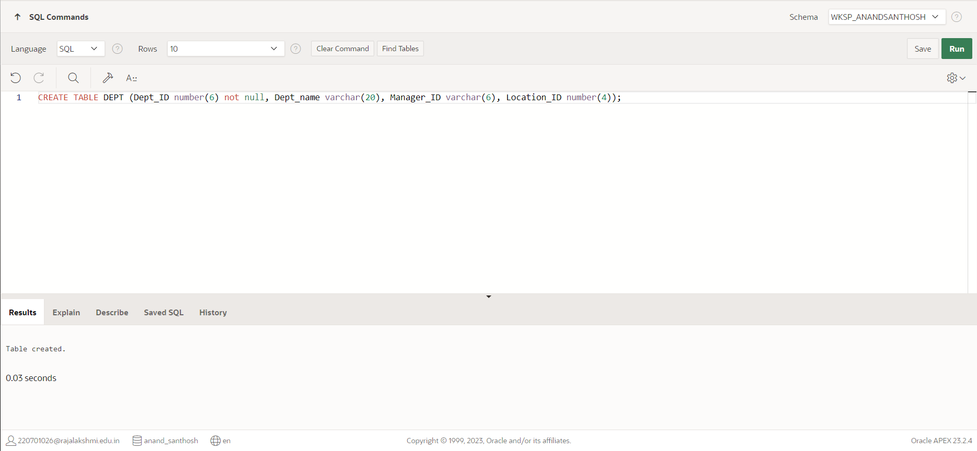

1. Create the EMP table based on the following instance chart. Confirm that the table is created.

|  |  |  |  |  |
| --- | --- | --- | --- | --- |
| **Column name** | ID | LAST_NAME | FIRST_NAME | DEPT_ID |
| **Key Type** |  |  |  |  |
| **Nulls/Unique** |  |  |  |  |
| **FK table** |  |  |  |  |
| **FK column** |  |  |  |  |
| **Data Type** | Number | Varchar2 | Varchar2 | Number |
| **Length** | 7 | 25 | 25 | 7 |

**QUERY:**

CREATE TABLE EMP( ID int, Last_name varchar(25), First_name varchar(25), Dept_ID number(7));

**OUTPUT:**

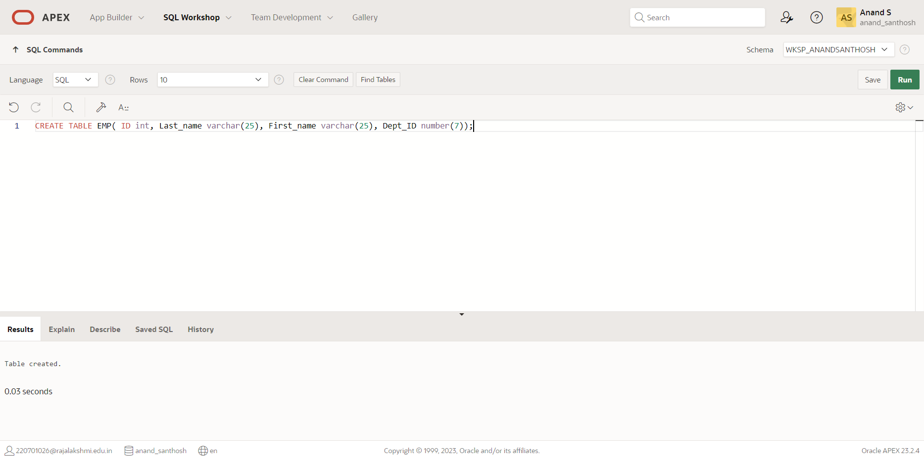

1. Modify the EMP table to allow for longer employee last names. Confirm the modification.(Hint: Increase the size to 50)

**QUERY:**

ALTER TABLE EMP MODIFY(Last_name varchar(50));

**OUTPUT:**

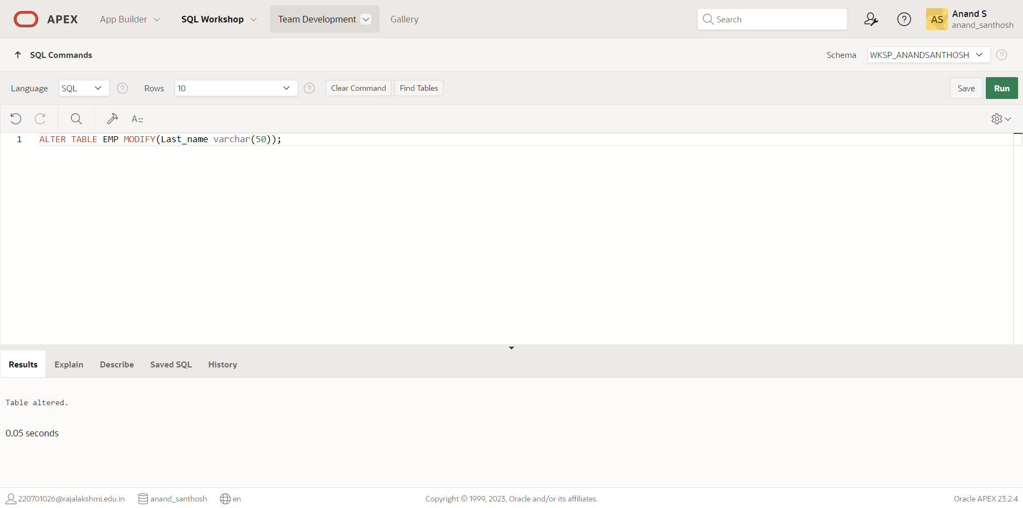

1. Create the EMPLOYEES2 table based on the structure of EMPLOYEES table. Include Only the Employee_id, First_name, Last_name, Salary and Dept_id coloumns. Name the columns Id, First_name, Last_name, salary and Dept_id respectively.

**QUERY:**

CREATE TABLE EMPLOYEE2(ID number(6) not null, First_name varchar(20), Last_Name varchar(25), Salary number(8,2), Dept_ID number(6) not null);

**OUTPUT:**

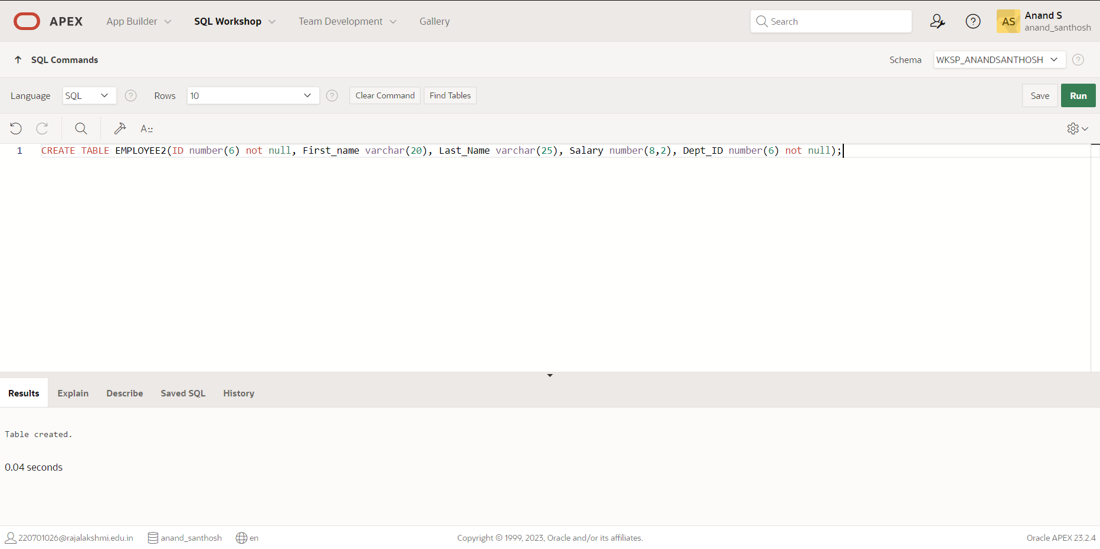

1. Drop the EMP table.

**QUERY:**

DROP TABLE EMP;

**OUTPUT:**

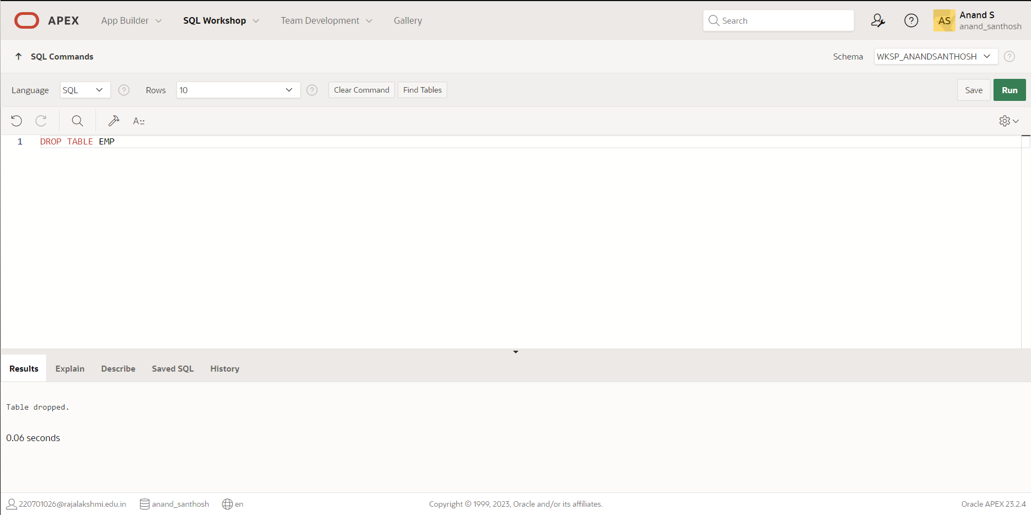

1. Rename the EMPLOYEES2 table as EMP.

**QUERY:**

RENAME EMPLOYEE2 to EMP;

**OUTPUT:**

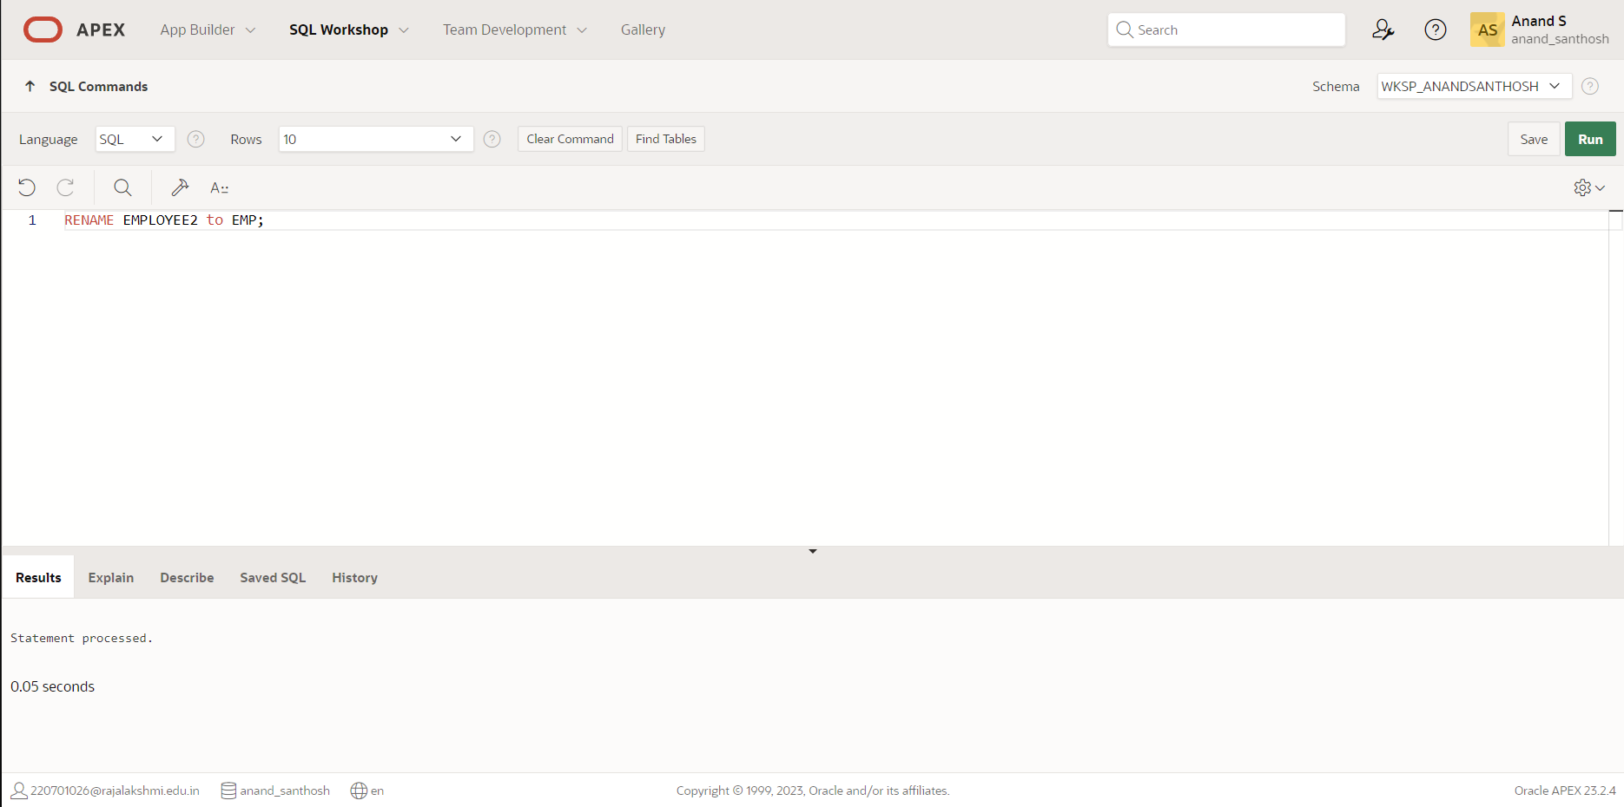

1. Add a comment on DEPT and EMP tables. Confirm the modification by describing the table.

**QUERY:**

COMMENT ON TABLE DEPT IS'DEPARTMENT_INFO';

COMMENT ON TABLE EMP IS 'EMPLOYEE_INFO';

**OUTPUT:**

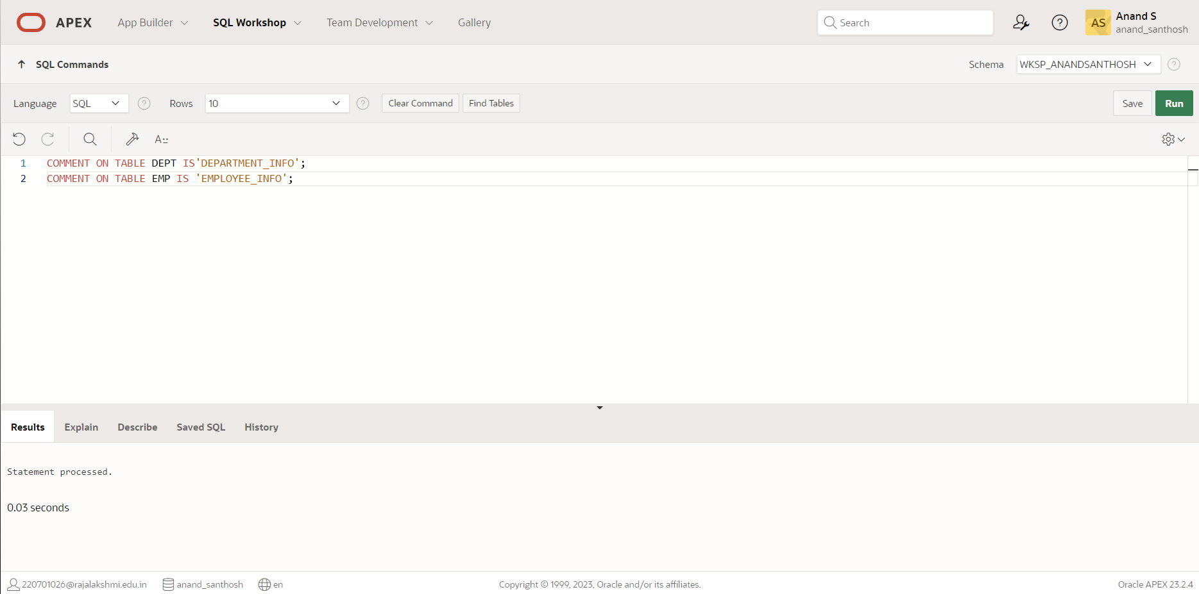

1. Drop the First_name column from the EMP table and confirm it.

**QUERY:**

ALTER TABLE EMP DROP COLUMN First_name;

**OUTPUT:**

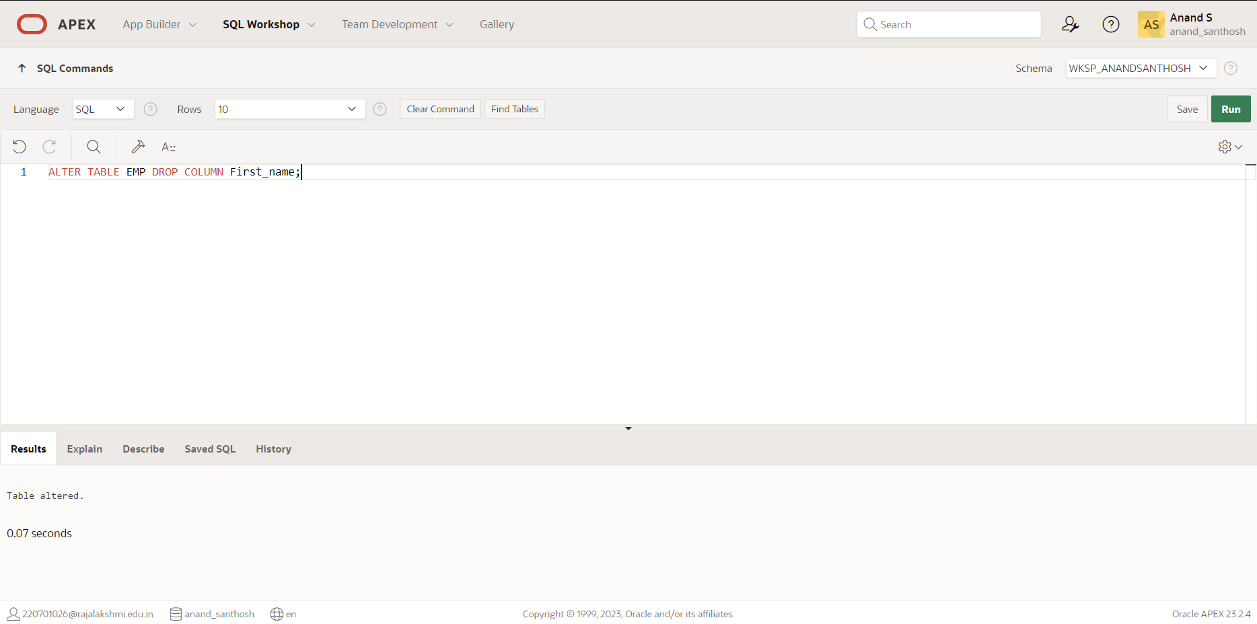

|  |  |
| --- | --- |
| Evaluation Procedure | Marks awarded |
| Query(5) |  |
| Execution (5) |  |
| Viva(5) |  |
| Total (15) |  |
| Faculty Signature |  |

**MANIPULATING DATA**

**EX.NO:2 DATE: 23 – 2 - 24**

**REG.NO: 220701306**

1. Create MY_EMPLOYEE table with the following structure

|  |  |  |
| --- | --- | --- |
| NAME | NULL? | TYPE |
| ID | Not null | Number(4) |
| Last_name |  | Varchar(25) |
| First_name |  | Varchar(25) |
| Userid |  | Varchar(25) |
| Salary |  | Number(9,2) |

**QUERY:**

CREATE TABLE MY_EMPLOYEE( ID number(4), Last_name varchar(25), First_name varchar(25), Userid varchar(25), Salary number(9,2));

**OUTPUT:**

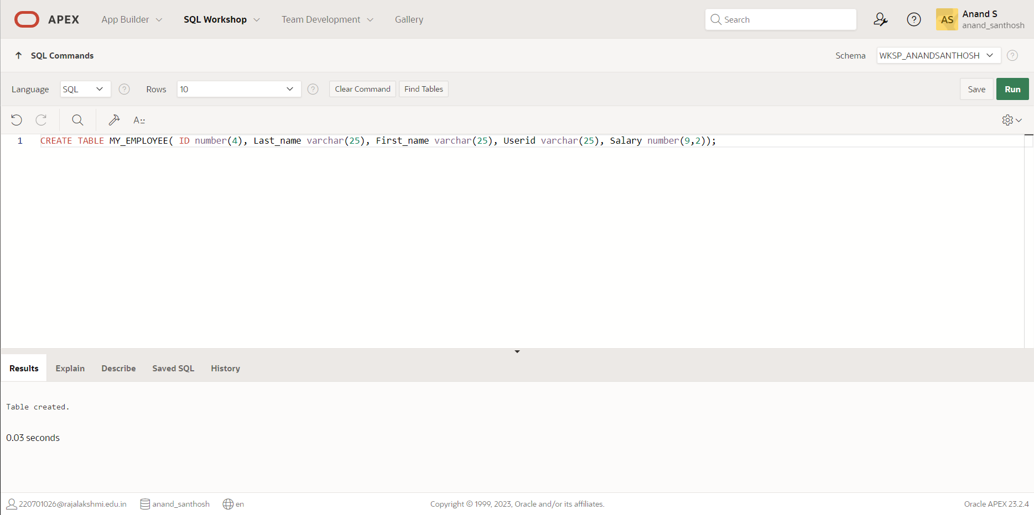

1. Add the first and second rows data to MY_EMPLOYEE table from the following sample data.

|  |  |  |  |  |
| --- | --- | --- | --- | --- |
| **ID** | **Last_name** | **First_name** | **Userid** | **salary** |
| 1 | Patel | Ralph | rpatel | 895 |
| 2 | Dancs | Betty | bdancs | 860 |
| 3 | Biri | Ben | bbiri | 1100 |
| 4 | Newman | Chad | Cnewman | 750 |
| 5 | Ropebur | Audrey | aropebur | 1550 |

**QUERY:**

INSERT INTO MY_EMPLOYEE VALUES(1,'Patel','Ralph','rpatel',895);

INSERT INTO MY_EMPLOYEE VALUES(2,'Dancs','Betty','bdancs',860);

**OUTPUT:**

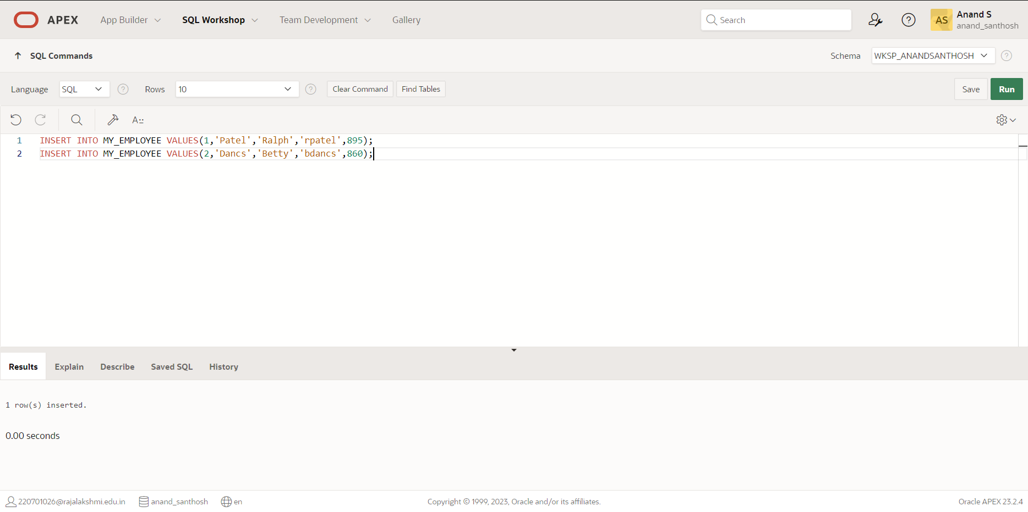

1. Display the table with values.

**QUERY:**

SELECT * FROM MY_EMPLOYEE

**OUTPUT:**

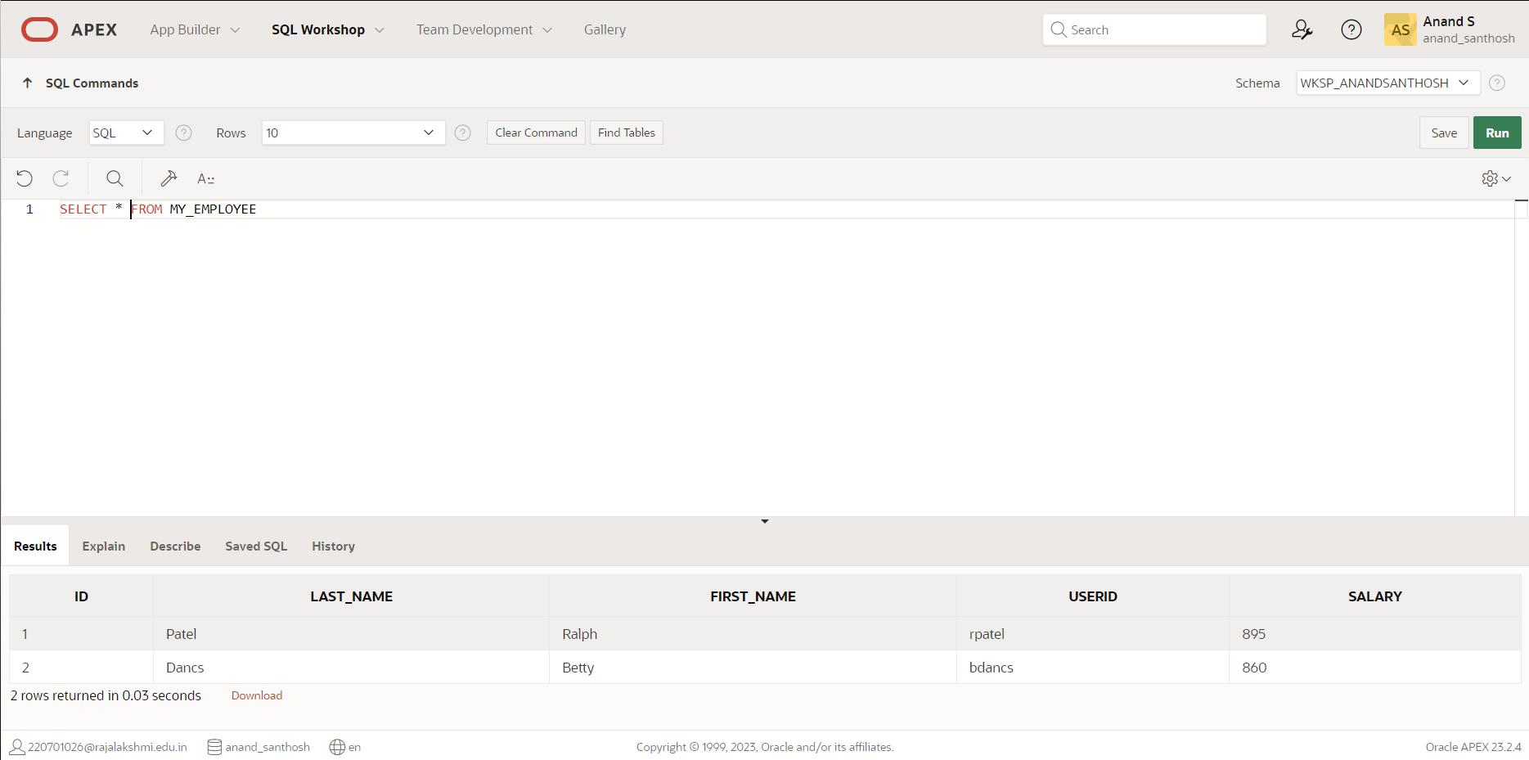

1. Populate the next two rows of data from the sample data. Concatenate the first letter of the first_name with the first seven characters of the last_name to produce Userid.

**QUERY:**

INSERT INTO MY_EMPLOYEE VALUES(3,'Biri','Ben','bbiri',1100);

INSERT INTO MY_EMPLOYEE VALUES(4,'Newman','Chad','Cnewman',750);

**OUTPUT:**

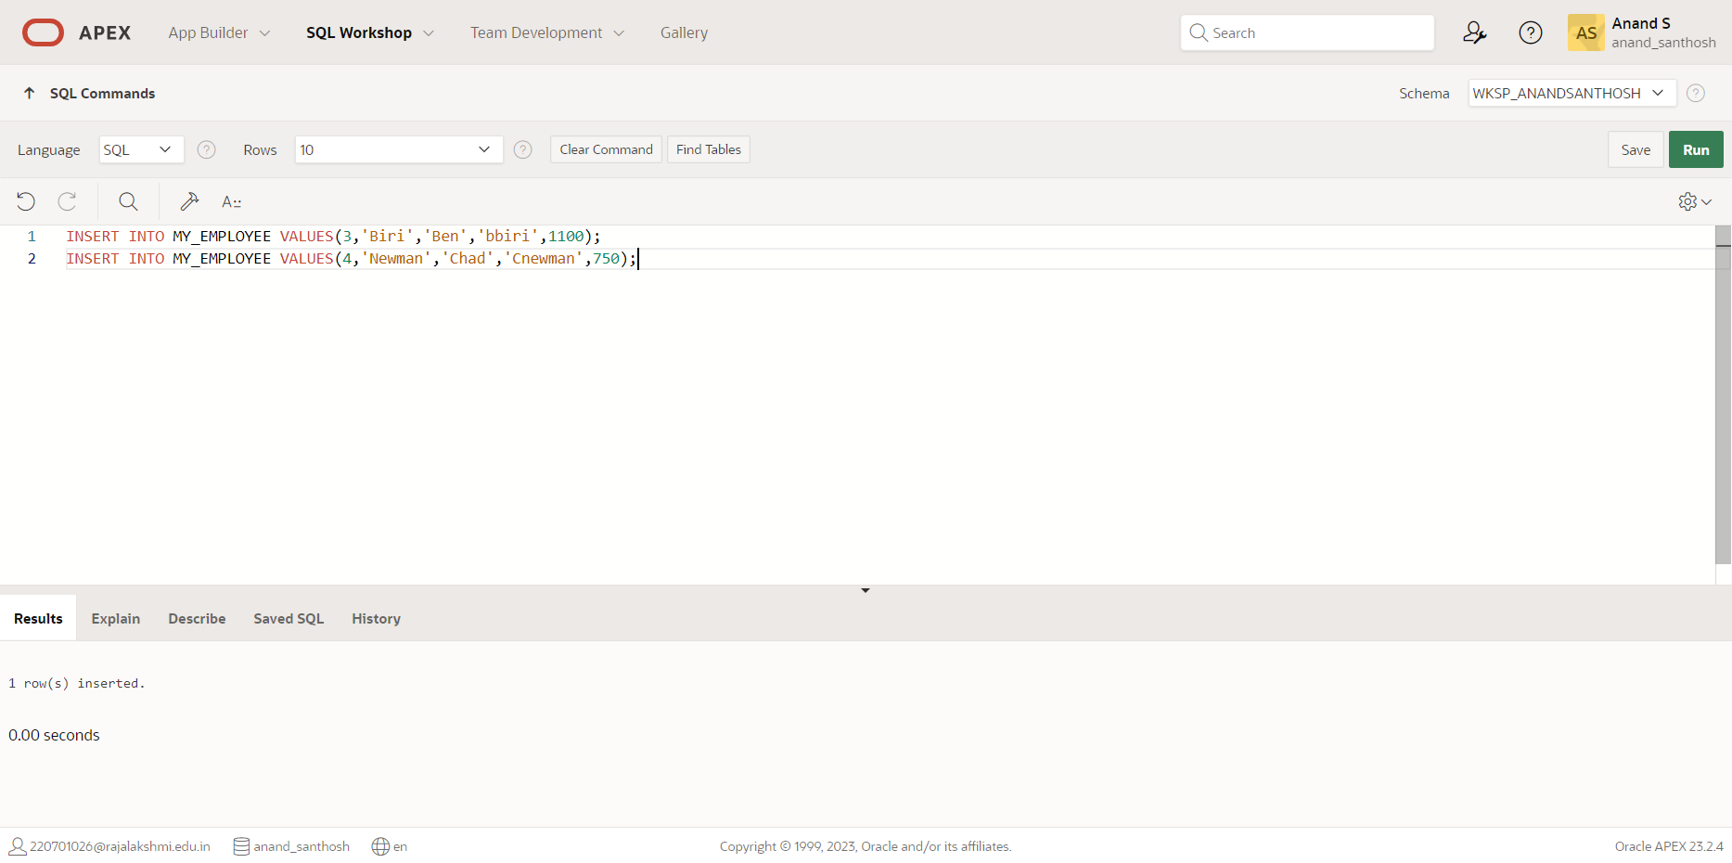

1. Make the data additions permanent.

**QUERY:**

SELECT * FROM MY_EMPLOYEE ORDER BY ID;

**OUTPUT:**

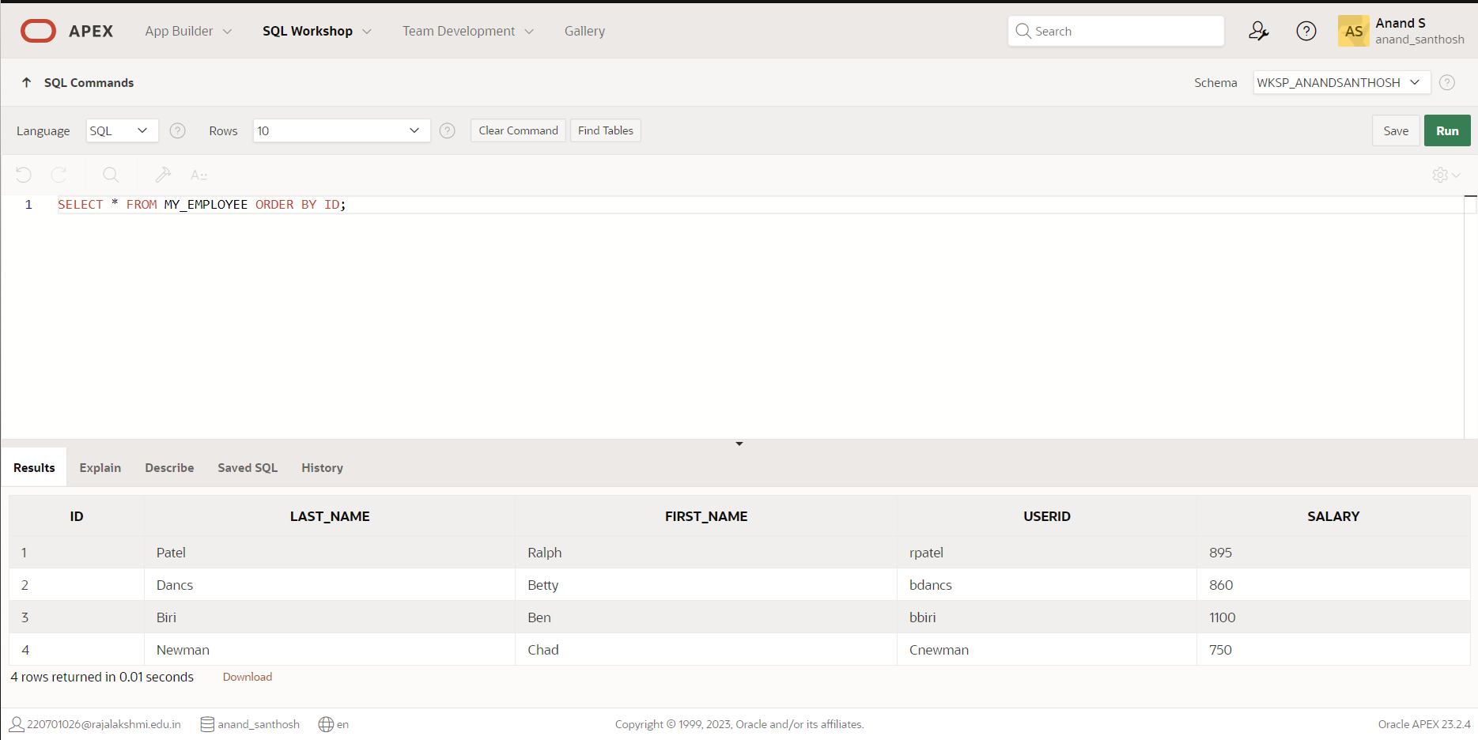

1. Change the last name of employee 3 to Drexler.

**QUERY:**

UPDATE MY_EMPLOYEE SET Last_name='Drexler' WHERE ID=3;

**OUTPUT:**

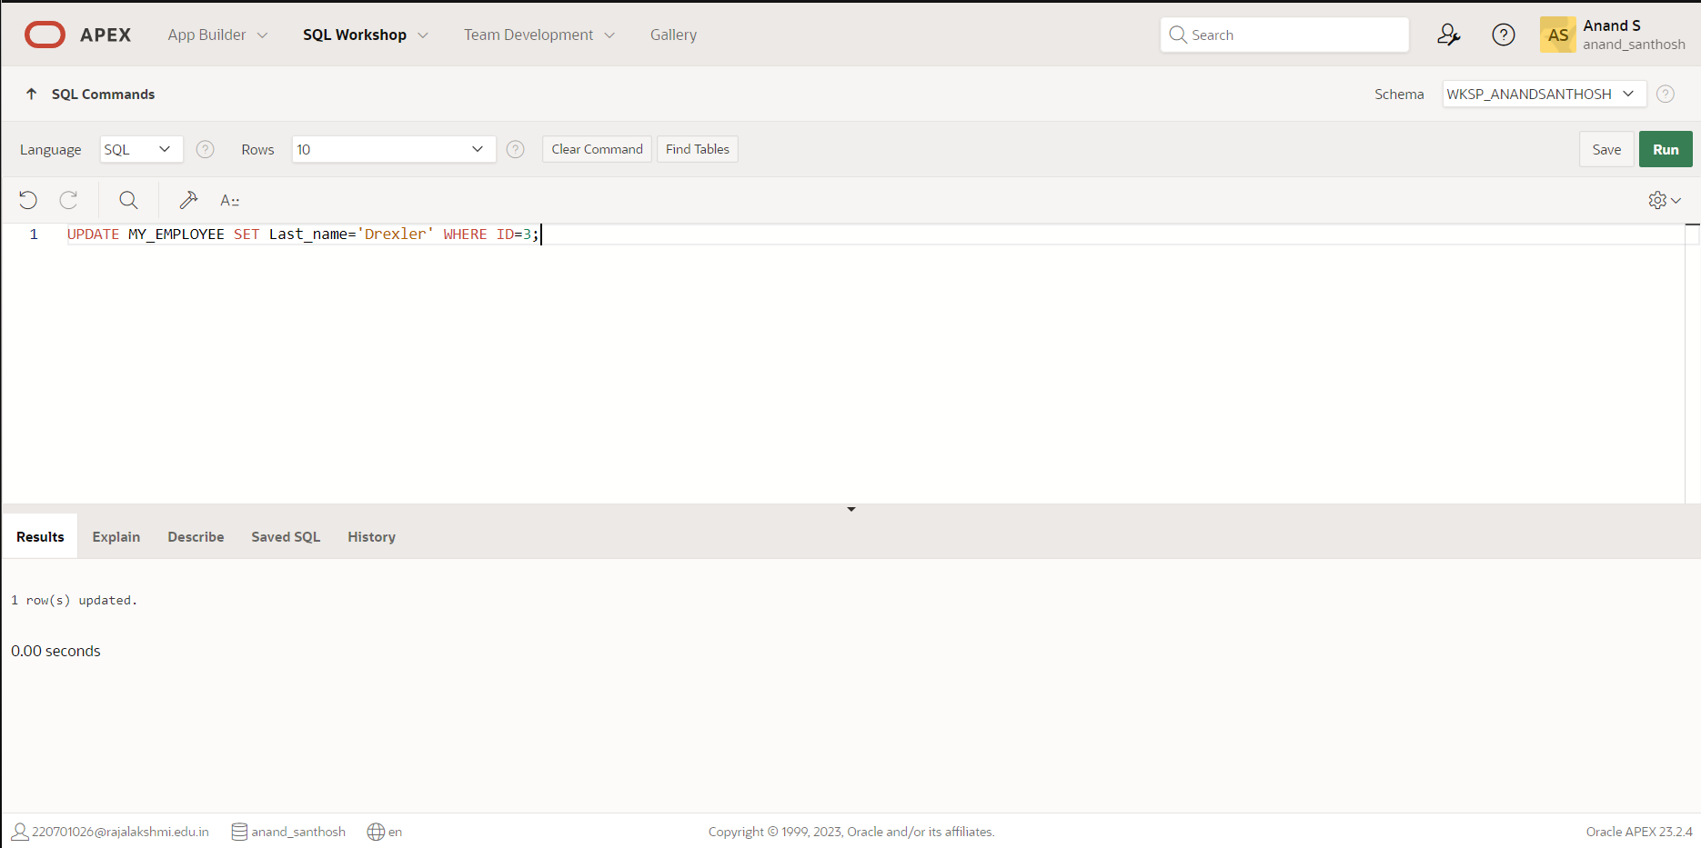

1. Change the salary to 1000 for all the employees with a salary less than 900.

**QUERY:**

UPDATE MY_EMPLOYEE SET Salary=1000 WHERE Salary<900;

**OUTPUT:**

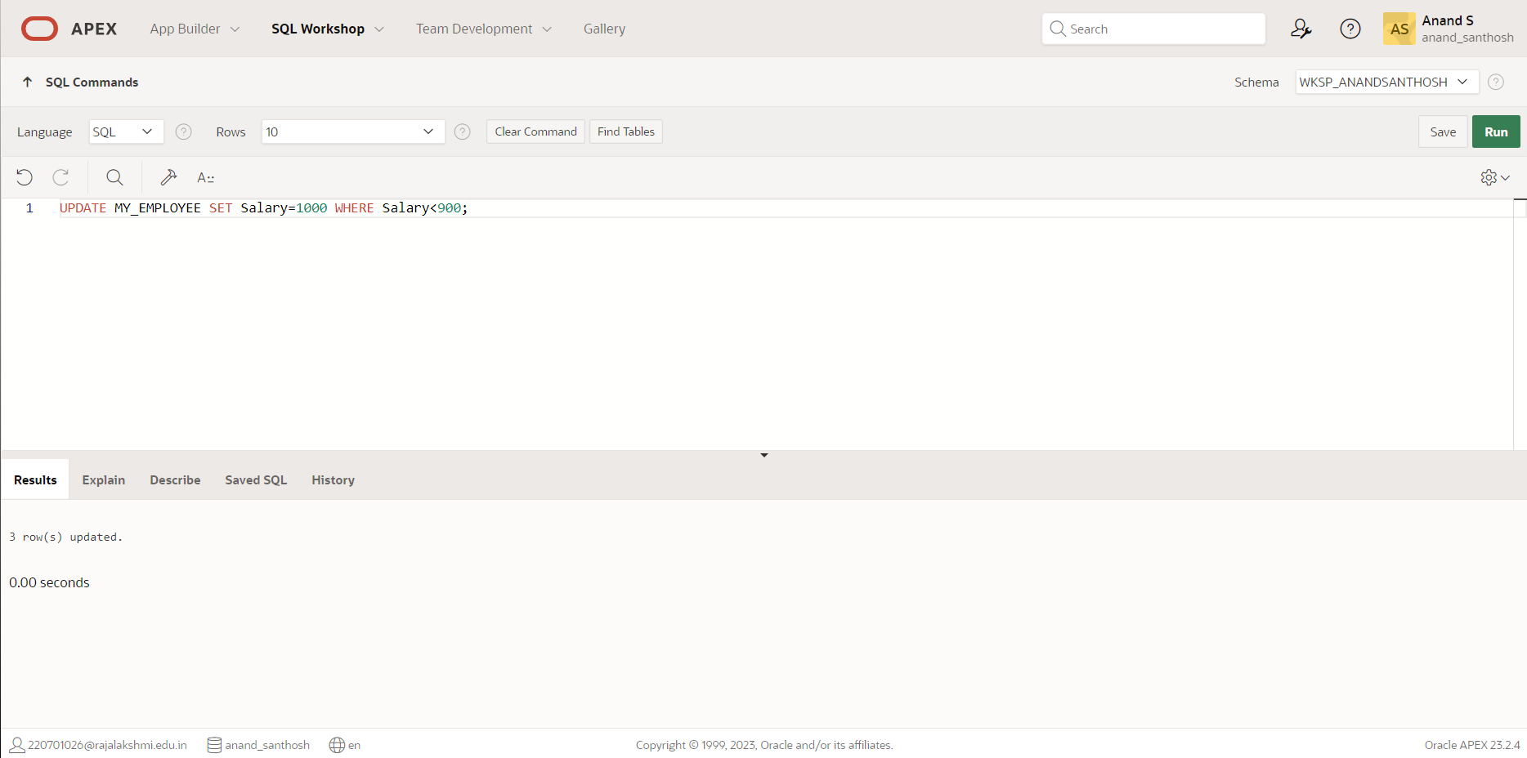

1. Delete Betty dancs from MY _EMPLOYEE table.

**QUERY:**

DELETE FROM MY_EMPLOYEE WHERE First_name='Betty';

**OUTPUT:**

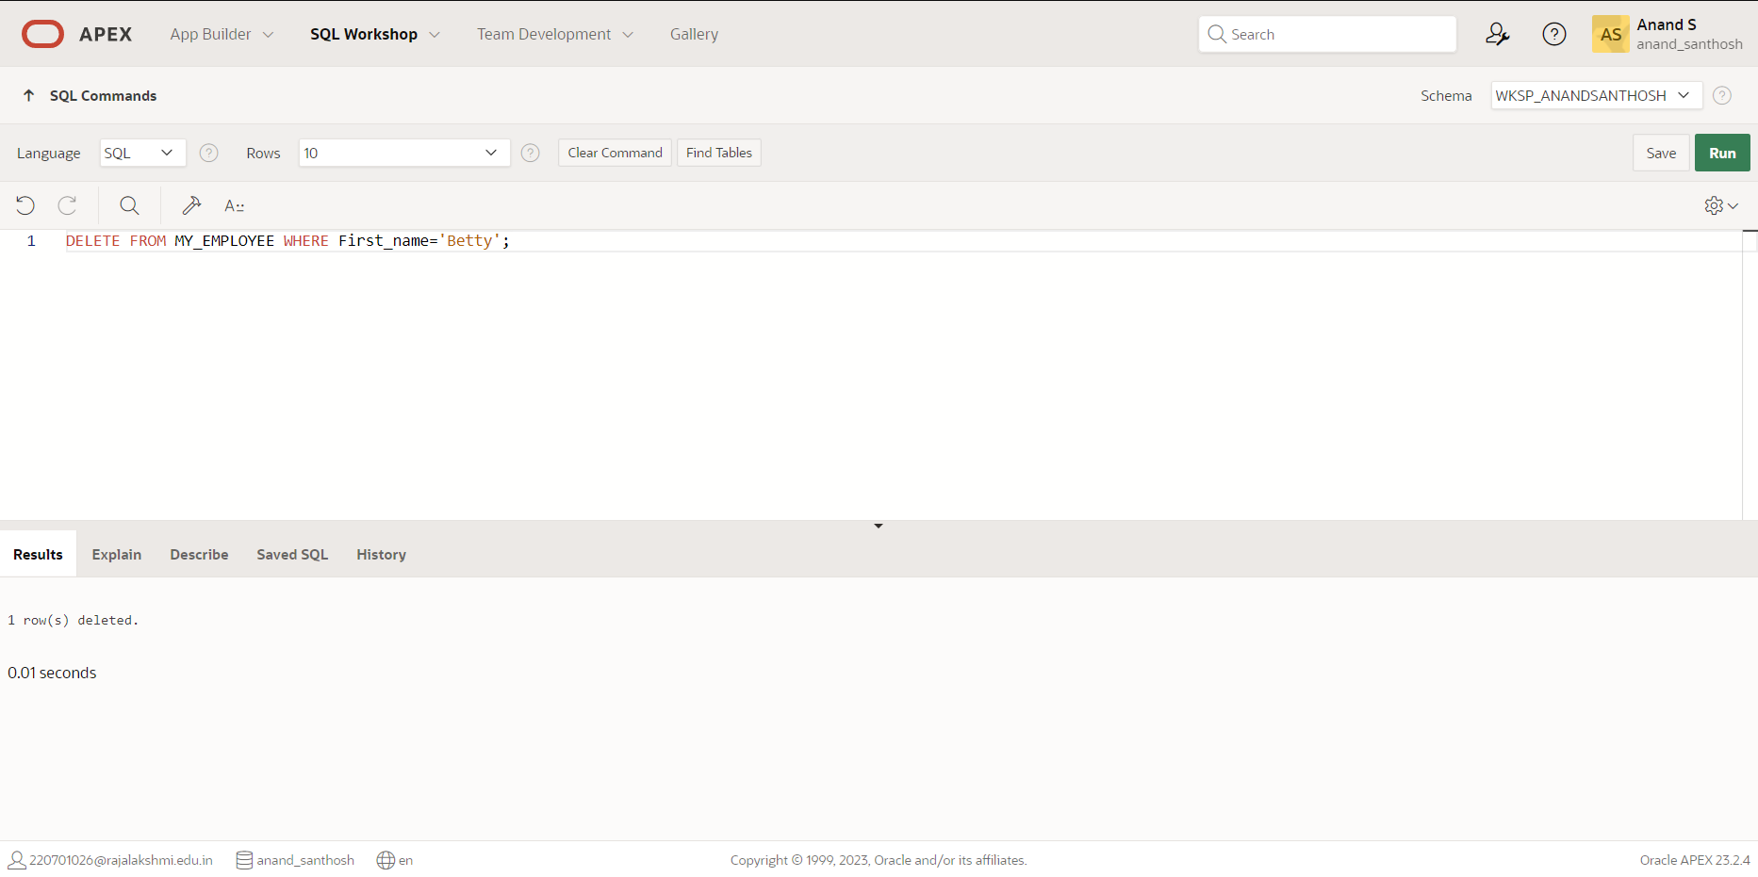

1. Empty the fourth row of the emp table.

**QUERY:**

DELETE FROM MY_EMPLOYEE WHERE ID=4;

**OUTPUT:**

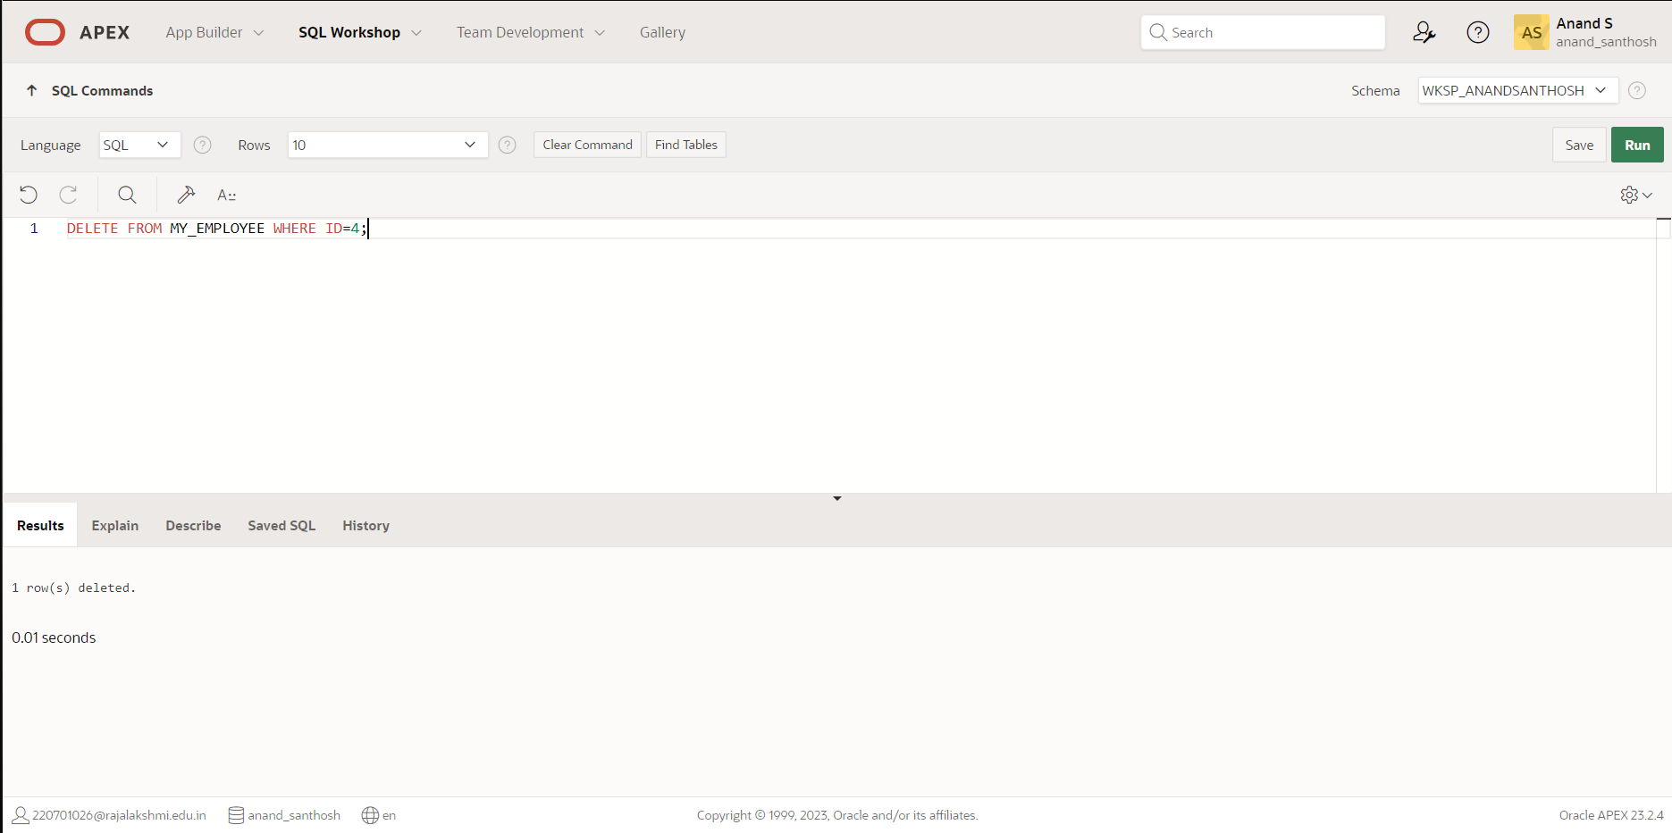

|  |  |
| --- | --- |
| Evaluation Procedure | Marks awarded |
| Query(5) |  |
| Execution (5) |  |
| Viva(5) |  |
| Total (15) |  |
| Faculty Signature |  |

**INCLUDING CONSTRAINTS**

**EX.NO:3 DATE: 27 – 2 - 24**

**REG.NO: 220701306**

1. Add a table-level PRIMARY KEY constraint to the EMP table on the ID column.The constraint should be named at creation. Name the constraint my_emp_id_pk.

**QUERY:**

CREATE TABLE EMPLOYEES (Employ_id number(6) not null, First_name varchar(40), Last_name varchar(40), CONSTRAINT my_emp_id_pk PRIMARY KEY(Employ_id));

**OUTPUT:**

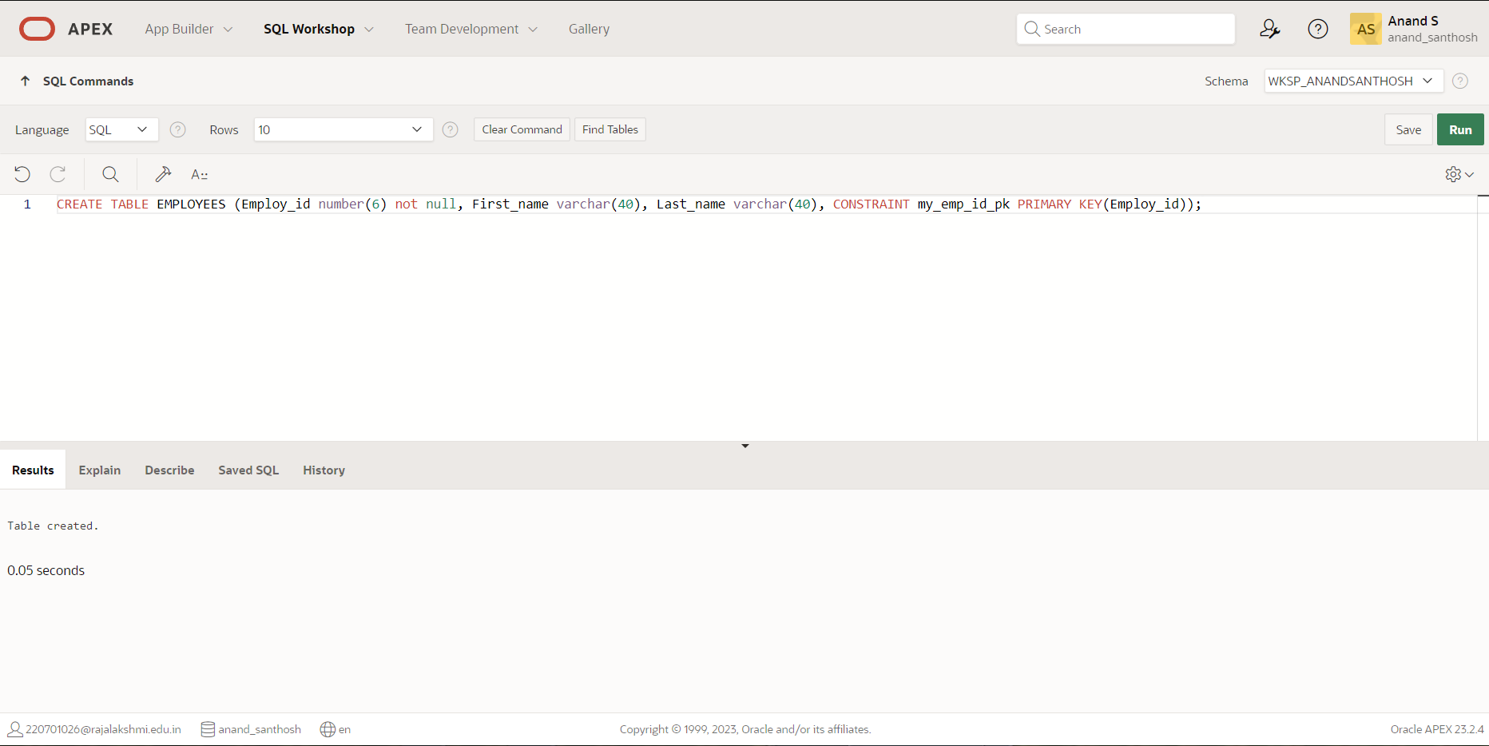

1. Create a PRIMAY KEY constraint to the DEPT table using the ID colum. The constraint should be named at creation. Name the constraint my_dept_id_pk.

**QUERY:**

CREATE TABLE DEPARTMENT (Dept_id number(6) not null, First_name varchar(40), Last_name varchar(40), age int, CONSTRAINT my_dept_id_pk PRIMARY KEY (Dept_id));

**OUTPUT:**

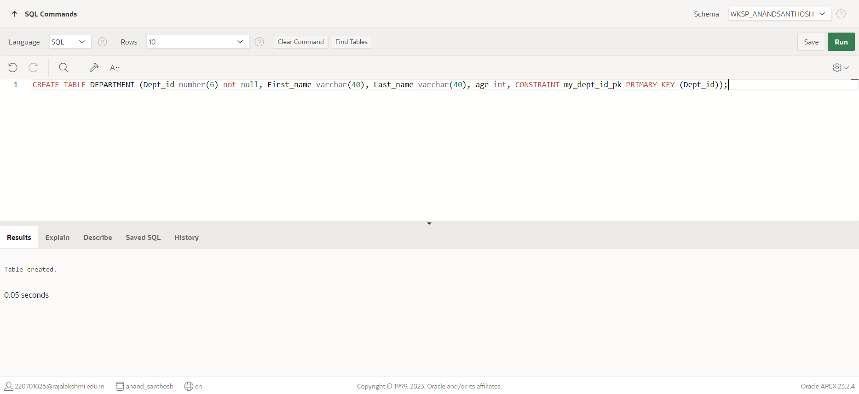

1. Add a column DEPT_ID to the EMP table. Add a foreign key reference on the EMP table that ensures that the employee is not assigned to nonexistent deparment. Name the constraint my_emp_dept_id_fk.

**QUERY:**

ALTER TABLE EMPLOYEES ADD(Dept_id int);

ALTER TABLE EMPLOYEES ADD CONSTRAINT my_emp_dept_id_fk FOREIGN KEY (Dept_id) REFERENCES DEPARTMENT(Dept_id);

**OUTPUT:**

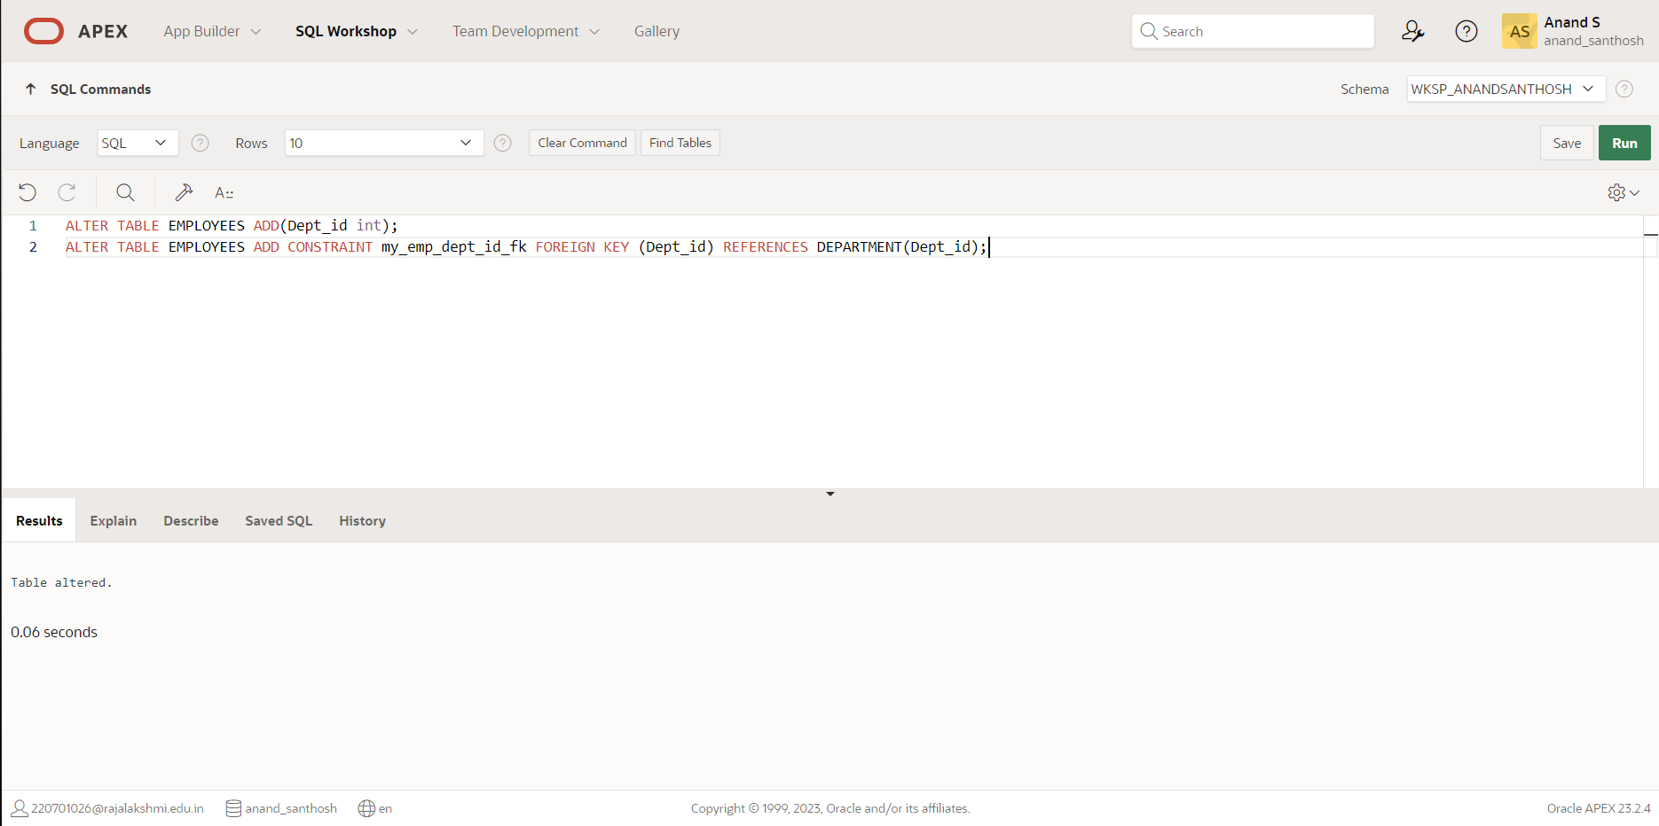

1. Modify the EMP table. Add a COMMISSION column of NUMBER data type, precision 2, scale 2. Add a constraint to the commission column that ensures that a commission value is greater than zero.

**QUERY:**

ALTER TABLE EMPLOYEES ADD(Commision number(8));

**OUTPUT:**

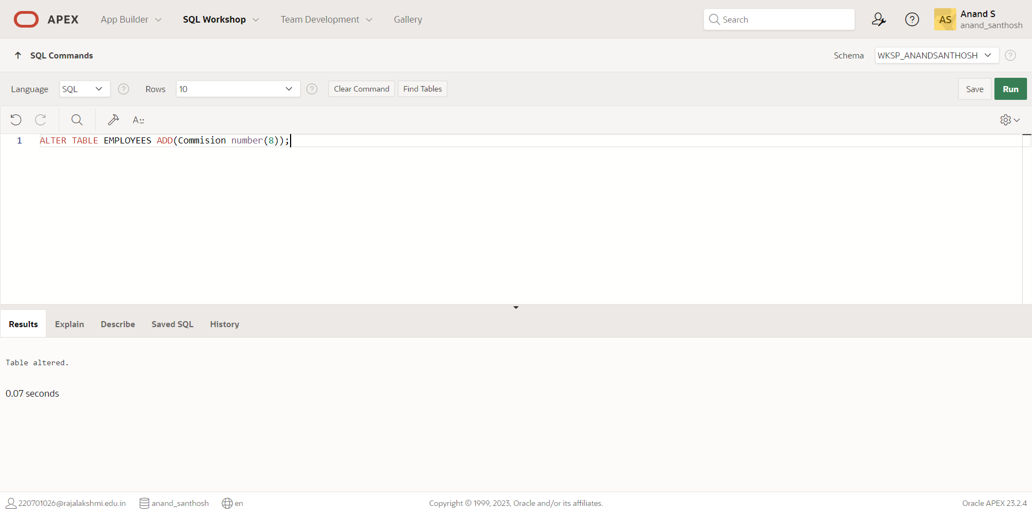

|  |  |
| --- | --- |
| Evaluation Procedure | Marks awarded |
| Query(5) |  |
| Execution (5) |  |
| Viva(5) |  |
| Total (15) |  |
| Faculty Signature |  |

**WRITING BASIC SQL SELECT STATEMENTS**

**EX.NO:4 DATE: 01 – 3 - 24**

**REG.NO: 220701306**

1. The following statement executes successfully.

**Identify the Errors**

SELECT employee_id, last_name

sal*12 ANNUAL SALARY

FROM employees;

**QUERY:**

SELECT EMPLOYEE_ID,Last_name ,Salary*12 as Annual salary

From employee;

1. Show the structure of departments the table. Select all the data from it.

**QUERY:**

DESC DEPARTMENT;

**OUTPUT:**

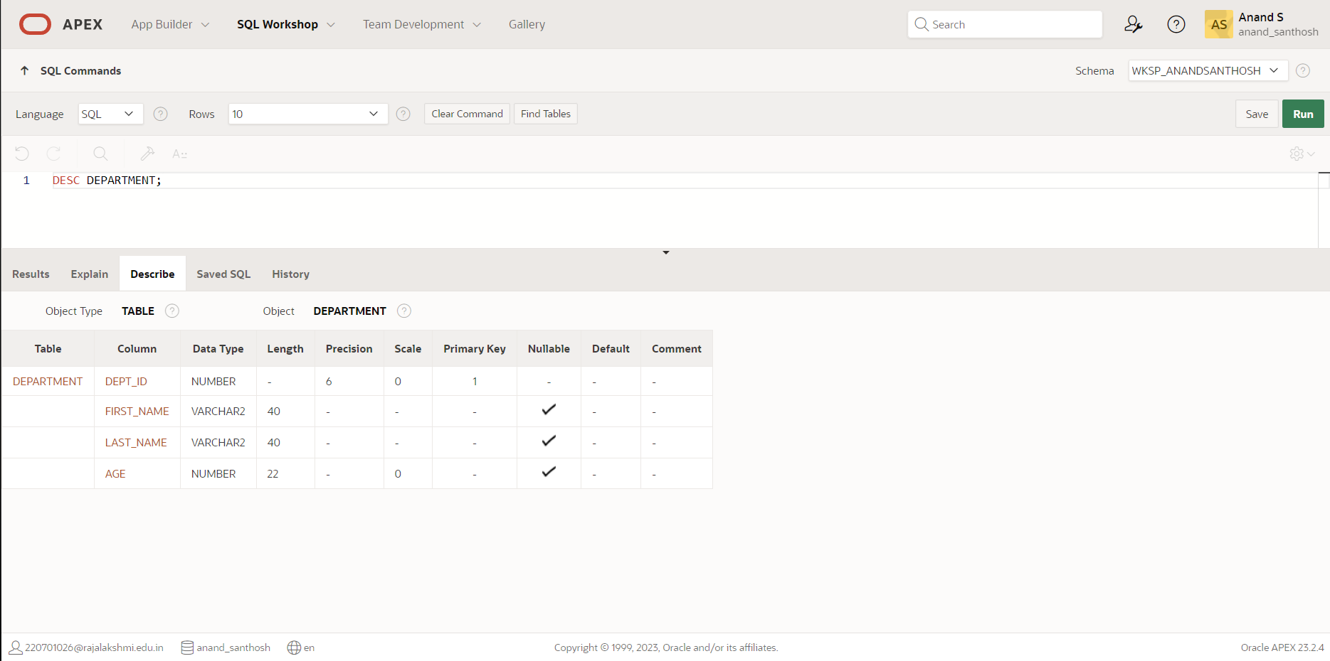

1. Create a query to display the last name, job code, hire date, and employee number for each employee, with employee number appearing first.

**QUERY:**

CREATE TABLE EMPLOY(Employee_number int, Last_name varchar(255), Job_code varchar(255), Hire_date varchar(10), Salary number(10,2), Department_id int, Supervisor_id int);

INSERT INTO EMPLOY VALUES (101, 'Smith', 'MGR', '2020-01-01', 80000, 10, NULL);

INSERT INTO EMPLOY VALUES (102, 'Johnson', 'SA', '2020-02-01', 60000, 20, 101);

INSERT INTO EMPLOY VALUES (103, 'Williams', 'SA', '2020-03-01', 60000, 20, 101);

INSERT INTO EMPLOY VALUES (104, 'Brown', 'SA', '2020-04-01', 60000, 20, 101);

INSERT INTO EMPLOY VALUES (105, 'Jones', 'CLR', '2020-05-01', 50000, 30, 101);

SELECT Employee_number, Last_name, Job_code, Hire_date FROM EMPLOY ORDER BY Employee_number;

**OUTPUT:**

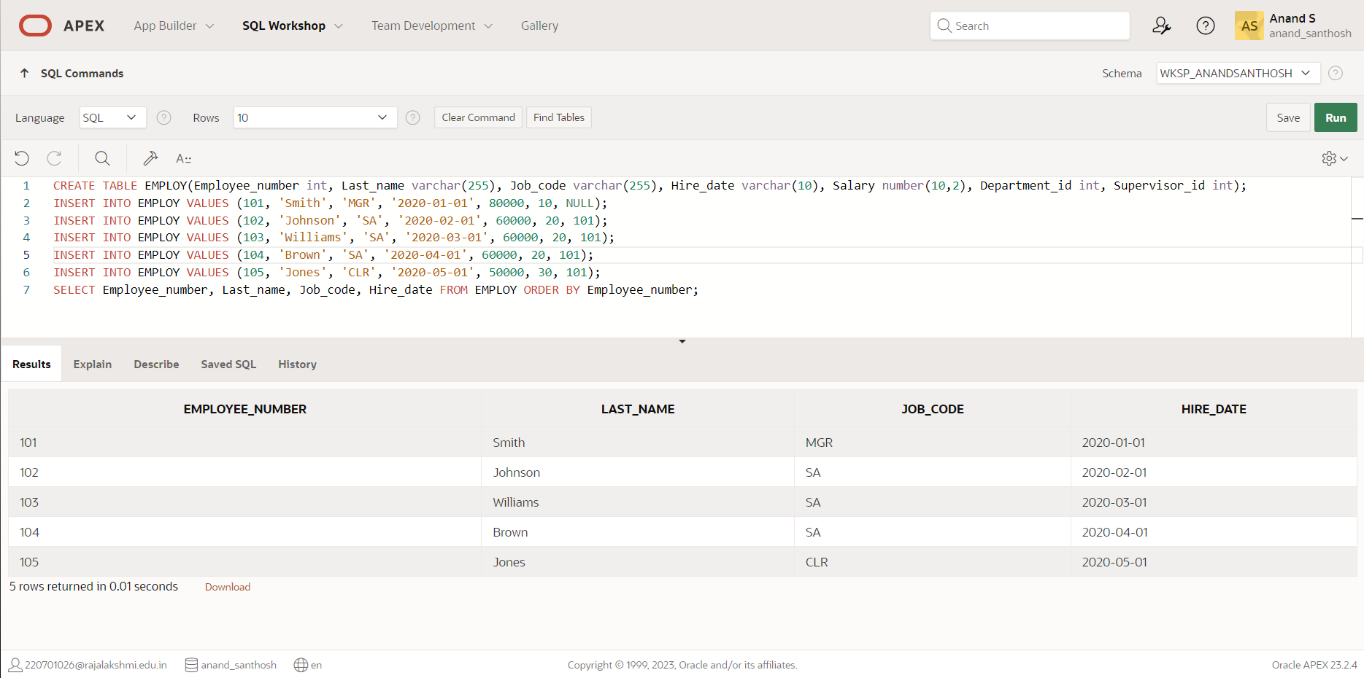

1. Provide an alias STARTDATE for the hire date.

**QUERY:**

SELECT Hire_date AS STARTDATE FROM EMPLOY;

**OUTPUT:**

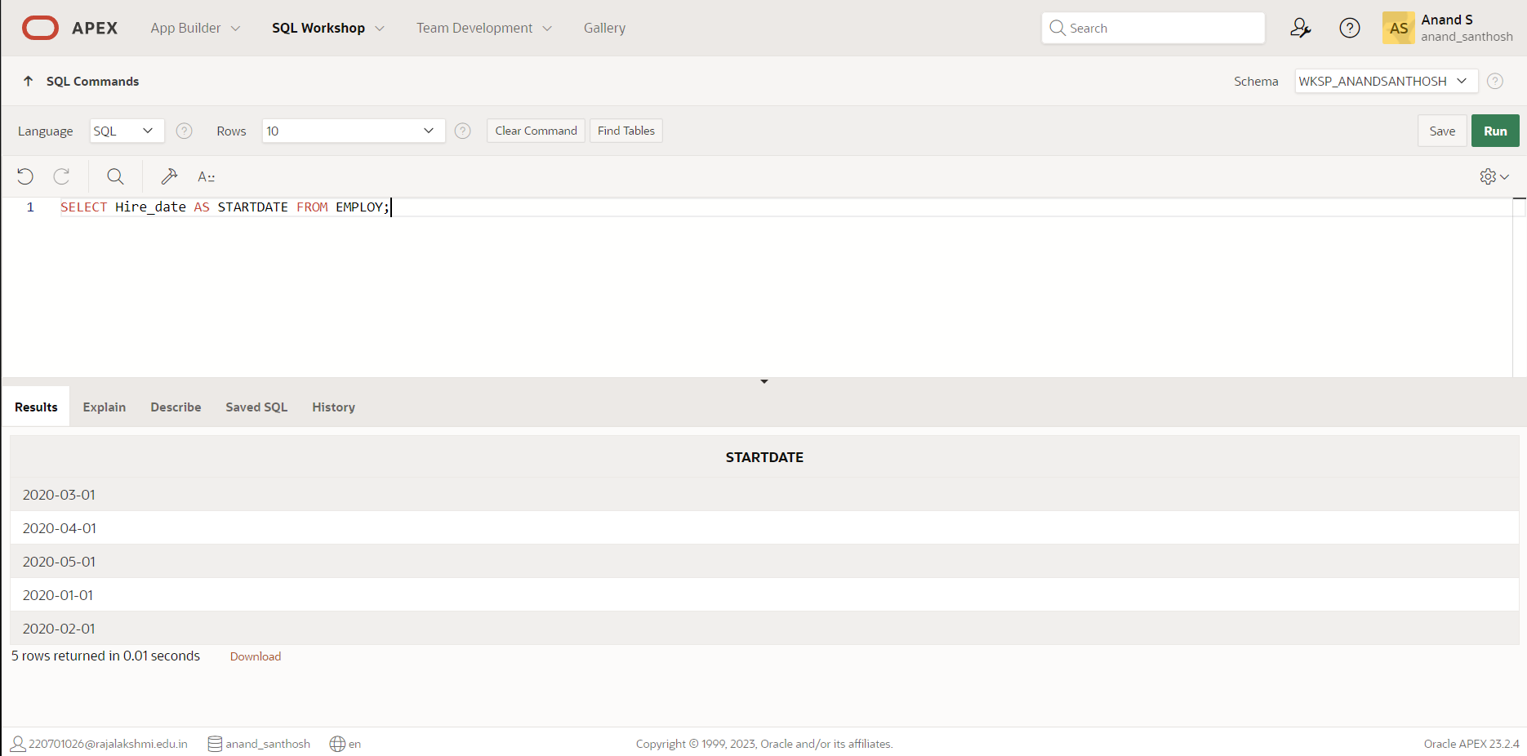

1. Create a query to display unique job codes from the employee table.

**QUERY:**

SELECT DISTINCT Job_code FROM EMPLOY;

**OUTPUT:**

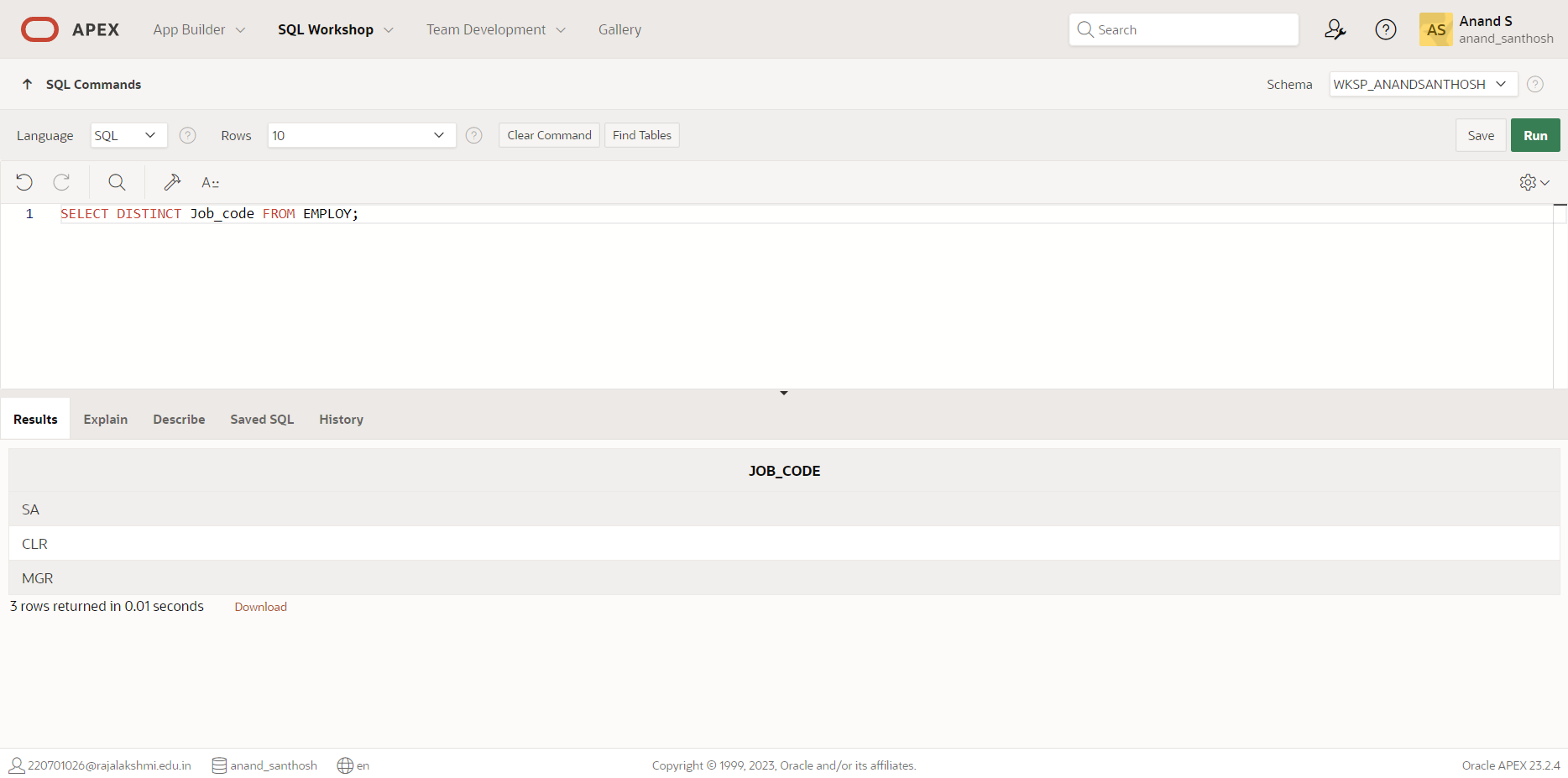

1. Display the last name concatenated with the job ID , separated by a comma and space, and name the column EMPLOYEE and TITLE.

**QUERY:**

SELECT Last_name||','||Job_code AS EMPLOYEE_and_TITLE FROM EMPLOY;

**OUTPUT:**

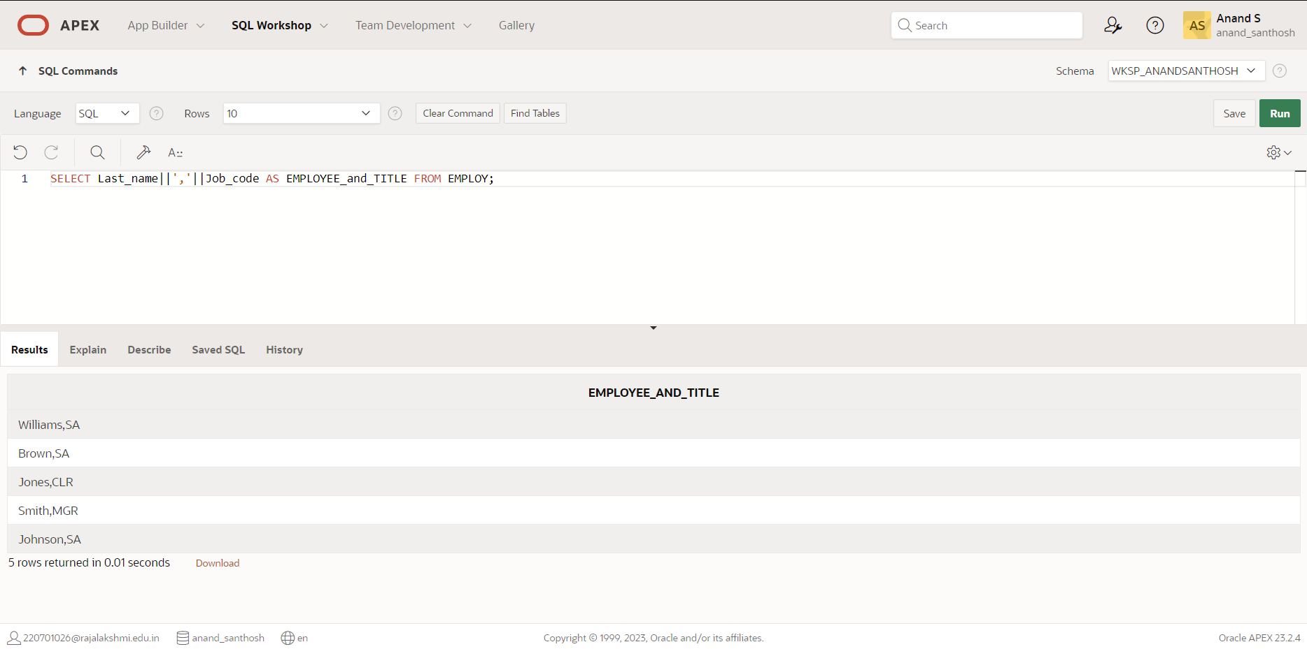

1. Create a query to display all the data from the employees table. Separate each column by a comma. Name the column THE_OUTPUT.

**QUERY:**

SELECT Last_name||','||Job_code||','||Employee_number||','||Hire_date AS THE_OUTPUT FROM EMPLOY;

**OUTPUT:**

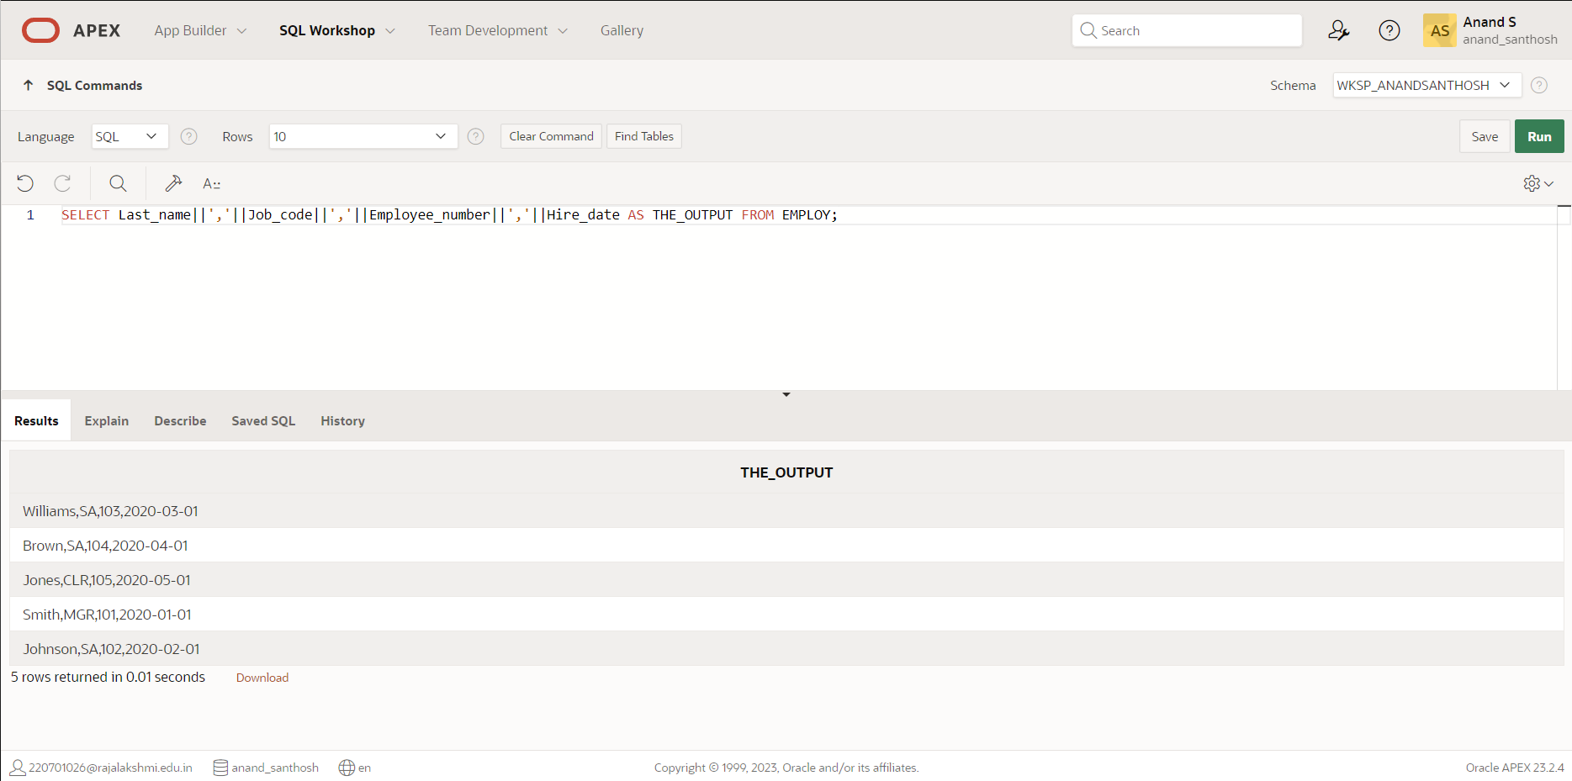

|  |  |
| --- | --- |
| Evaluation Procedure | Marks awarded |
| Query(5) |  |
| Execution (5) |  |
| Viva(5) |  |
| Total (15) |  |
| Faculty Signature |  |

**RESTRICTING AND STORING DATA**

**EX.NO:5 DATE: 08 – 3 - 24**

**REG.NO: 220701306**

* + - 1. Create a query to display the last name and salary of employees earning more than 12000.

**QUERY:**

SELECT Last_name, Salary FROM EMPLOY2 WHERE Salary > 12000;

**OUTPUT:**

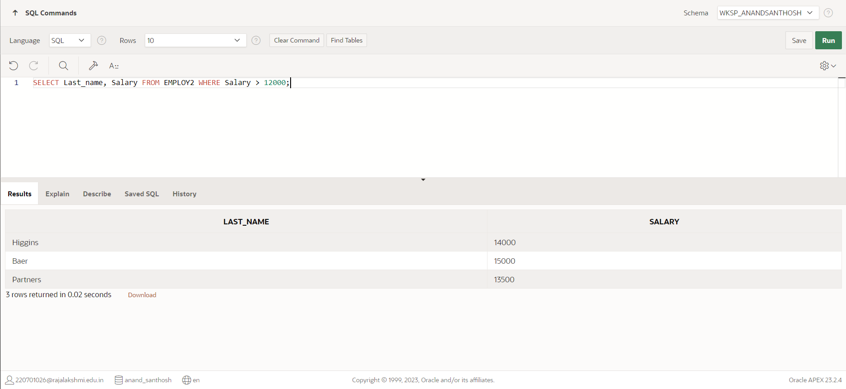

* + - 1. Create a query to display the employee last name and department number for employee number 176.

**QUERY:**

SELECT Last_name, Department_id FROM EMPLOY2 WHERE Employee_id = 176;

**OUTPUT:**

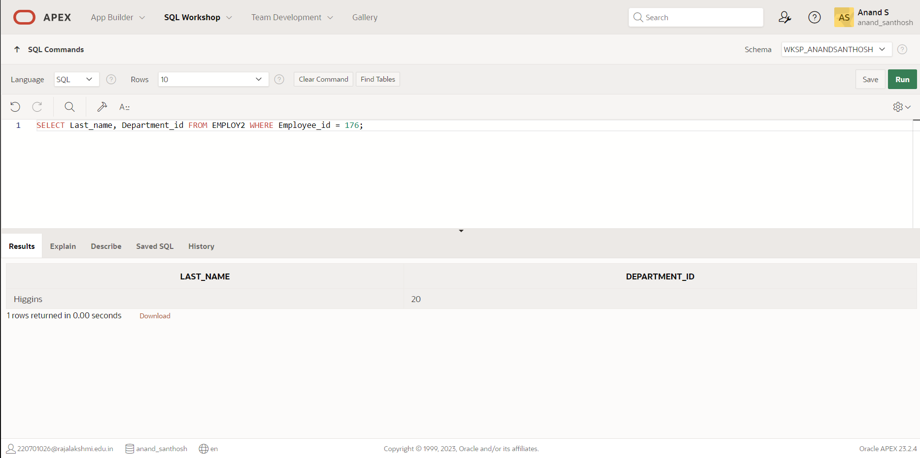

* + - 1. Create a query to display the last name and salary of employees whose salary is not in the range of 5000 and 12000. (hints: not between )

**QUERY:**

SELECT Last_name, Salary FROM EMPLOY2 WHERE Salary NOT BETWEEN 5000 AND 12000;

**OUTPUT:**

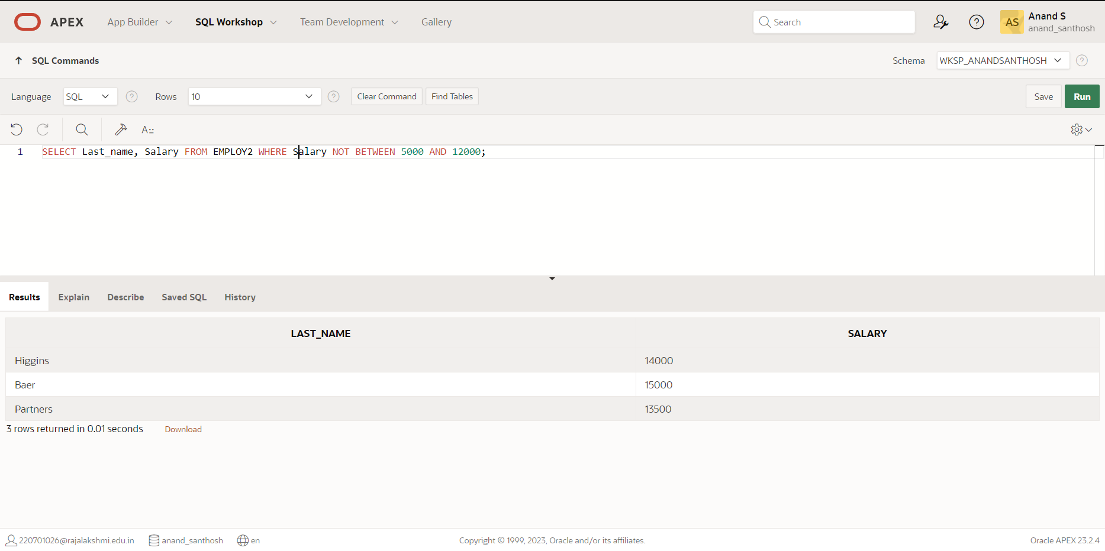

* + - 1. Display the employee last name, job ID, and start date of employees hired between February 20,1998 and May 1,1998.order the query in ascending order by start date.(hints: between)

**QUERY:**

**OUTPUT:**

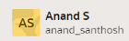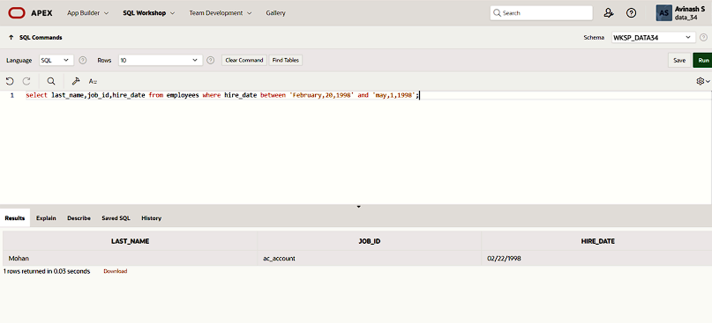

* + - 1. Display the last name and department number of all employees in departments 20 and 50 in alphabetical order by name.(hints: in, orderby)

**QUERY:**

SELECT Last_name, Department_id FROM EMPLOY2 WHERE Department_id IN (20, 50) ORDER BY Last_name;

**OUTPUT:**

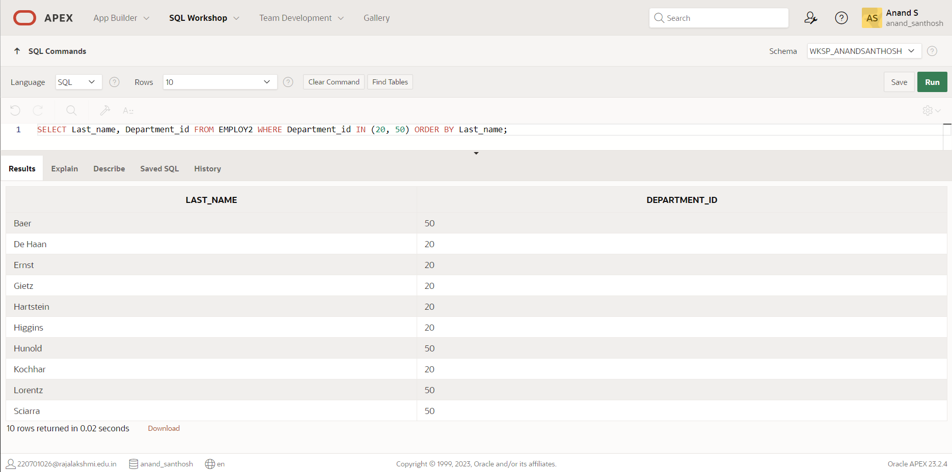

* + - 1. Display the last name and salary of all employees who earn between 5000 and 12000 and are in departments 20 and 50 in alphabetical order by name. Label the columns EMPLOYEE, MONTHLY SALARY respectively.(hints: between, in)

**QUERY:**

SELECT Last_name, Job_id, Hire_date FROM EMPLOY2 WHERE Salary BETWEEN 5000 AND 12000 AND Department_id IN (20, 50) ORDER BY Last_name;

**OUTPUT:**

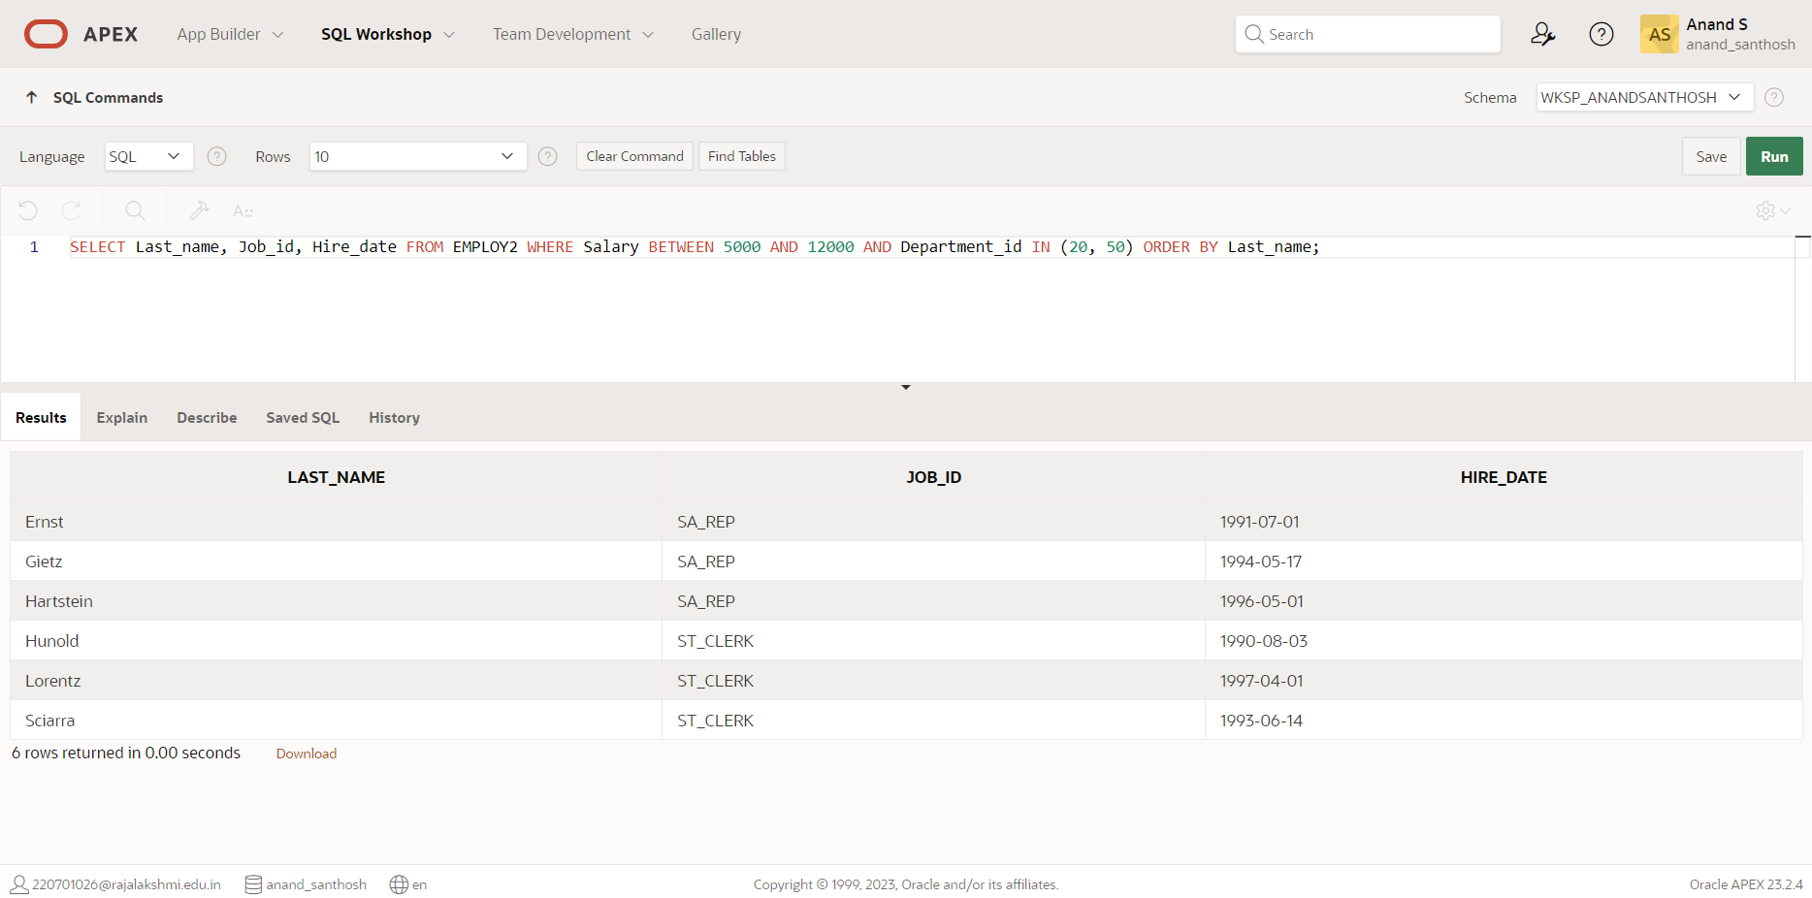

* + - 1. Display the last name and hire date of every employee who was hired in 1994.(hints: like)

**QUERY:**

SELECT Last_name, Hire_date FROM EMPLOY2 WHERE Hire_date LIKE '1994-%-%';

**OUTPUT:**

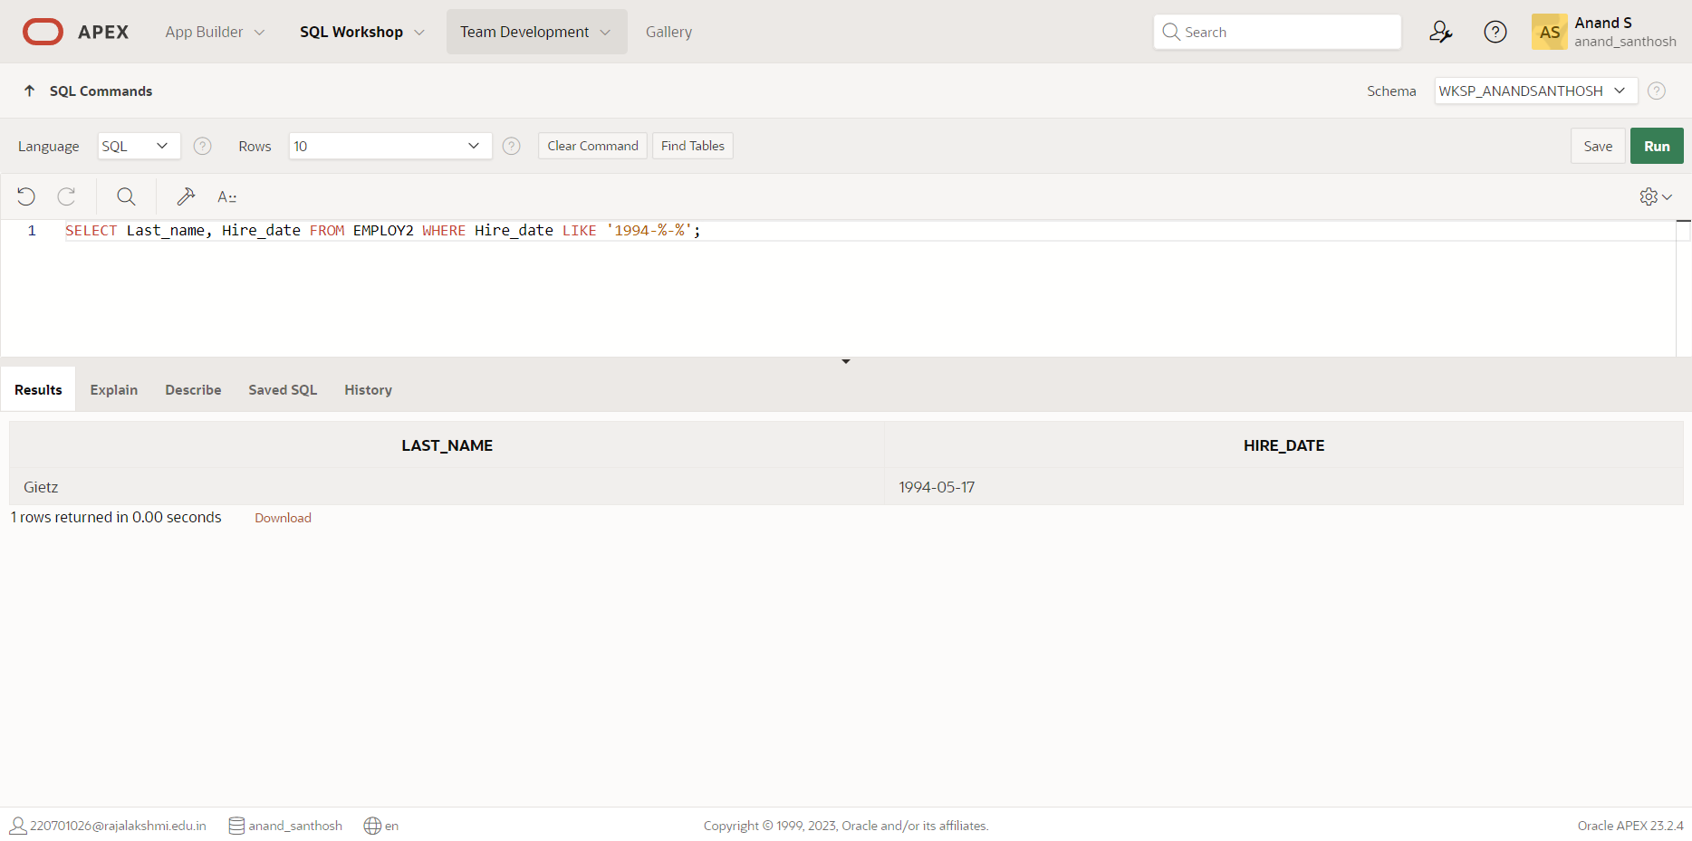

1. Display the last name and job title of all employees who do not have a manager.(hints: is null)

**QUERY:**  
SELECT Last_name, Job_id FROM EMPLOY2 WHERE Manager_id IS NULL;  
  
  
  
  
**OUTPUT:**

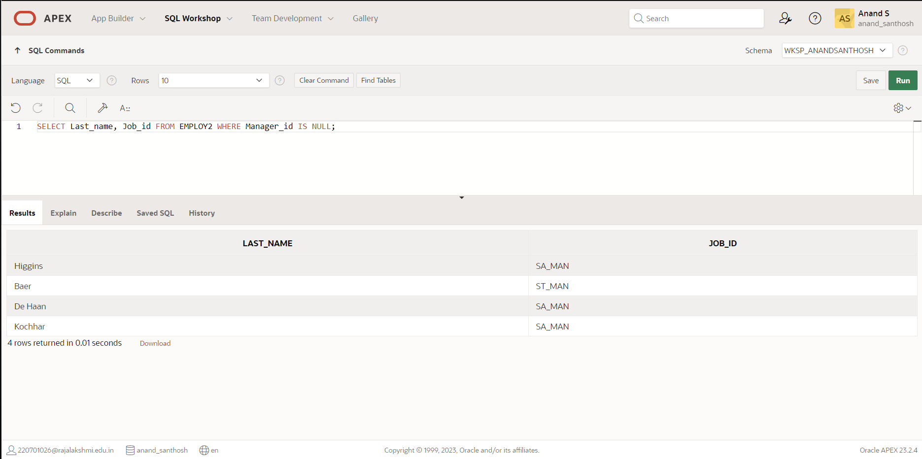

1. Display the last name, salary, and commission for all employees who earn commissions. Sort data in descending order of salary and commissions.(hints: is not nul,orderby)

**QUERY:**

SELECT Last_name, Salary, Commission_pct FROM EMPLOY2 WHERE Commission_pct IS NOT NULL ORDER BY Salary DESC, Commission_pct DESC;

**OUTPUT:**

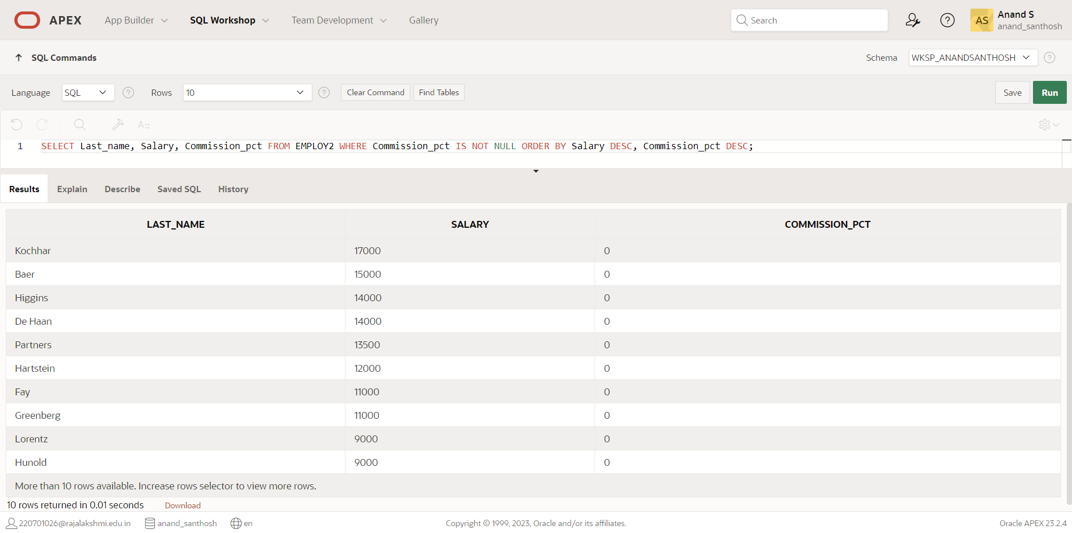

1. Display the last name of all employees where the third letter of the name is ***a***.(hints:like)

**QUERY:**

SELECT Last_name FROM EMPLOY2 WHERE Last_name LIKE '__a%'

**OUTPUT:**

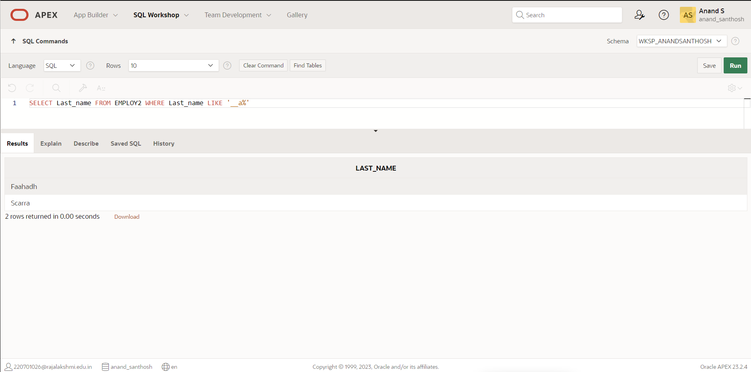

1. Display the last name of all employees who have an a and an ***e*** in their last name.(hints: like)

**QUERY:**

SELECT Last_name FROM EMPLOY2 WHERE Last_name LIKE '%a%' AND Last_name LIKE '%e%';

**OUTPUT:**

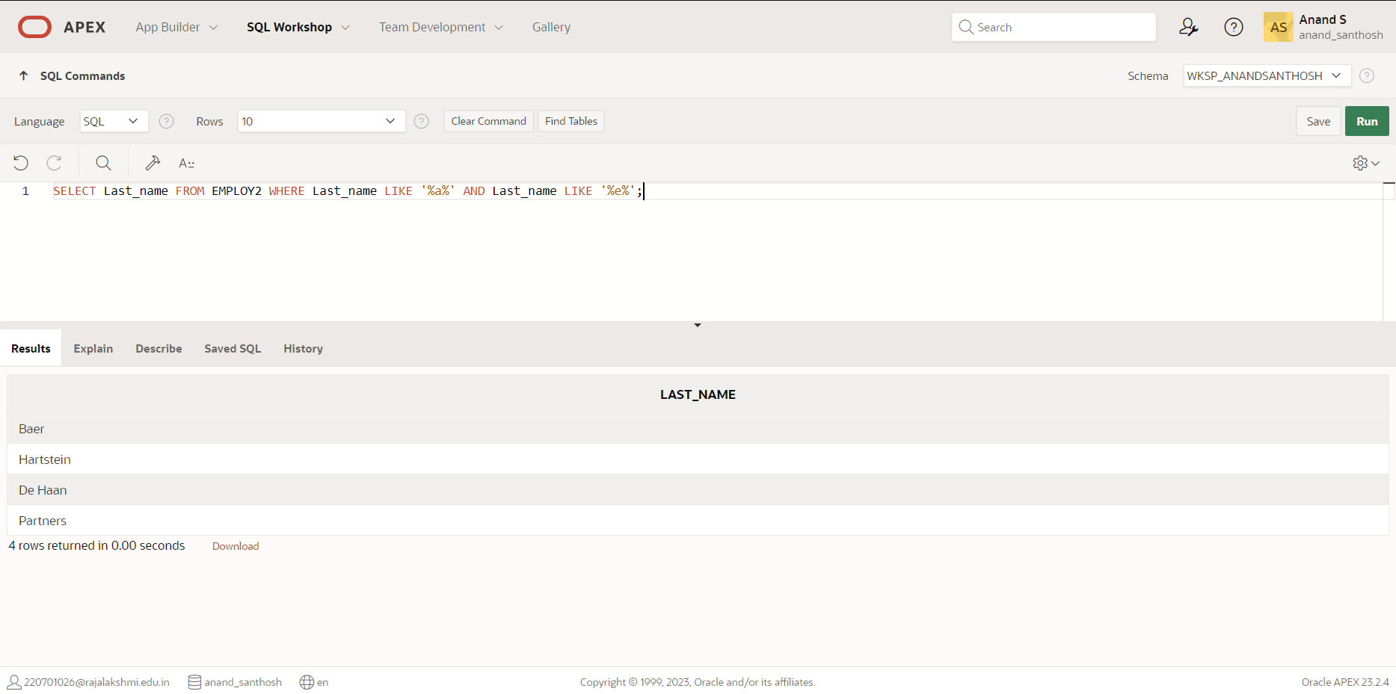

1. Display the last name and job and salary for all employees whose job is sales representative or stock clerk and whose salary is not equal to 2500 ,3500 or 7000.(hints:in,not in)

**QUERY:**

SELECT Last_name, Job_ID, Salary FROM EMPLOY2 WHERE (Job_ID = 'SA_REP' OR Job_ID = 'ST_CLERK') AND Salary NOT IN (2500, 3500, 7000);

**OUTPUT:**

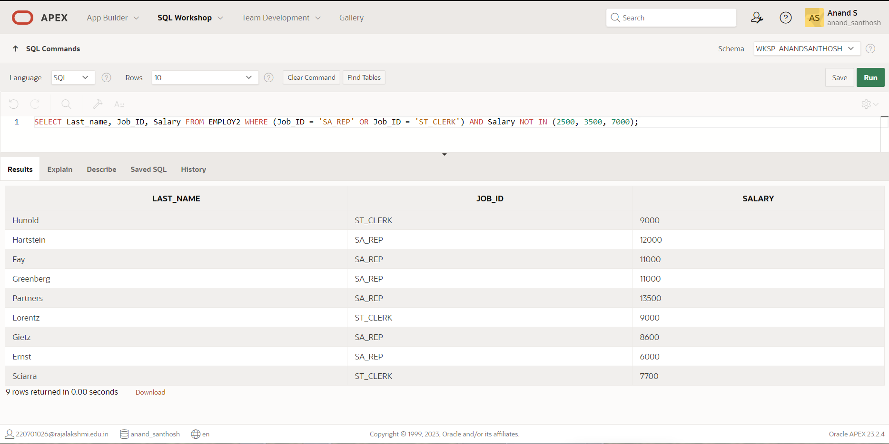

1. Display the last name, salary, and commission for all employees whose commission amount is 20%.(hints:use predicate logic)

**QUERY:**

SELECT Last_name, Salary, Commission_pct FROM EMPLOY2 WHERE Commission_pct = 0.2;

**OUTPUT:**

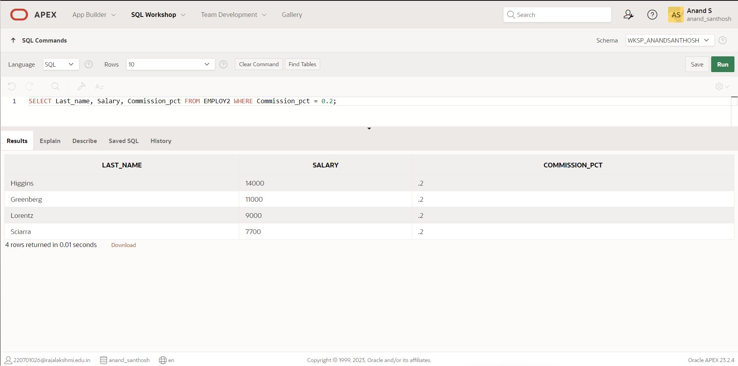

|  |  |
| --- | --- |
|  | Marks awarded |
| Query(5) |  |
| Execution (5) |  |
| Viva(5) |  |
| Total (15) |  |
| Faculty Signature |  |

**SINGLE ROW FUNCTIONS**

**EX.NO:6 DATE: 12 – 3 - 24**

**REG.NO: 220701306**

1. Write a query to display the current date. Label the column Date.

**QUERY:**

SELECT CURRENT_DATE AS "Date" FROM EMP2;

**OUTPUT:**

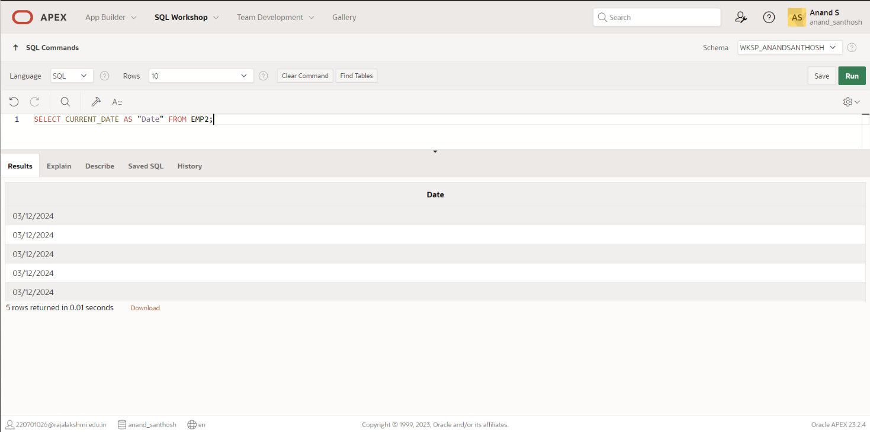

1. The HR department needs a report to display the employee number, last name, salary, and increased by 15.5% (expressed as a whole number) for each employee. Label the column New Salary.

**QUERY:**

SELECT employee_number, last_name, salary, ROUND(salary * 0.155, 0) AS "New Salary" FROM EMP2;

**OUTPUT:**

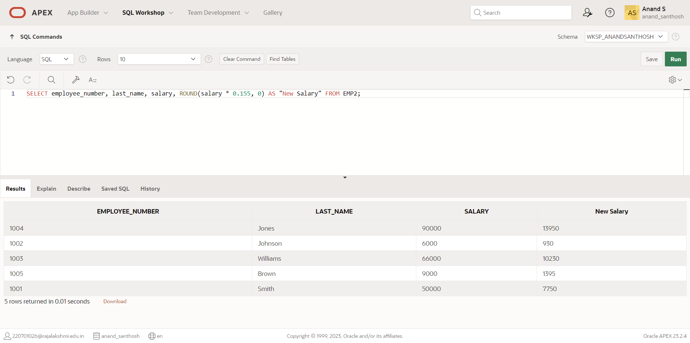

1. Modify your query lab_03_02.sql to add a column that subtracts the old salary from the new salary. Label the column Increase.

**QUERY:**

SELECT employee_number, last_name, salary, ROUND(salary * 0.155, 0) AS "New Salary", salary - ROUND(salary * 0.155, 0) AS "Increase" FROM EMP2;

**OUTPUT:**

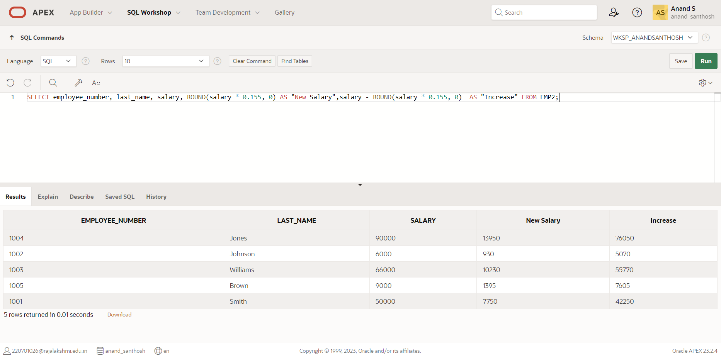

1. Write a query that displays the last name (with the first letter uppercase and all other letters lowercase) and the length of the last name for all employees whose name starts with the letters J, A, or M. Give each column an appropriate label. Sort the results by the employees’ last names.

**QUERY:**

SELECT last_name, LENGTH(last_name) AS "Length" FROM EMP2 WHERE last_name LIKE 'J%' OR last_name LIKE 'A%' OR last_name LIKE 'M%';

**OUTPUT:**

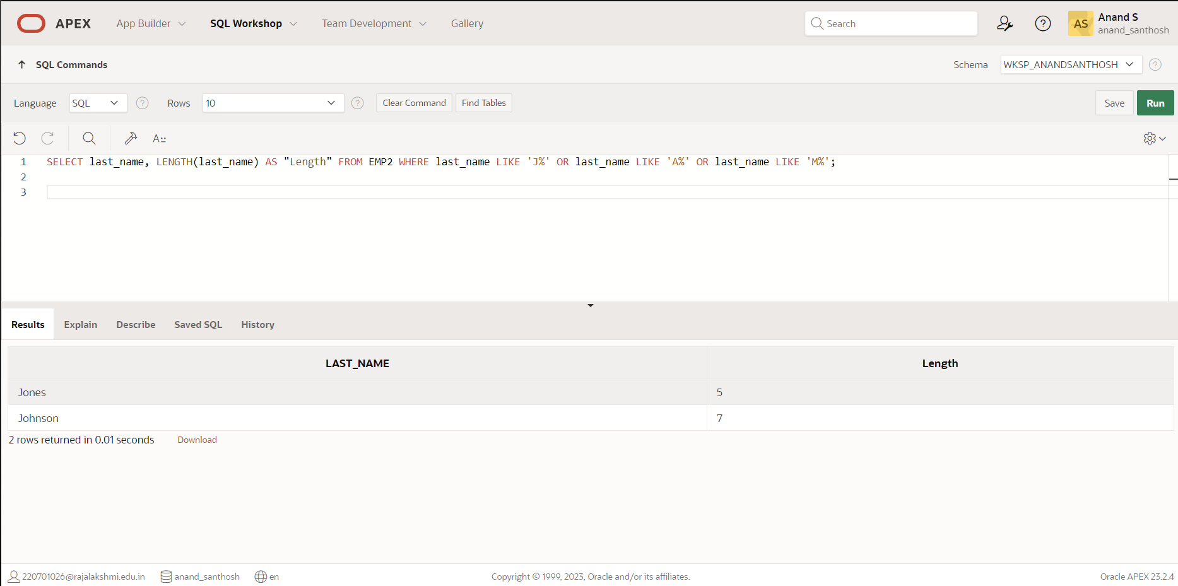

1. Rewrite the query so that the user is prompted to enter a letter that starts the last name. For example, if the user enters H when prompted for a letter, then the output should show all employees whose last name starts with the letter H.

**QUERY:**

SELECT last_name, LENGTH(last_name) AS "Length" FROM EMP2 WHERE last_name LIKE 'H%';

**OUTPUT:**

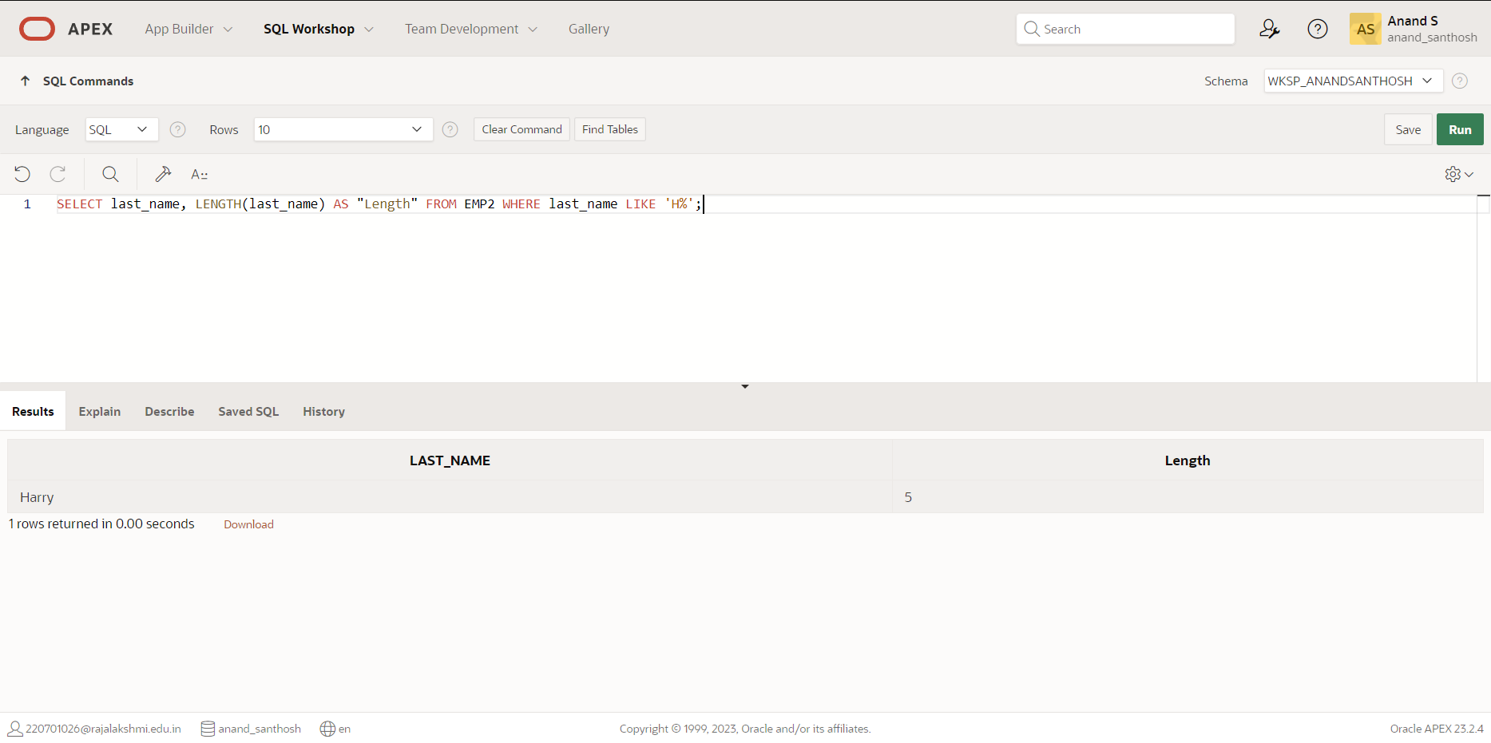

1. The HR department wants to find the length of employment for each employee. For each employee, display the last name and calculate the number of months between today and the date on which the employee was hired. Label the column MONTHS_WORKED. Order your results by the number of months employed. Round the number of months up to the closest whole number.

**Note:** Your results will differ.

**QUERY:**

SELECT last_name, hire_date, ROUND(MONTHS_BETWEEN(CURRENT_DATE, hire_date)) AS "Months Worked" FROM EMP2 ORDER BY "Months Worked";

**OUTPUT:**

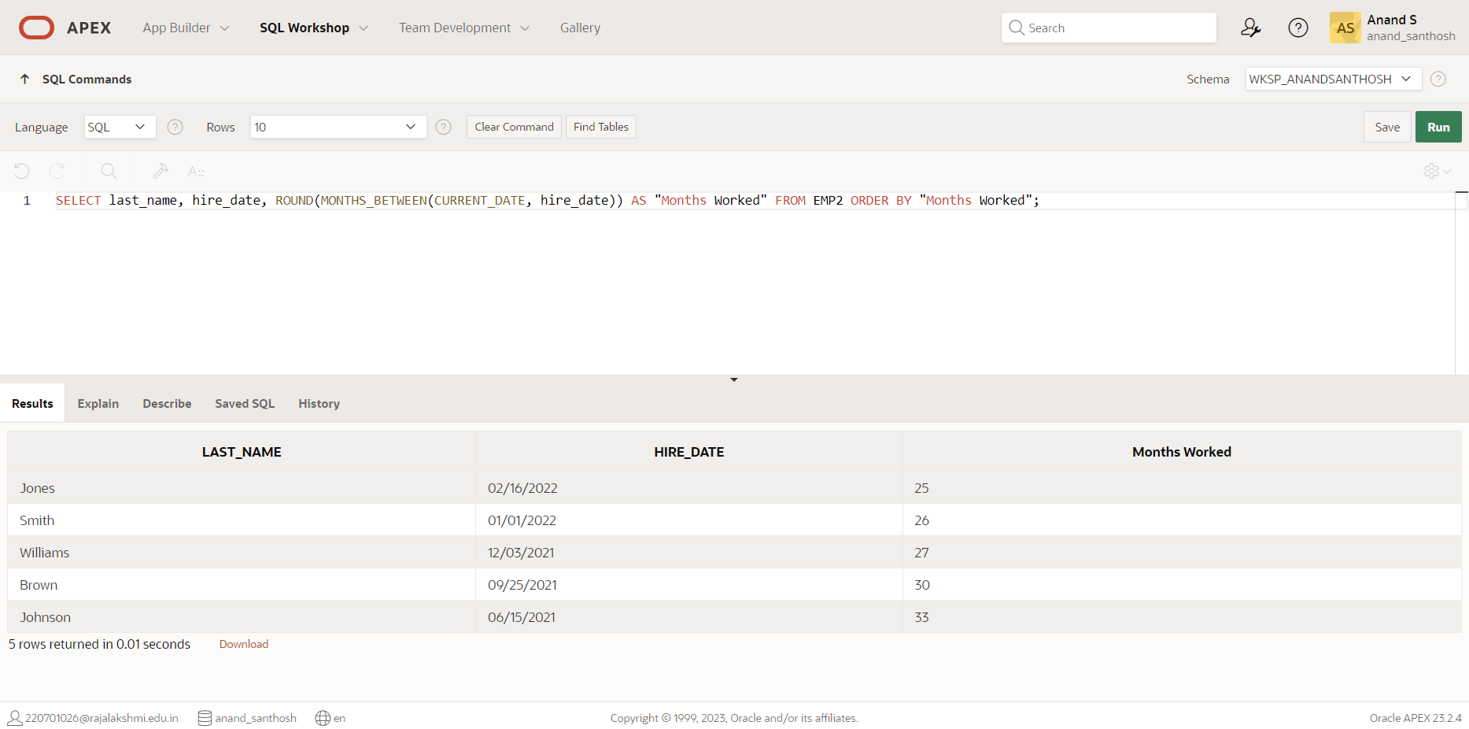

1. Create a report that produces the following for each employee:

<employee last name> earns <salary> monthly but wants <3 times salary>. Label the column Dream Salaries.

**QUERY:**

SELECT last_name, salary, ROUND(salary * 3, 0) AS "Dream Salaries" FROM EMP2;

**OUTPUT:**

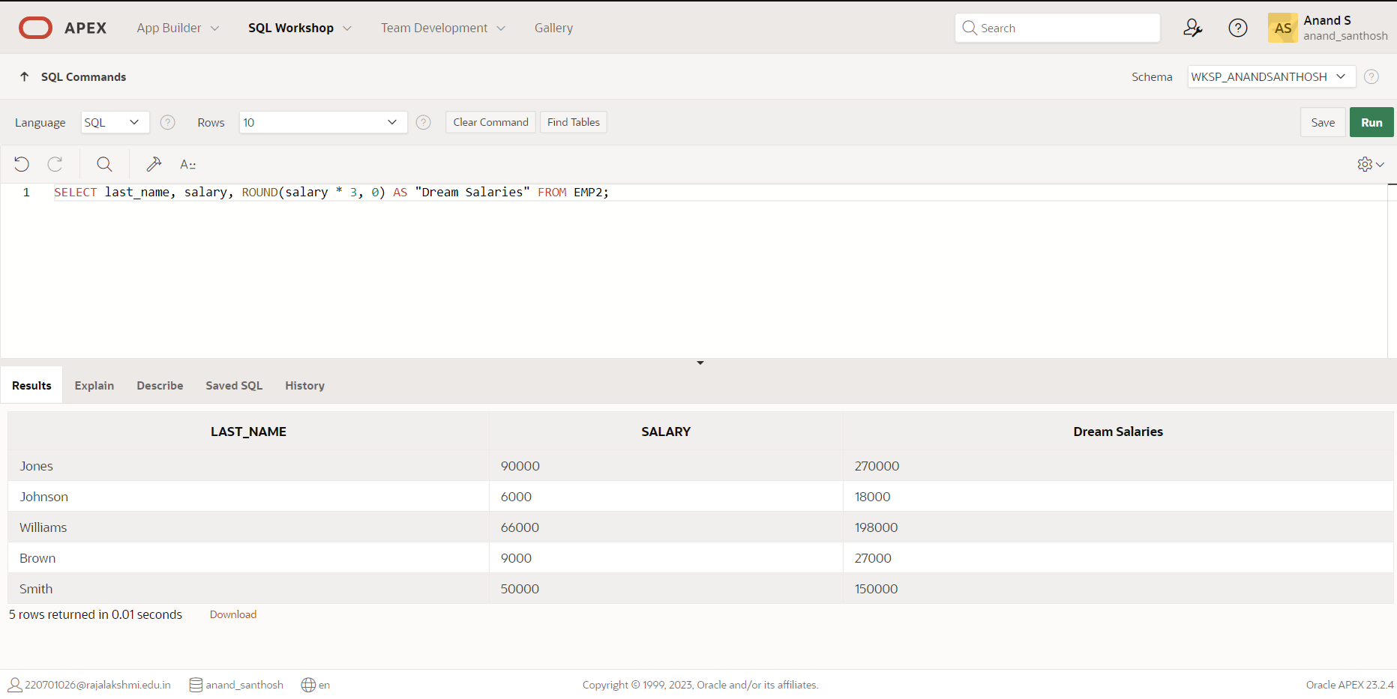

1. Create a query to display the last name and salary for all employees. Format the salary to be 15 characters long, left-padded with the $ symbol. Label the column SALARY.

**QUERY:**

SELECT last_name, LPAD(salary, 15, '$') AS "Salary" FROM EMP2;

**OUTPUT:**

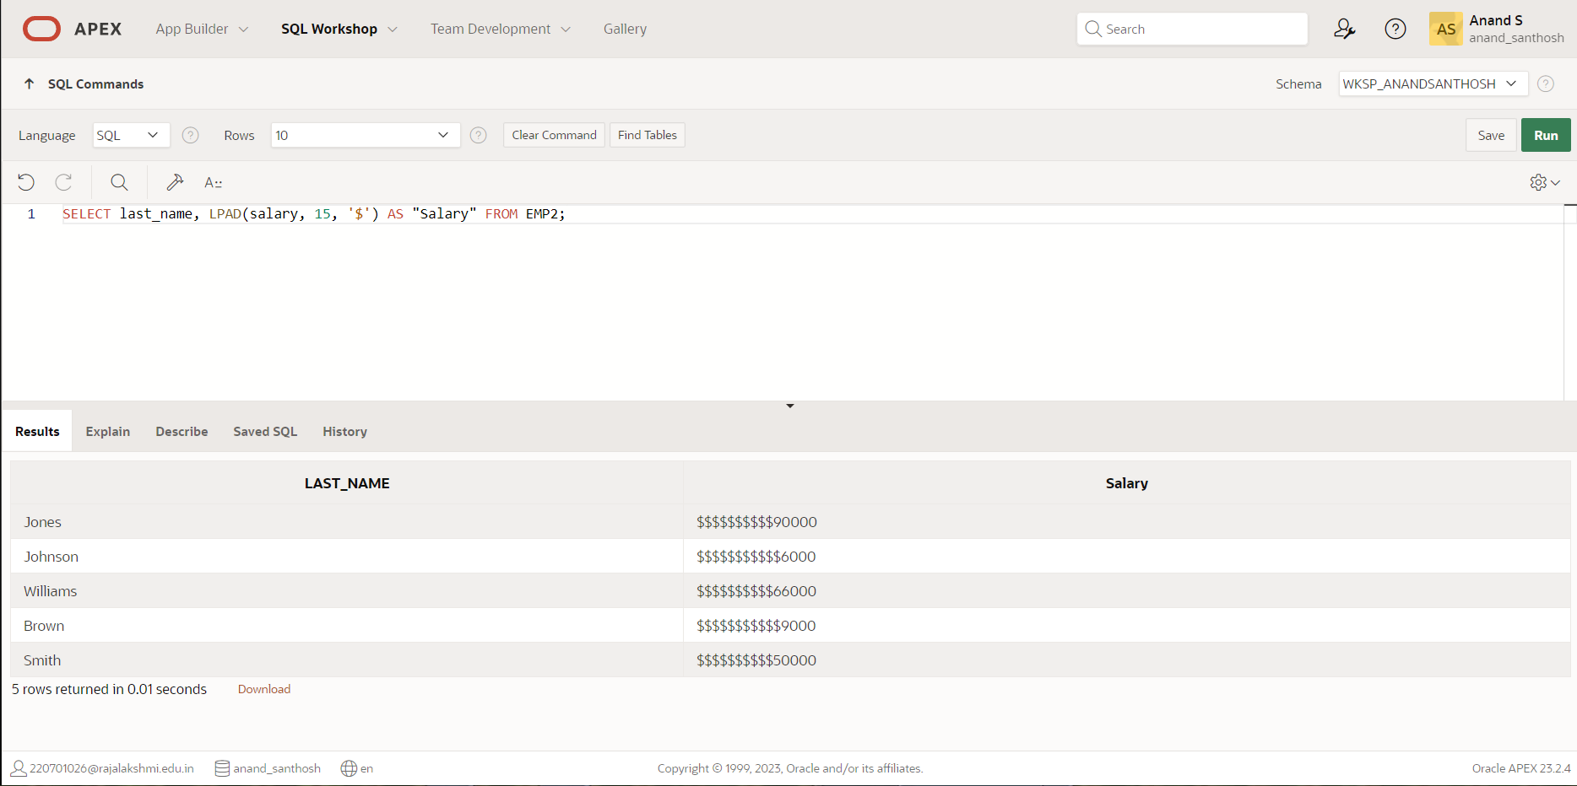

1. Display each employee’s last name, hire date, and salary review date, which is the first Monday after six months of service. Label the column REVIEW. Format the dates to appear in the format similar to “Monday, the Thirty-First of July, 2000.”

**QUERY:**

SELECT last_name,hire_date,TO_CHAR(NEXT_DAY(ADD_MONTHS(hire_date, 6), 'MONDAY'),'FMDay, "the "FMDD "of "FMMonth, YYYY') AS REVIEW FROM employees;

**OUTPUT:**

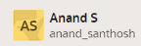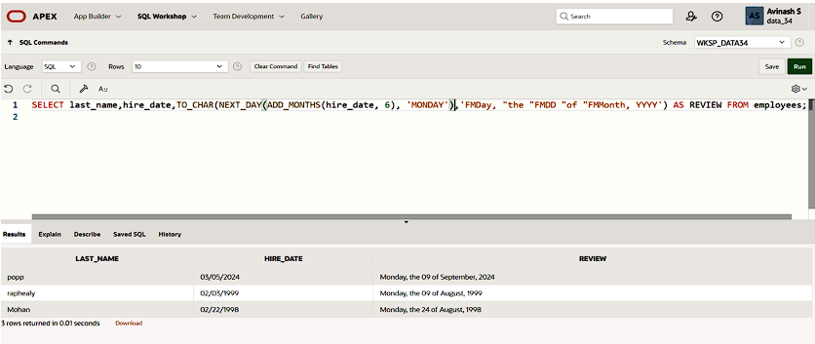

1. Display the last name, hire date, and day of the week on which the employee started. Label the column DAY. Order the results by the day of the week, starting with Monday.

**QUERY:**

SELECT last_name, TO_CHAR(hire_date, 'Day') AS "Day" FROM EMP2 ORDER BY "Day";

**OUTPUT:**

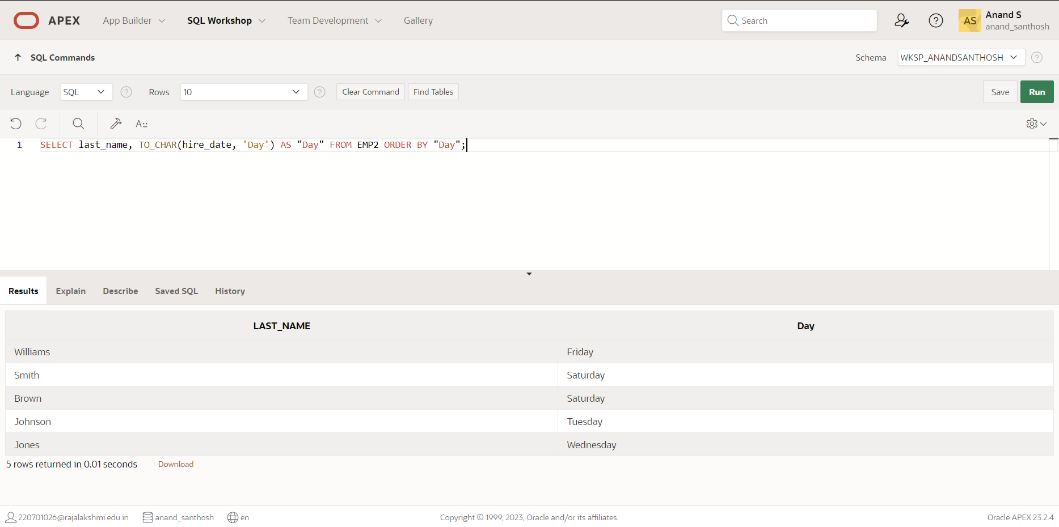

|  |  |
| --- | --- |
| Evaluation Procedure | Marks awarded |
| Query(5) |  |
| Execution (5) |  |
| Viva(5) |  |
| Total (15) |  |
| Faculty Signature |  |

**DISPLAYING DATA FROM MULTIPLE TABLES**

**EX.NO:7 DATE: 15 – 3 - 24**

**REG.NO: 220701306**

* + - 1. Write a query to display the last name, department number, and department name for all employees .

**QUERY:**

SELECT e.last_name, e.department_id, d.department_name FROM employees e JOIN departments d ON e.department_id = d.department_id ORDER BY e.last_name;

**OUTPUT:**

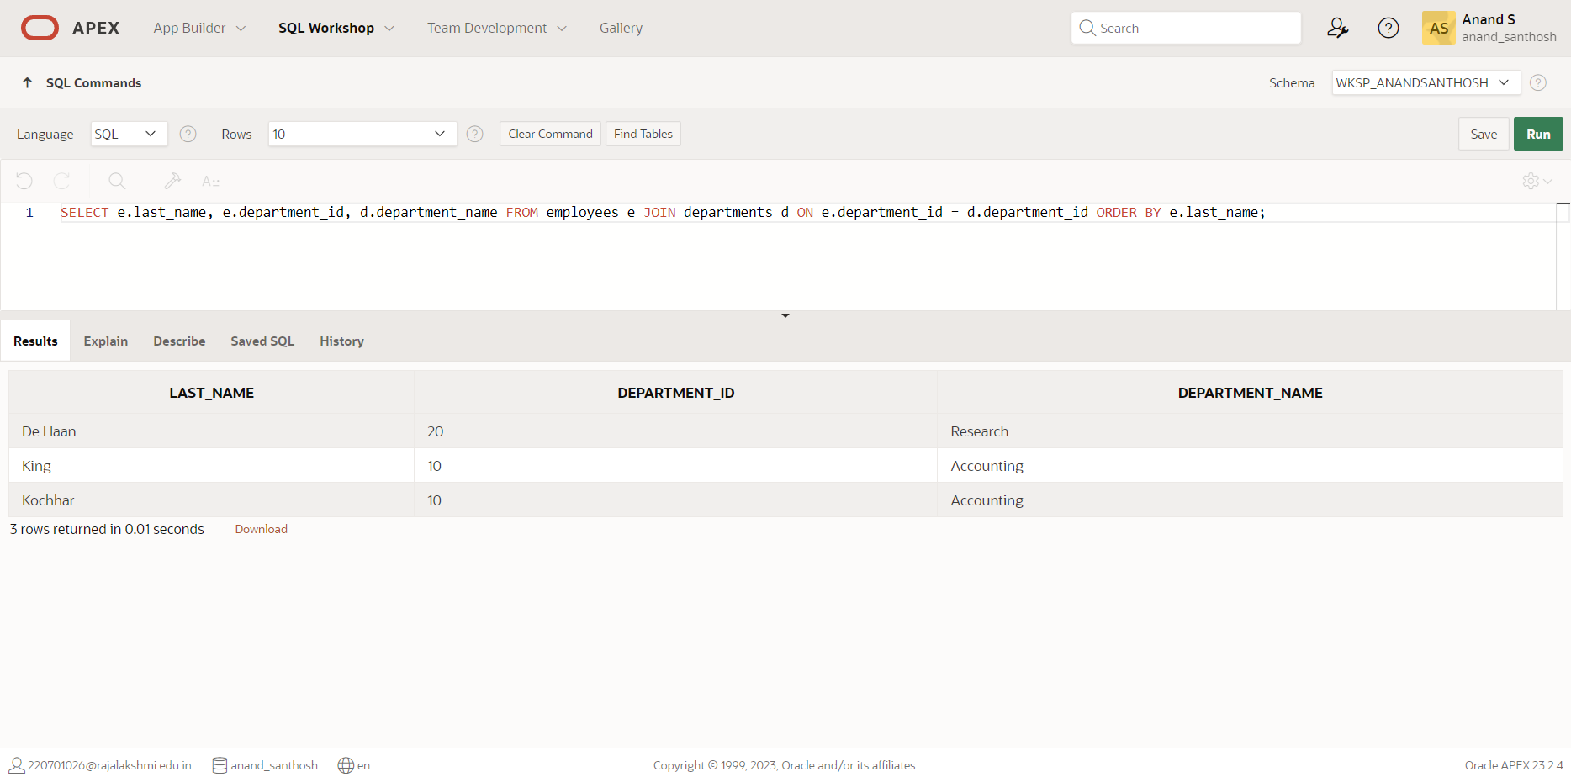

2. Create a unique listing of all jobs that are in department 80. Include the location of the department in the output.

**QUERY:**

SELECT DISTINCT j.job_title, l.city FROM jobs j JOIN departments d ON j.min_salary <= d.department_budget AND j.max_salary >= d.department_budget JOIN locations l ON d.location_id = l.location_id WHERE d.department_id = 80;

**OUTPUT:**

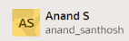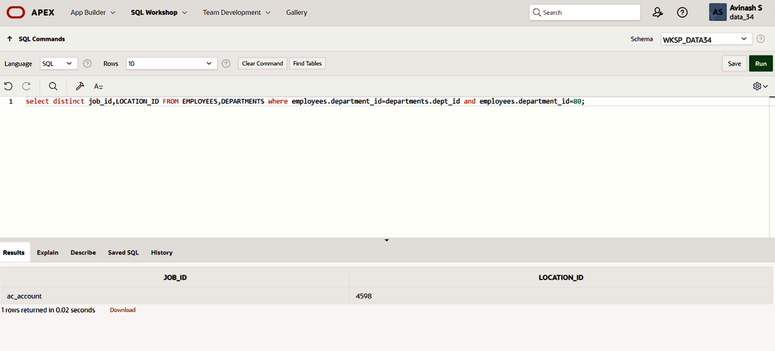

3. Write a query to display the employee last name, department name, location ID, and city of all employees who earn a commission

**QUERY:**

SELECT e.last_name, d.department_name, l.location_id, l.city FROM employees e JOIN departments d ON e.department_id = d.department_id JOIN locations l ON d.location_id = l.location_id WHERE e.commission_pct IS NOT NULL;

**OUTPUT**

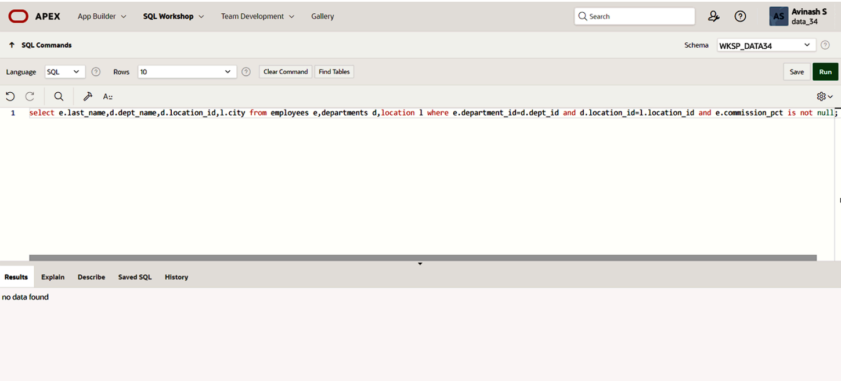

4. Display the employee last name and department name for all employees who have an a(lowercase) in their last names. P

**QUERY:**

SELECT e.last_name, d.department_name FROM employees e JOIN departments d ON e.department_id = d.department_id WHERE e.last_name LIKE '%a%';

**OUTPUT:**

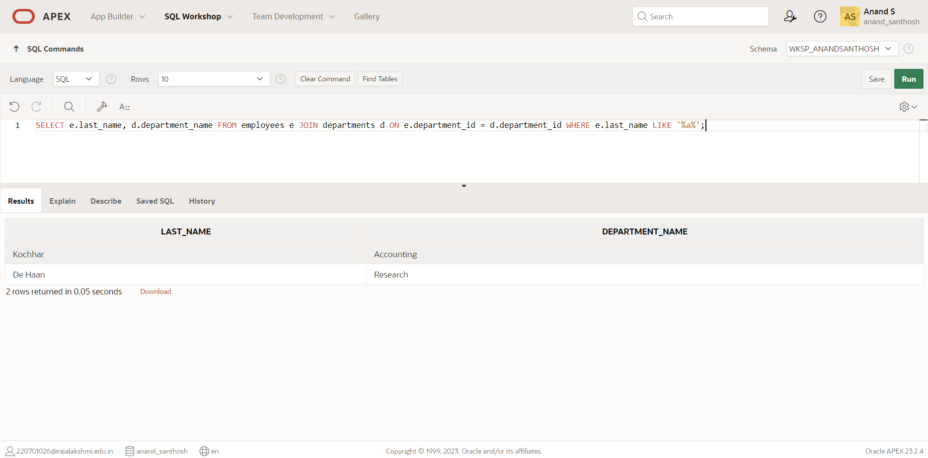

5. Write a query to display the last name, job, department number, and department name for all employees who work in Toronto.

**QUERY:**

SELECT e.last_name, j.job_title, e.department_id, d.department_name FROM employees e JOIN departments d ON e.department_id = d.department_id JOIN jobs j ON e.job_id = j.job_id JOIN locations l ON d.location_id = l.location_id WHERE l.city = 'Toronto';

**OUTPUT:**

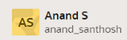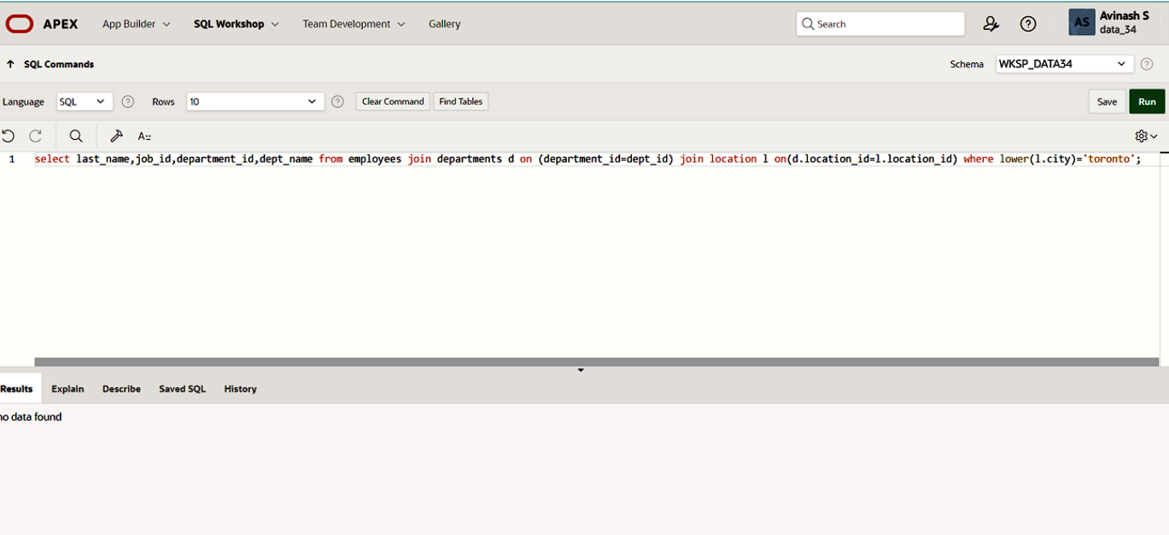

6. Display the employee last name and employee number along with their manager’s last name and manager number. Label the columns Employee, Emp#, Manager, and Mgr#, Respectively

**QUERY:**

SELECT e.last_name AS Employee, e.employee_id AS Emp#, m.last_name AS Manager, m.employee_id AS Mgr# FROM employees e JOIN employees m ON e.manager_id = m.employee_id ORDER BY e.employee_id;

**OUTPUT:**

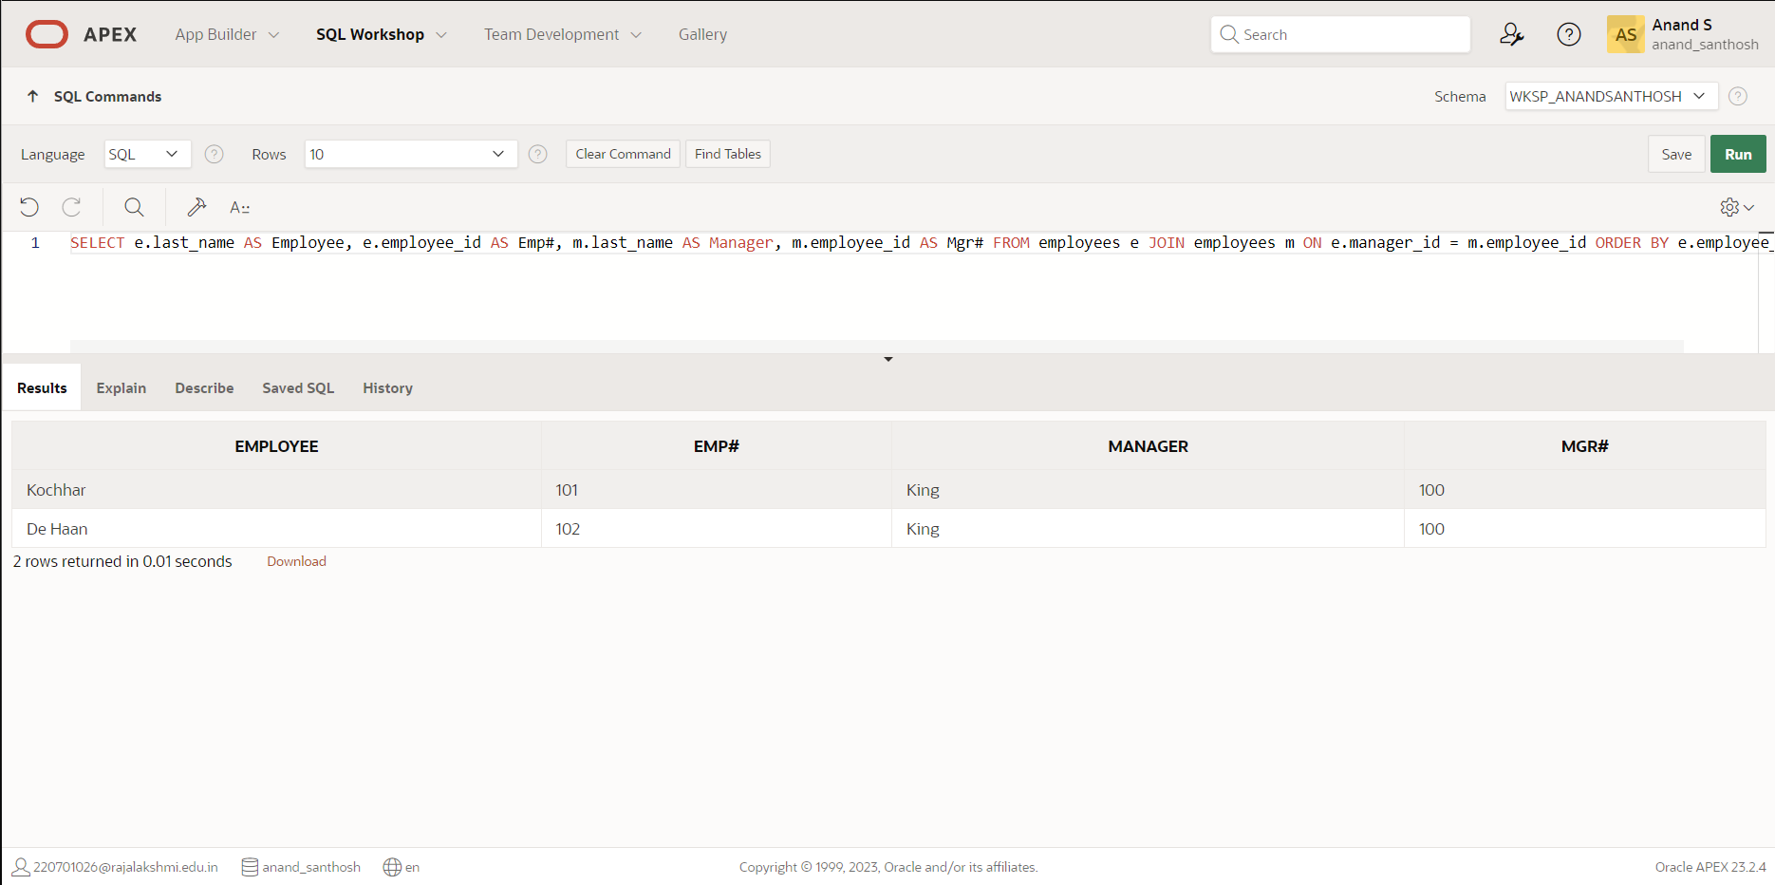

7. Modify lab4_6.sql to display all employees including King, who has no manager. Order the results by the employee number.

**QUERY:**

SELECT e.last_name AS Employee, e.employee_id AS Emp#, m.last_name AS Manager, m.employee_id AS Mgr# FROM employees e LEFT JOIN employees m ON e.manager_id = m.employee_id ORDER BY e.employee_id;

**OUTPUT:**

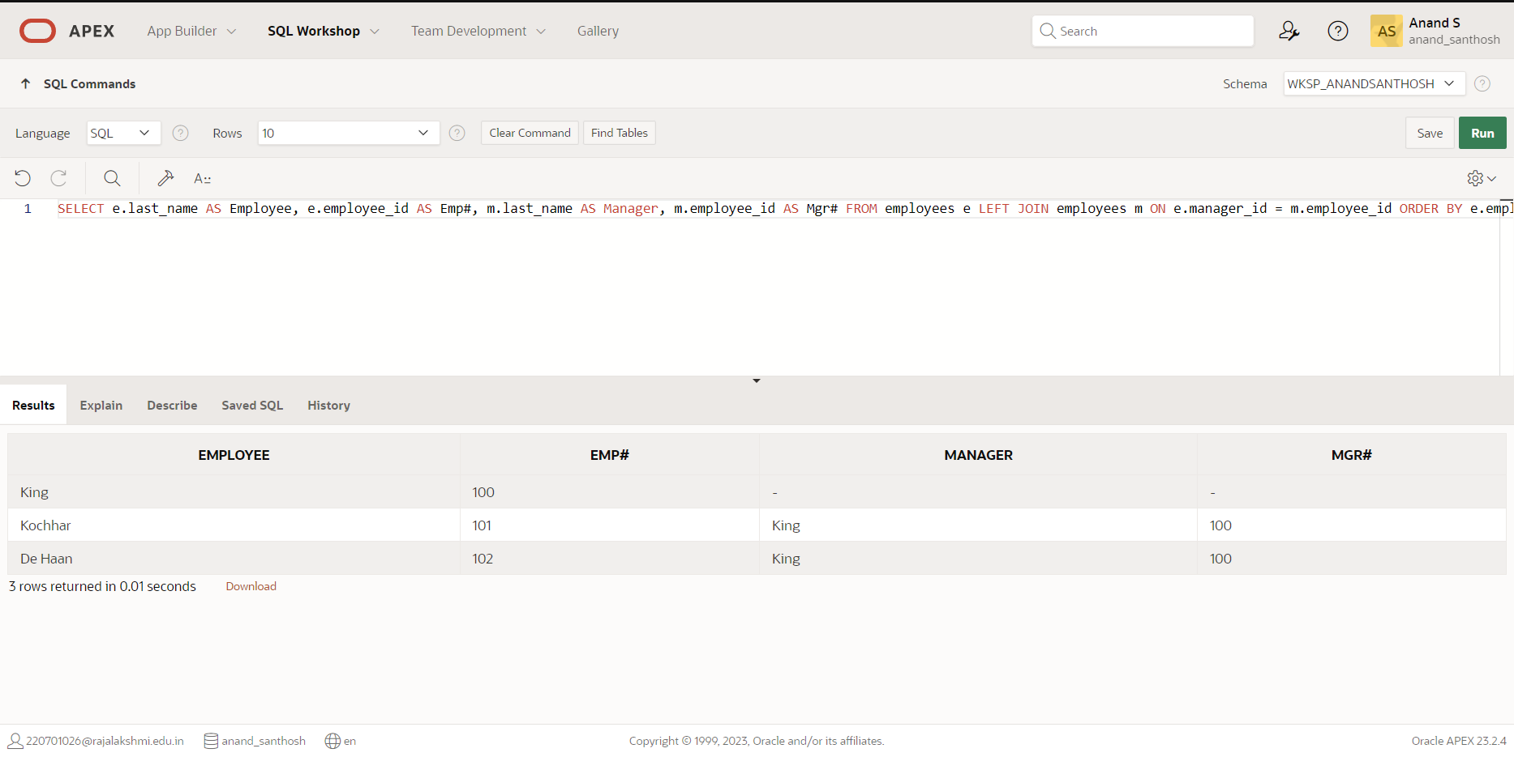

8. Create a query that displays employee last names, department numbers, and all the employees who work in the same department as a given employee. Give each column an appropriate label

**QUERY:**

SELECT e.last_name AS Employee, e.department_id AS Dept_No, d.department_name AS Dept_Name, ed.employee_id, ed.last_name FROM employees e JOIN departments d ON e.department_id = d.department_id LEFT JOIN employees ed ON e.department_id = ed.department_id ORDER BY e.last_name;

**OUTPUT:**

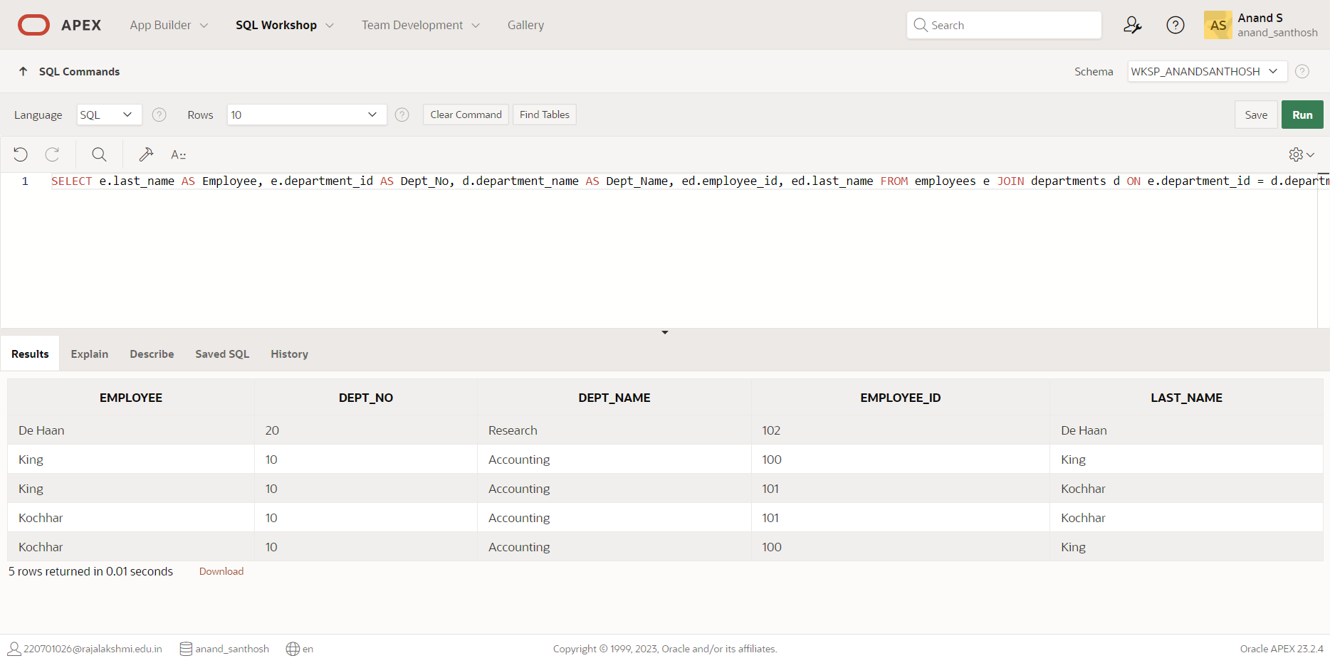

9. Show the structure of the JOB_GRADES table. Create a query that displays the name, job,

department name, salary, and grade for all employees

**QUERY:**

DESCRIBE job_grades;

SELECT e.first_name || ' ' || e.last_name AS Name, j.job_title, d.department_name, e.salary, jg.grade_level FROM employees e JOIN jobs j ON e.job_id = j.job_id JOIN departments d ON e.department_id = d.department_id JOIN job_grades jg ON e.salary BETWEEN jg.lowest_sal AND jg.highest_sal;

**OUTPUT:**

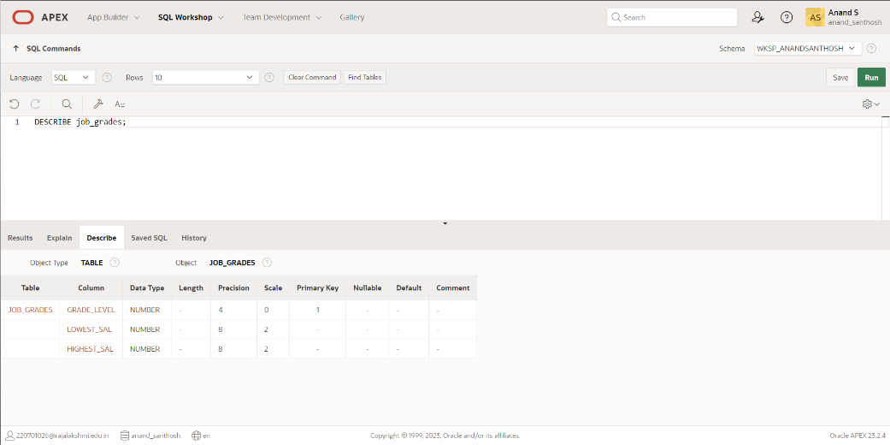

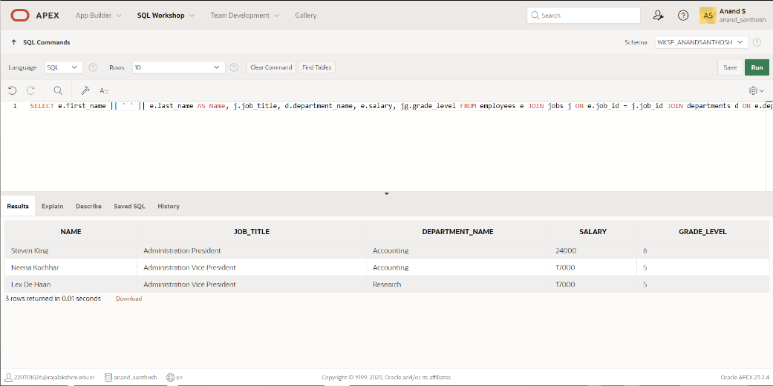

10. Create a query to display the name and hire date of any employee hired after employee Davies.

**QUERY:**

SELECT e.first_name || ' ' || e.last_name AS Employee, e.hire_date FROM employees e WHERE e.hire_date > (SELECT e2.hire_date FROM employees e2 WHERE e2.last_name = 'Davies');

**OUTPUT:**

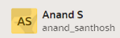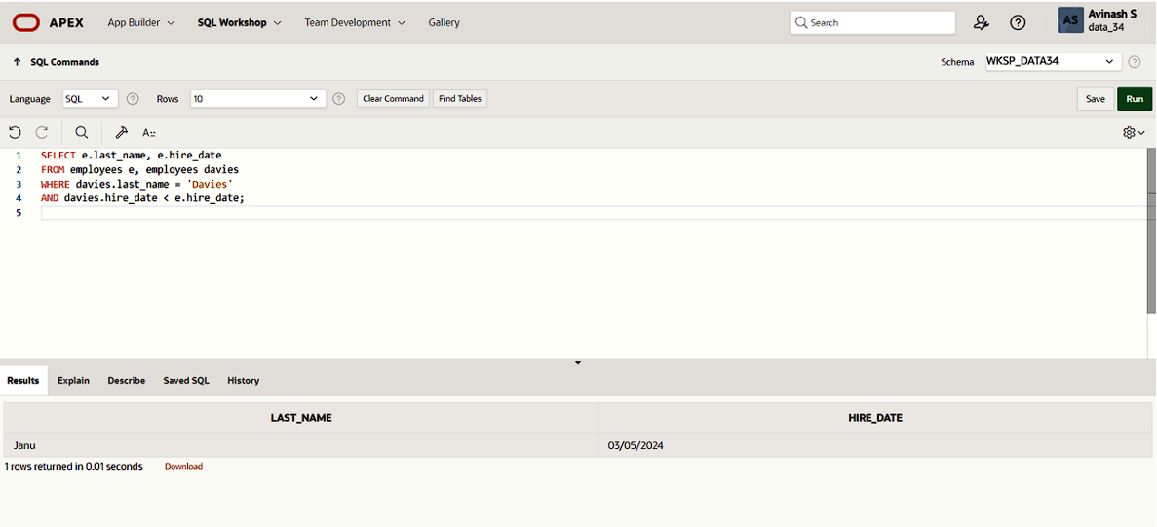

11. Display the names and hire dates for all employees who were hired before their managers,

along with their manager’s names and hire dates. Label the columns Employee, Emp Hired, Manager, and Mgr Hired, respectively.

**QUERY:**

SELECT e.first_name || ' ' || e.last_name AS Employee, e.hire_date AS Emp_Hired, m.first_name || ' ' || m.last_name AS Manager, m.hire_date AS Mgr_Hired FROM employees e JOIN employees m ON e.manager_id = m.employee_id WHERE e.hire_date < m.hire_date ORDER BY e.hire_date;

**OUTPUT:**

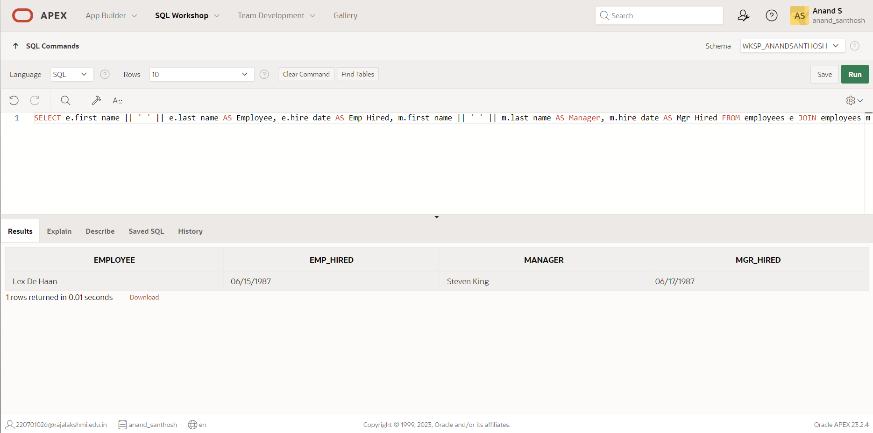

|  |  |
| --- | --- |
| Evaluation Procedure | Marks awarded |
| Query(5) |  |
| Execution (5) |  |
| Viva(5) |  |
| Total (15) |  |
| Faculty Signature |  |

**AGGREGATING DATA USING GROUP FUNCTIONS**

**EX.NO:8 DATE: 19 – 3 - 24**

**REG.NO: 220701306**

Determine the validity of the following three statements. Circle either True or False.

1. Group functions work across many rows to produce one result per group.

True/False

2. Group functions include nulls in calculations.

True/False

3. The WHERE clause restricts rows prior to inclusion in a group calculation.

True/False

**The HR department needs the following reports:**

4. Find the highest, lowest, sum, and average salary of all employees. Label the columns

Maximum, Minimum, Sum, and Average, respectively. Round your results to the nearest

whole number

**QUERY:**

SELECT MAX(salary) AS "Maximum", MIN(salary) AS "Minimum", SUM(salary) AS "Sum", ROUND(AVG(salary)) AS "Average" FROM employees;

**OUTPUT:**

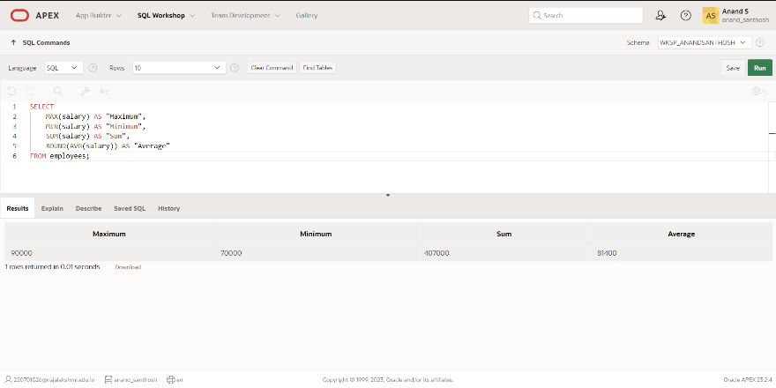

5. Modify the above query to display the minimum, maximum, sum, and

average salary for each job type.

**QUERY:**

SELECT job_title AS "Job Type", MAX(salary) AS "Maximum", MIN(salary) AS "Minimum", SUM(salary) AS "Sum", ROUND(AVG(salary)) AS "Average" FROM employees GROUP BY job_title;

**OUTPUT:**

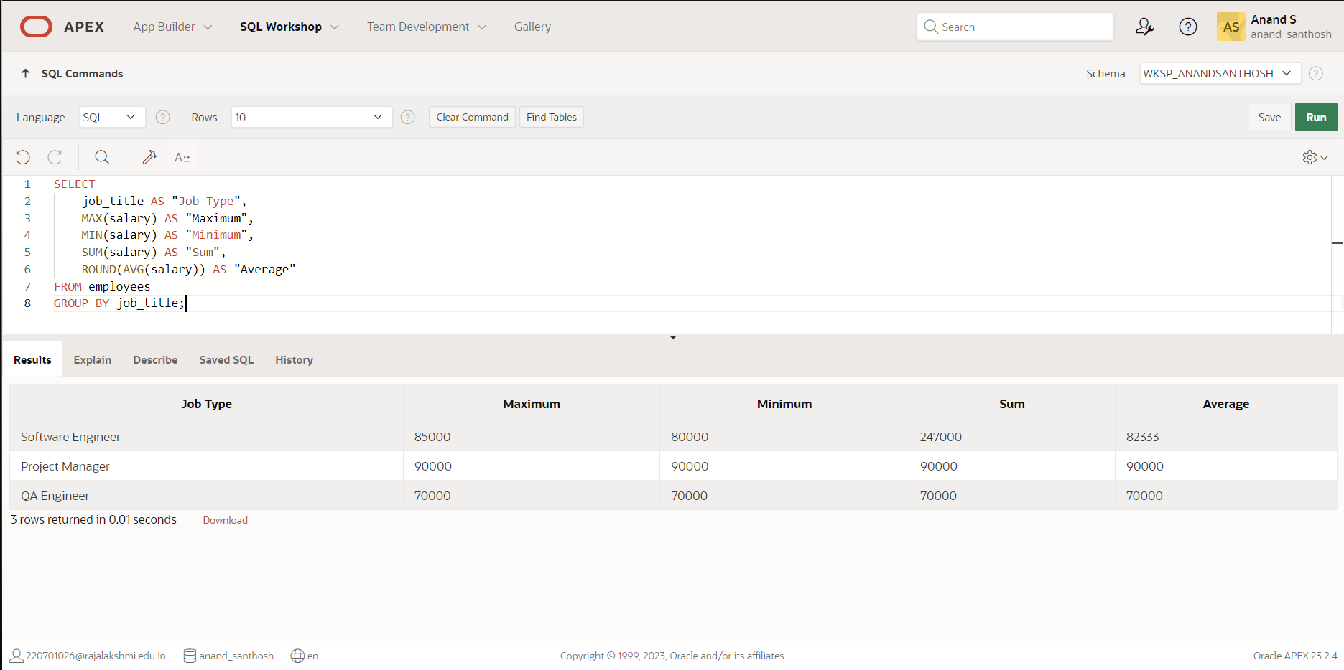

6.Write a query to display the number of people with the same job. Generalize the query so that the user in the HR department is prompted for a job title.

**QUERY:**

SELECT job_title, COUNT(*) AS "Number of Employees" FROM employees WHERE job_title = &job_title;

**OUTPUT:**

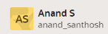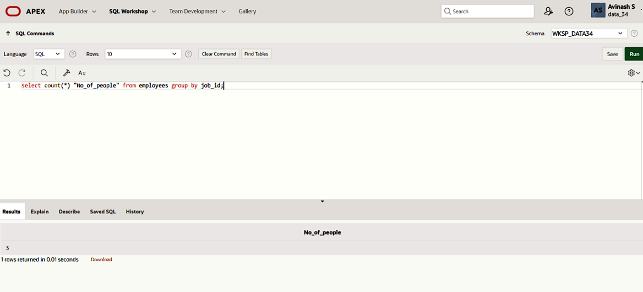

7. Determine the number of managers without listing them. Label the column Number

of Managers. *Hint: Use the MANAGER_ID column to determine the number of*

*managers.*

**QUERY:**

SELECT COUNT(*) AS "Number of Managers" FROM employees WHERE manager_id IS NOT NULL;

**OUTPUT:**

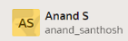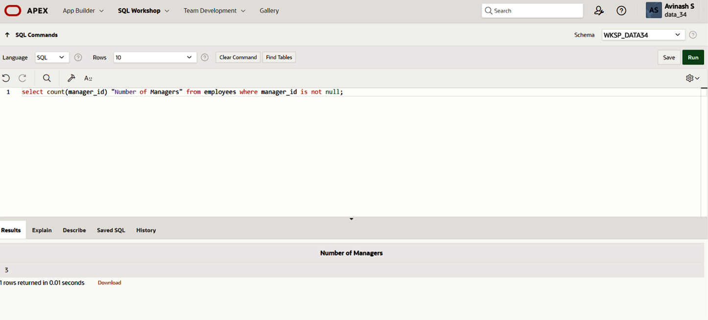

8. Find the difference between the highest and lowest salaries. Label the column

DIFFERENCE.

**QUERY:**

SELECT MAX(salary) - MIN(salary) AS "DIFFERENCE" FROM employees;

**OUTPUT:**

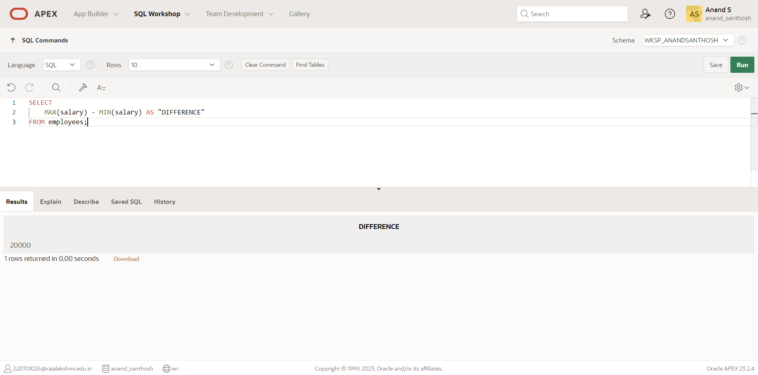

9. Create a report to display the manager number and the salary of the lowest-paid

employee for that manager. Exclude anyone whose manager is not known. Exclude any

groups where the minimum salary is $6,000 or less. Sort the output in descending order

of salary.

**QUERY:**

SELECT manager_id, MIN(salary) AS "Lowest Salary" FROM employees WHERE manager_id IS NOT NULL AND salary > 6000 GROUP BY manager_id ORDER BY MIN(salary) DESC;

**OUTPUT:**

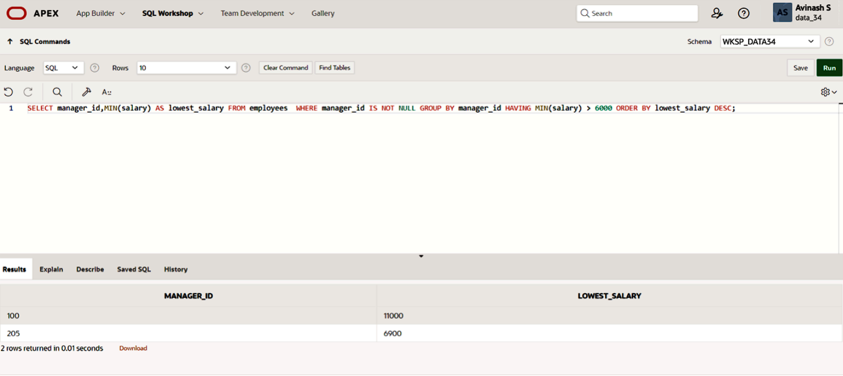

10. Create a query to display the total number of employees and, of that total, the number of

employees hired in 1995, 1996, 1997, and 1998. Create appropriate column headings.

**QUERY:**

SELECT COUNT(*) AS "Total Employees",

SUM(CASE WHEN hire_date LIKE '1995%' THEN 1 ELSE 0 END) AS "Employees in 1995",

SUM(CASE WHEN hire_date LIKE '1996%' THEN 1 ELSE 0 END) AS "Employees in 1996",

SUM(CASE WHEN hire_date LIKE '1997%' THEN 1 ELSE 0 END) AS "Employees in 1997",

SUM(CASE WHEN hire_date LIKE '1998%' THEN 1 ELSE 0 END) AS "Employees in 1998"

FROM employees;

**OUTPUT:**

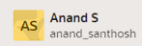

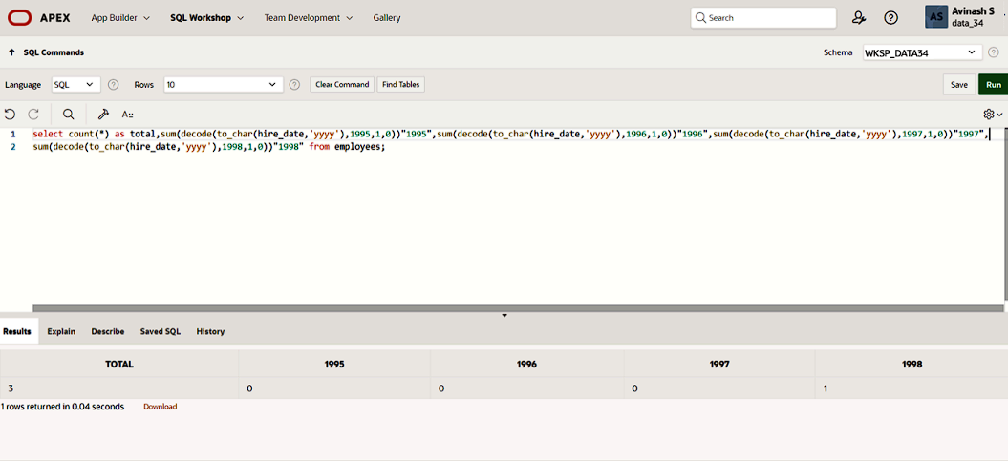

11. Create a matrix query to display the job, the salary for that job based on department

number, and the total salary for that job, for departments 20, 50, 80, and 90, giving each

column an appropriate heading.

**QUERY:**

SELECT d.department_name AS "Department", e.job_title AS "Job", e.salary AS "Salary", SUM(e.salary) OVER (PARTITION BY e.job_title) AS "Total Salary"

FROM employees e JOIN departments d ON e.department_id = d.department_id

WHERE d.department_id IN (20, 50, 80, 90);

**OUTPUT:**

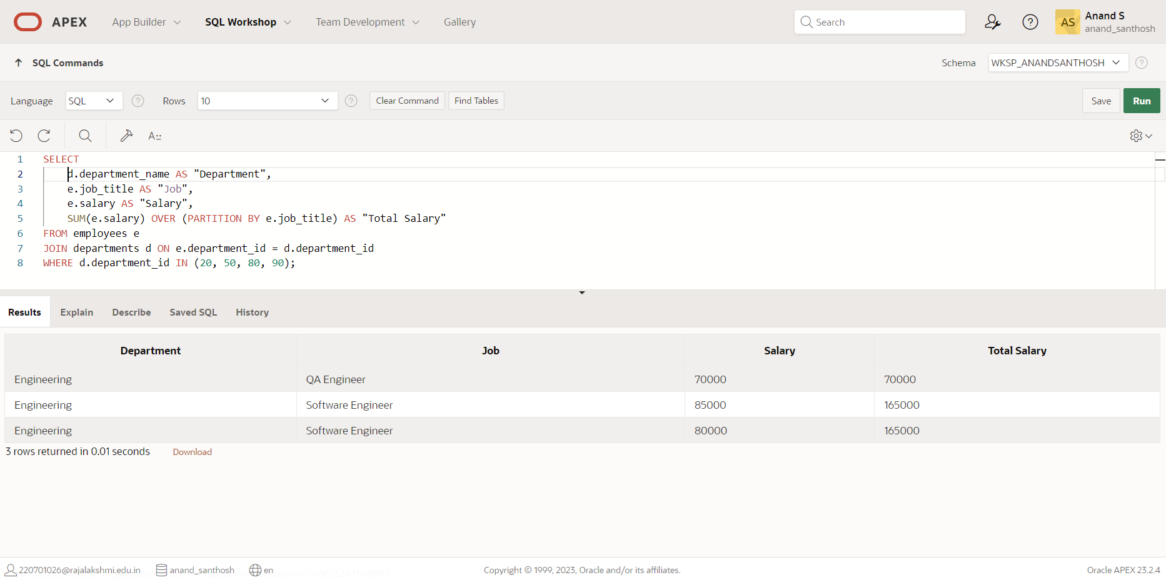

12.Write a query to display each department’s name, location, number of employees, and the average salary for all the employees in that department. Label the column name-Location, Number of people, and salary respectively. Round the average salary to two decimal places.

**QUERY:**

SELECT d.department_name AS "Location", d.location_id AS "Department", COUNT(*) AS "Number of people", ROUND(AVG(e.salary), 2) AS "Salary" FROM employees e

JOIN departments d ON e.department_id = d.department_id GROUP BY d.department_name, d.location ORDER BY "Salary" DESC;

**OUTPUT:**

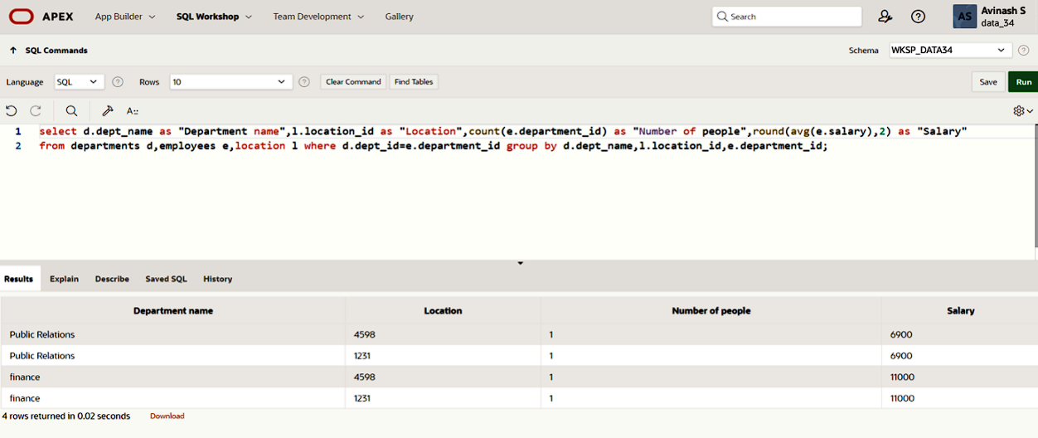

|  |  |
| --- | --- |
| Evaluation Procedure | Marks awarded |
| Query(5) |  |
| Execution (5) |  |
| Viva(5) |  |
| Total (15) |  |
| Faculty Signature |  |

**SUB QUERIES**

**EX.NO:9 DATE: 26 – 3 - 24**

**REG.NO: 220701306**

1. The HR department needs a query that prompts the user for an employee last name. The

query then displays the last name and hire date of any employee in the same department

as the employee whose name they supply (excluding that employee). For example, if the

user enters Zlotkey, find all employees who work with Zlotkey (excluding Zlotkey).

**QUERY:**

SELECT last_name, hire_date FROM employees

WHERE department_id IN (SELECT department_id FROM employees WHERE last_name = :last_name) AND employee_id != (SELECT employee_id FROM employees WHERE last_name :last_name);

**OUTPUT:**

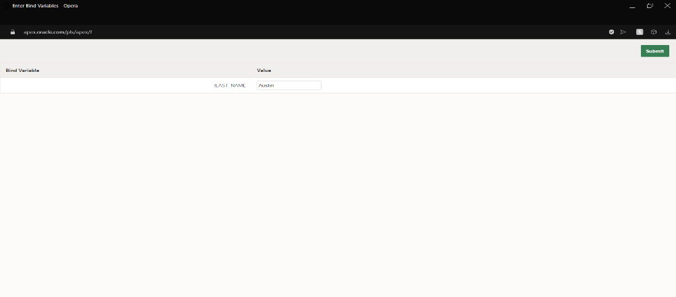

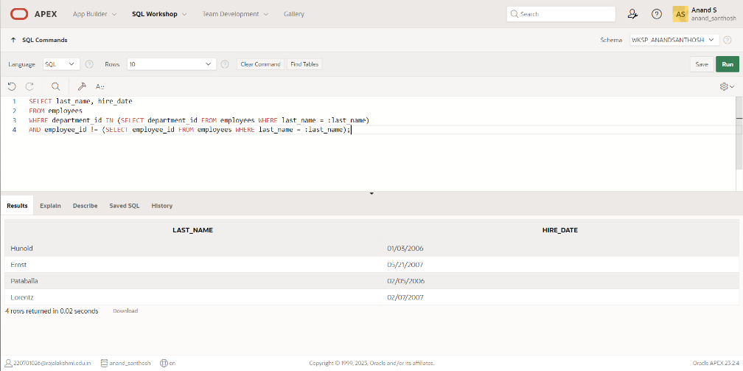

1. Create a report that displays the employee number, last name, and salary of all employees who earn more than the average salary. Sort the results in order of ascending salary.

**QUERY:**SELECT employee_id, last_name, salary FROM employees WHERE salary > (SELECT AVG(salary) FROM employees) ORDER BY salary ASC;

**OUTPUT:**

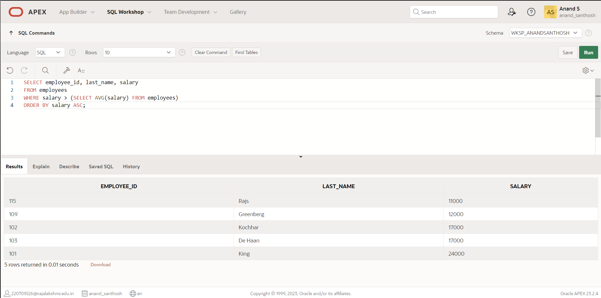

1. Write a query that displays the employee number and last name of all employees who work in a department with any employee whose last name contains a *u*.

**QUERY:**

SELECT employee_id, last_name

FROM employees

WHERE department_id IN (SELECT department_id FROM employees WHERE last_name LIKE '%u%');

**OUTPUT:  
  
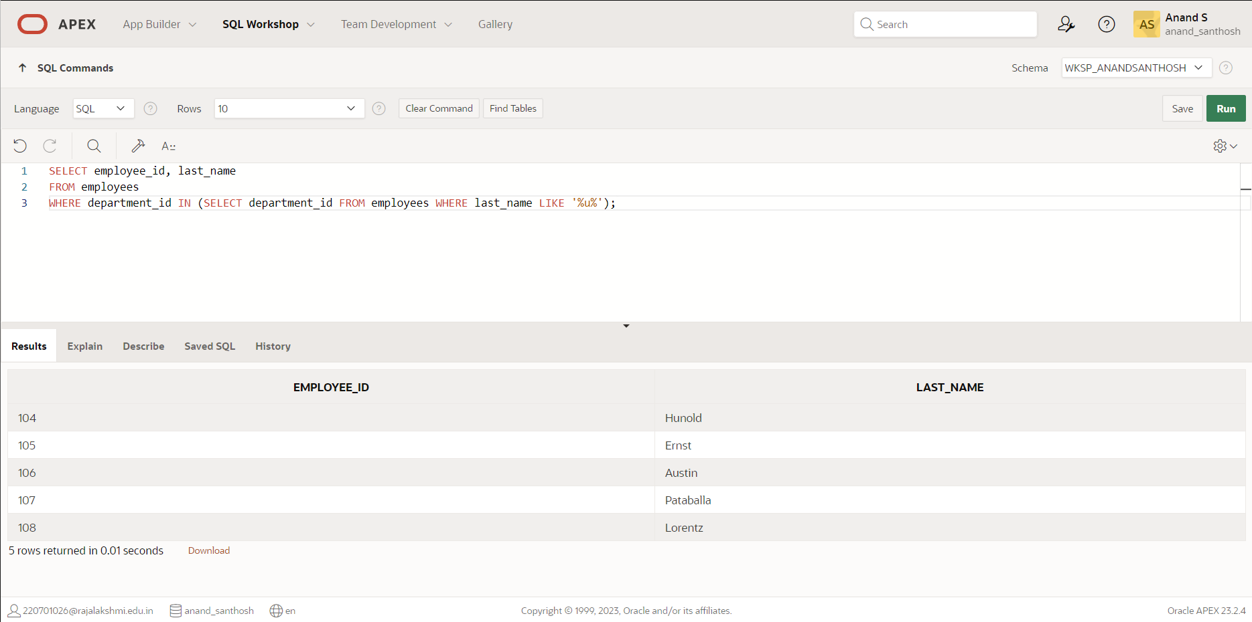**

1. The HR department needs a report that displays the last name, department number, and job ID of all employees whose department location ID is 1700.

**QUERY:**

SELECT last_name, department_id, job_id FROM employees WHERE department_id IN (SELECT department_id FROM departments WHERE location_id = 1700);

**OUTPUT:**

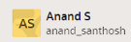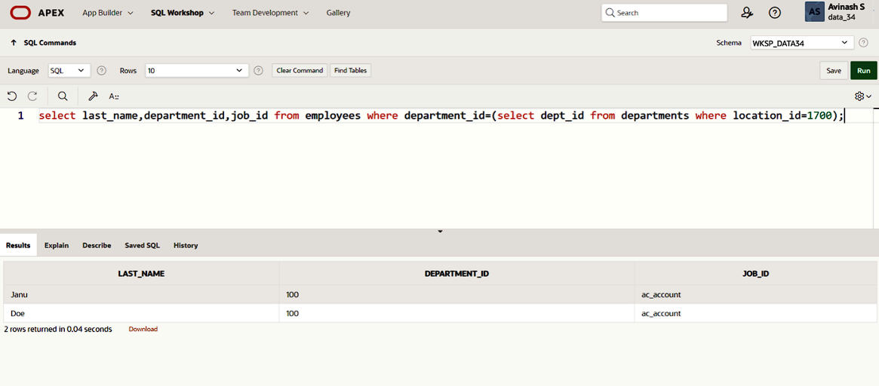

1. Create a report for HR that displays the last name and salary of every employee who reports to King.

**QUERY:**

SELECT last_name, salary

FROM employees

WHERE manager_id = (SELECT employee_id FROM employees WHERE last_name = 'King');

**OUTPUT:  
  
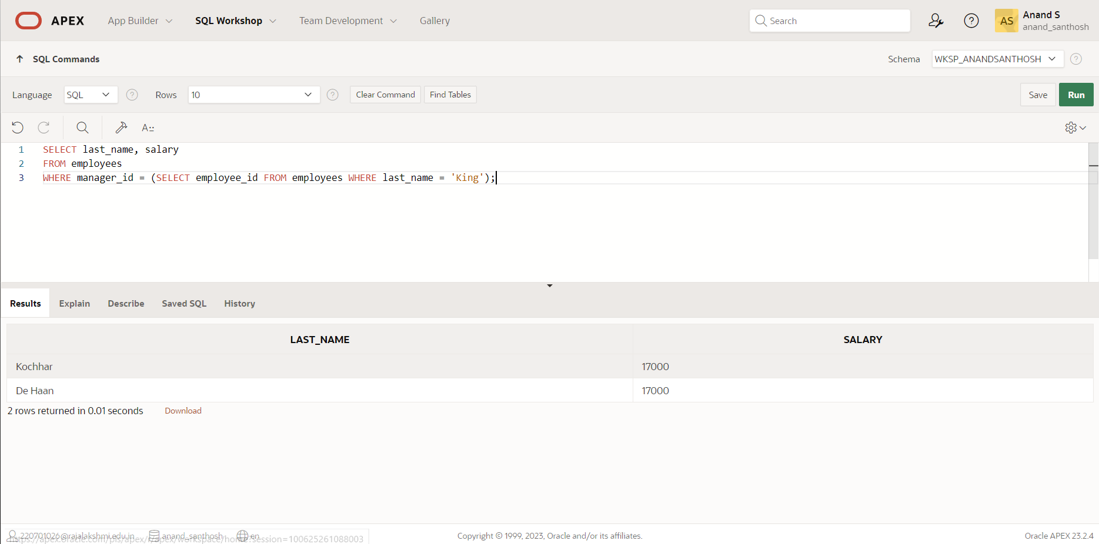**

1. Create a report for HR that displays the department number, last name, and job ID for

every employee in the Executive department.

**QUERY:**

SELECT department_id, last_name, job_id

FROM employees

WHERE department_id IN (SELECT department_id FROM departments WHERE department_name = 'Executive');

**OUTPUT:**

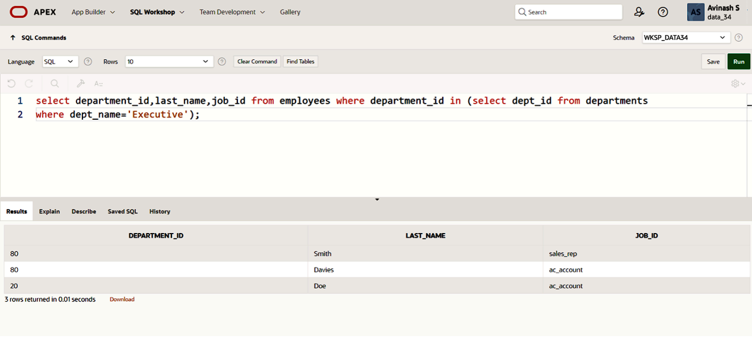

1. Modify the query 3 to display the employee number, last name, and salary of all employees who earn more than the average salary and who work in a department with any employee whose last name contains a *u*.

**QUERY:**

SELECT employee_id, last_name, salary FROM employees WHERE salary > (SELECT AVG(salary) FROM employees) AND department_id IN (SELECT department_id FROM employees WHERE last_name LIKE "%u%");

**OUTPUT:**

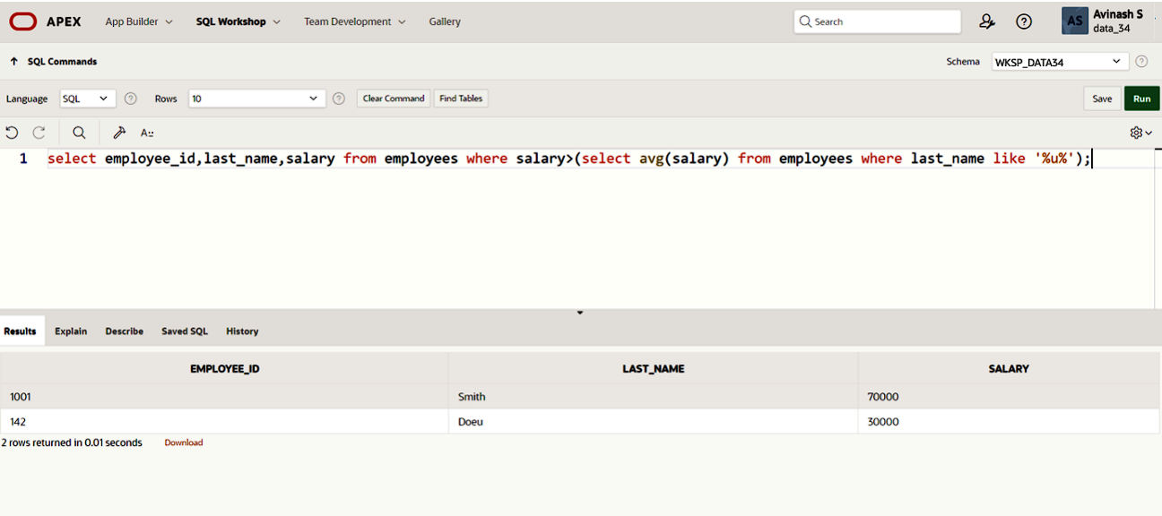

|  |  |
| --- | --- |
| Evaluation Procedure | Marks awarded |
| Query(5) |  |
| Execution (5) |  |
| Viva(5) |  |
| Total (15) |  |
| Faculty Signature |  |

**USING THE SET OPERATORS**

**EX.NO:10 DATE: 05 – 4 - 24**

**REG.NO: 220701306**

1. The HR department needs a list of department IDs for departments that do not contain

the job ID ST_CLERK. Use set operators to create this report.

**QUERY:**SELECT department_id FROM departments MINUS SELECT DISTINCT department_id FROM job_history WHERE job_id = 'ST_CLERK';

**OUTPUT:**

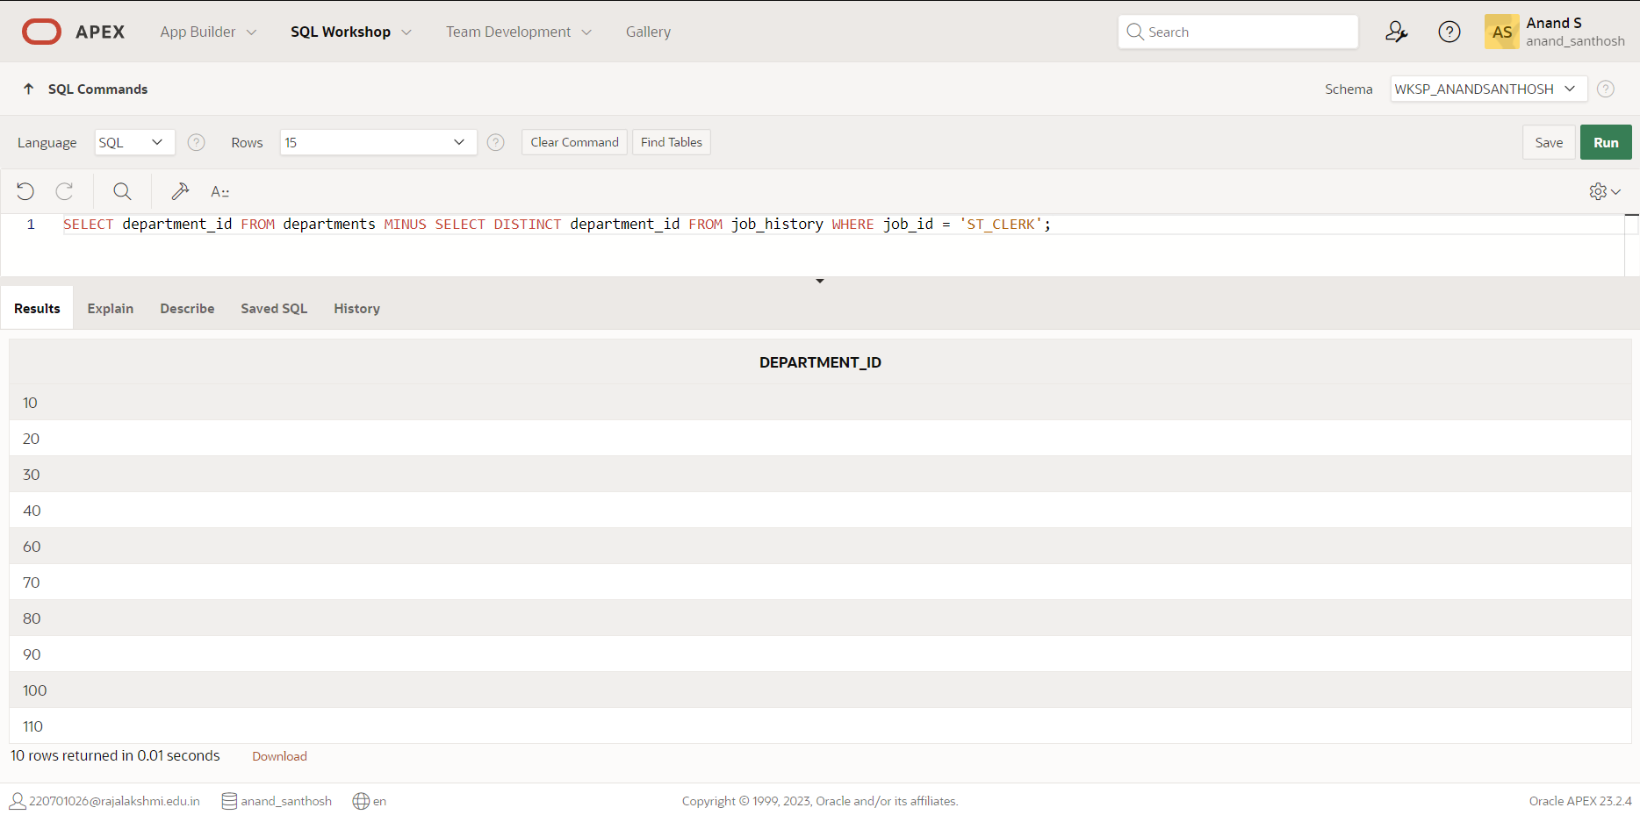

2. The HR department needs a list of countries that have no departments located in them.

Display the country ID and the name of the countries. Use set operators to create this report.

**QUERY:**

SELECT country_id, country_name FROM countries

MINUS

SELECT DISTINCT c.country_id, c.country_name FROM departments d

JOIN locations l ON d.location_id = l.location_id

JOIN countries c ON l.country_id = c.country_id;

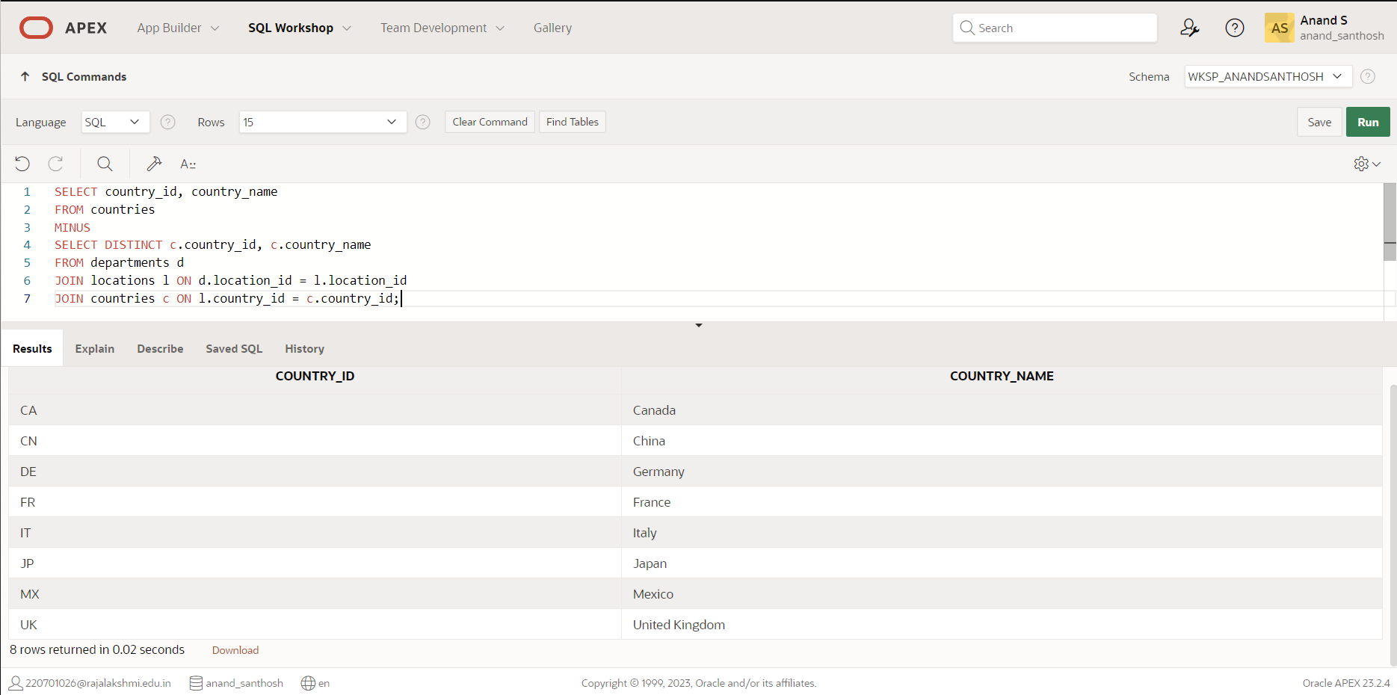**OUTPUT:**

3. Produce a list of jobs for departments 10, 50, and 20, in that order. Display job ID and

department ID using set operators.

**QUERY:**

select job_id,department_id from employees where department_id=10 union select job_id,department_id from employees where department_id=50 union select job_id,department_id from employees where department_id=20;

**OUTPUT:**

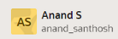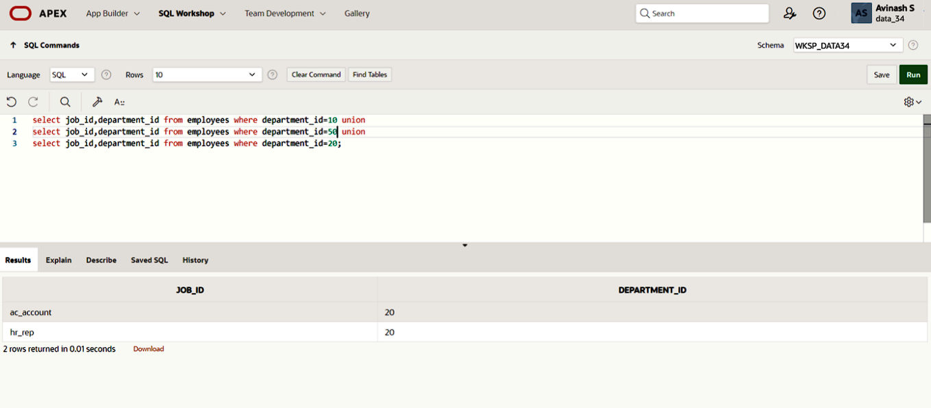

4. Create a report that lists the employee IDs and job IDs of those employees who

currently have a job title that is the same as their job title when they were initially

hired by the company (that is, they changed jobs but have now gone back to doing

their original job).

**QUERY:**

select job_id,employee_id from employees intersect select e.job_id,e.employee_id from employees e,job_history j where e.job_id=j.old_job_id;

**OUTPUT:**

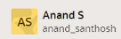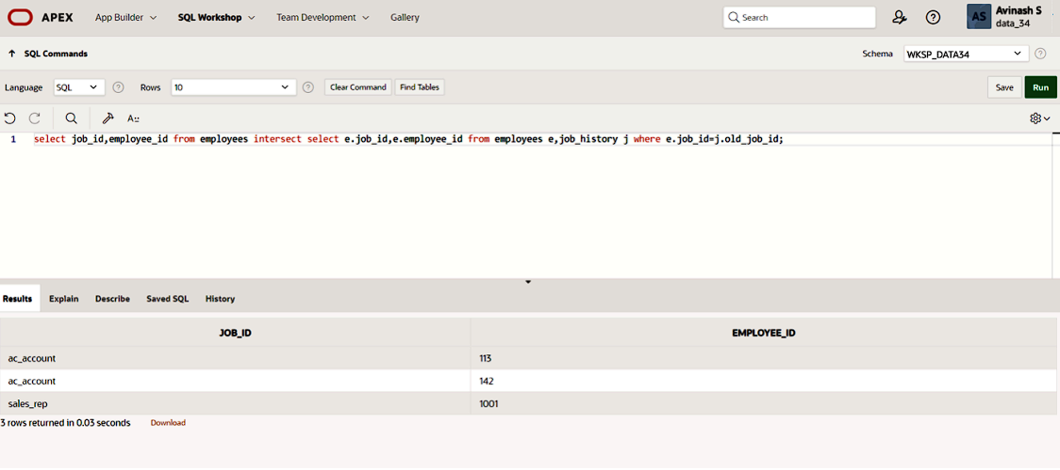

5. The HR department needs a report with the following specifications:

- Last name and department ID of all the employees from the EMPLOYEES table, regardless of whether or not they belong to a department.

- Department ID and department name of all the departments from the DEPARTMENTS table, regardless of whether or not they have employees working in them Write a compound query to accomplish this.

**QUERY:**

SELECT last_name, department_id FROM employees UNION SELECT department_name, department_id FROM departments;

**OUTPUT:**

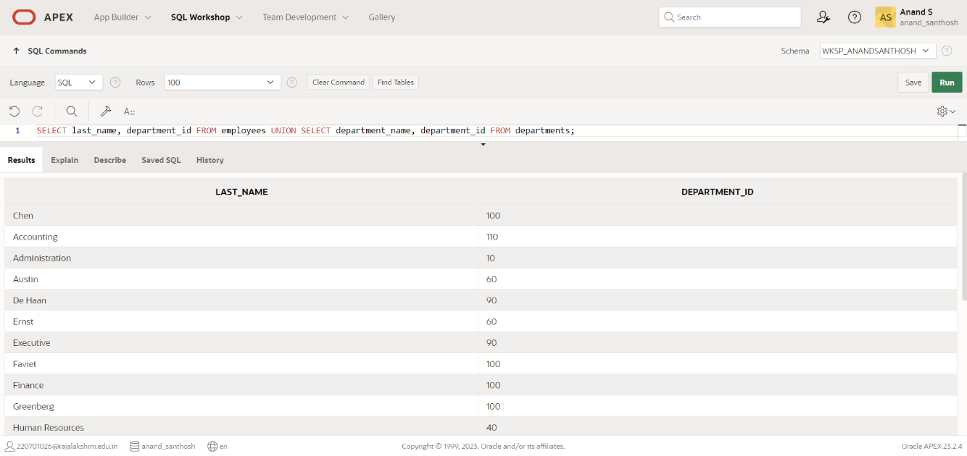

|  |  |
| --- | --- |
| Evaluation Procedure | Marks awarded |
| Query(5) |  |
| Execution (5) |  |
| Viva(5) |  |
| Total (15) |  |
| Faculty Signature |  |

**USING THE SET OPERATORS**

**EX.NO:11 DATE: 23 – 4 - 24**

**REG.NO: 220701306**

1. Create a view called EMPLOYEE_VU based on the employee numbers, employee names and department numbers from the EMPLOYEES table. Change the heading for the employee name to EMPLOYEE.

**QUERY:**

CREATE VIEW employee_vu (employee_number, employee, department_number)

AS SELECT employee_id, first_name || ' ' || last_name AS employee, department_id AS department_number

FROM employees;

**OUTPUT:**

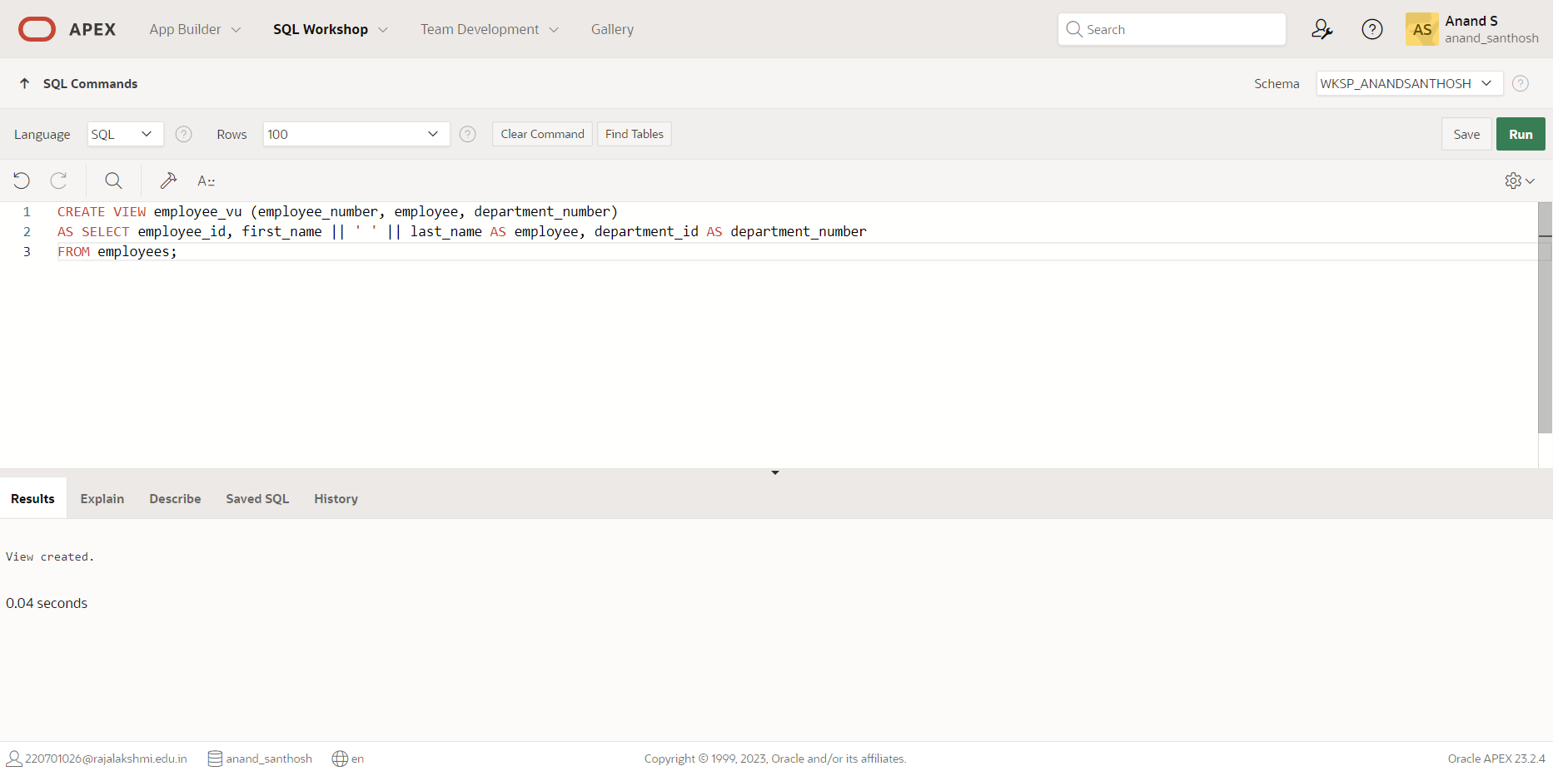

1. Display the contents of the EMPLOYEES_VU view.

**QUERY:**

SELECT * FROM employee_vu;

**OUTPUT:**

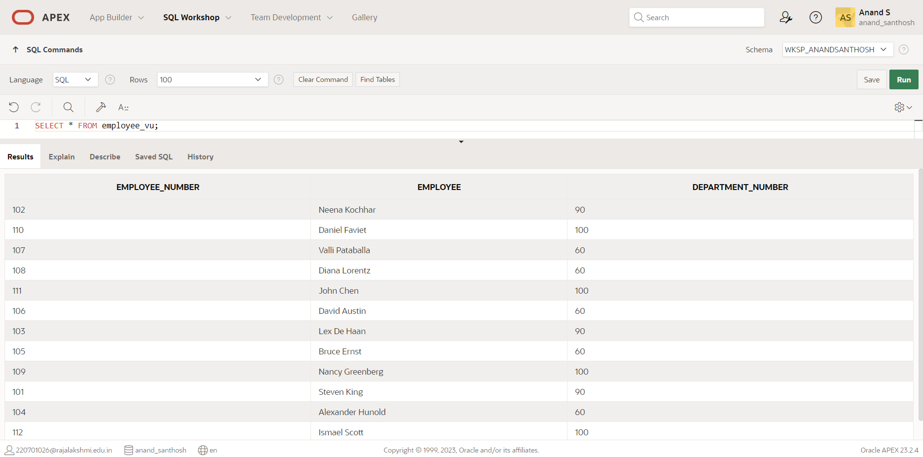

1. Select the view name and text from the USER_VIEWS data dictionary views.

**QUERY:**

SELECT view_name, text FROM user_views;

**OUTPUT:**

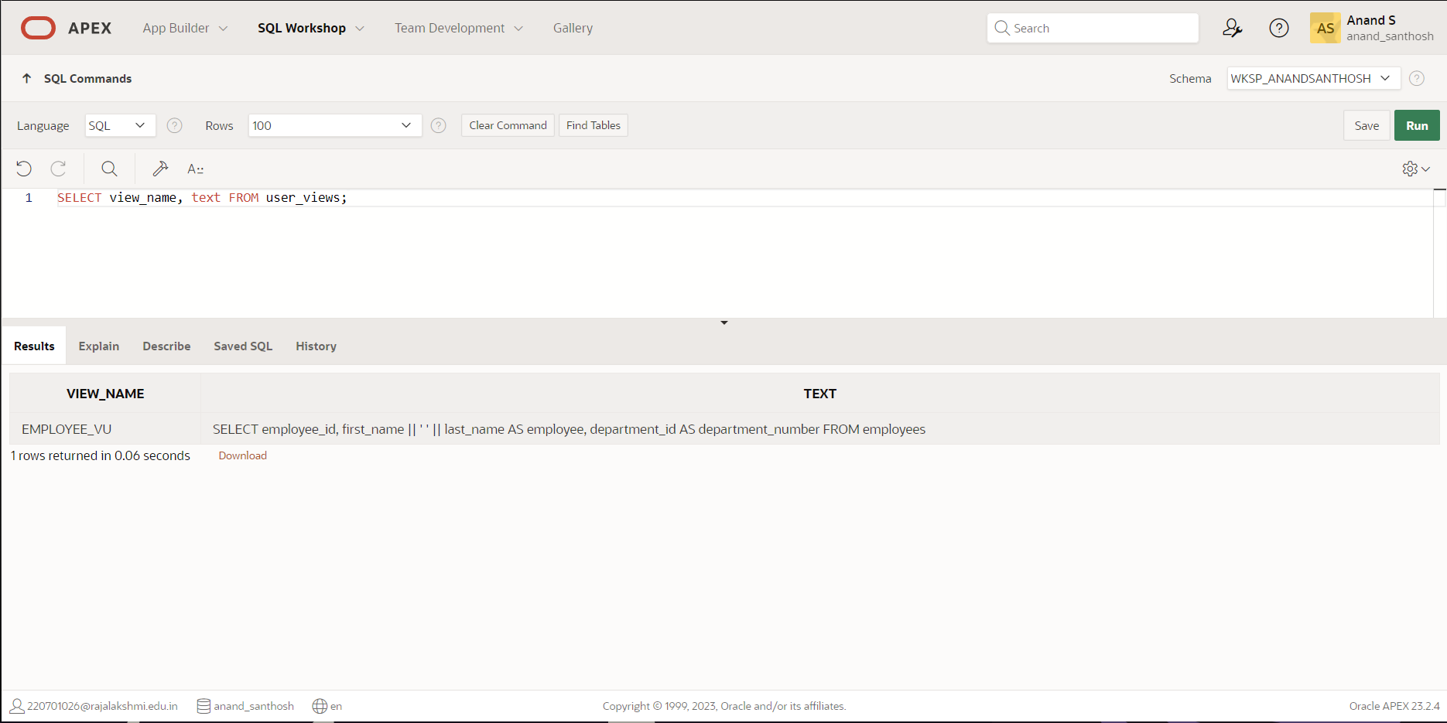

1. Using your EMPLOYEES_VU view, enter a query to display all employees names and department.

**QUERY:**

SELECT employee, department_number FROM employee_vu;

**OUTPUT:**

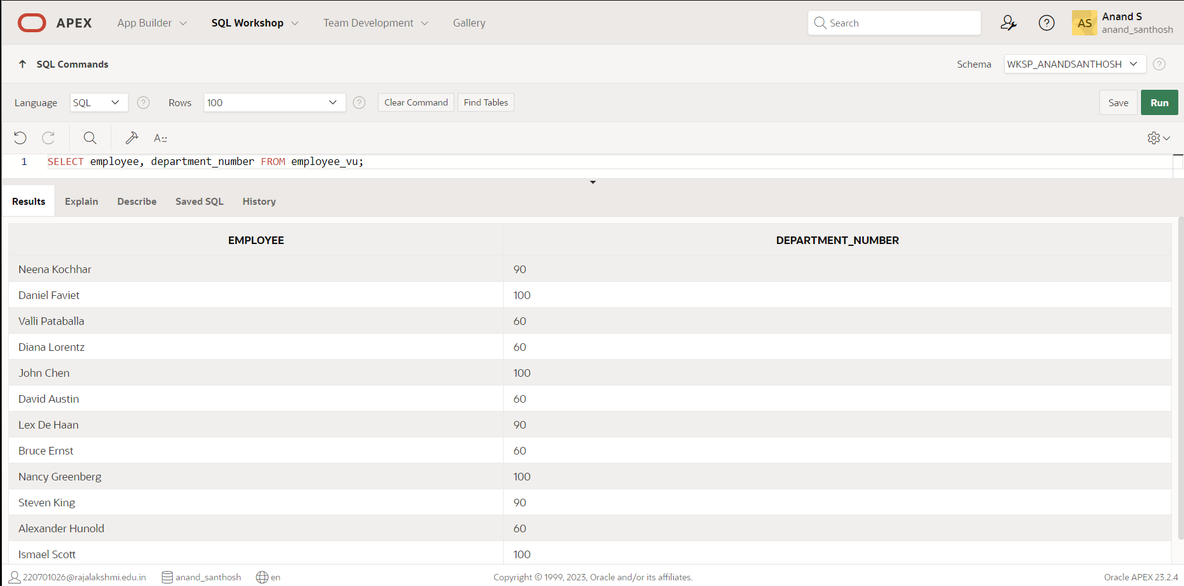

1. Create a view named DEPT50 that contains the employee number, employee last names and department numbers for all employees in department 50.Label the view columns EMPNO, EMPLOYEE and DEPTNO. Do not allow an employee to be reassigned to another department through the view.

**QUERY:**

CREATE VIEW dept50 (empno, employee, deptno)

AS SELECT employee_id, last_name, department_id

FROM employees

WHERE department_id = 50

WITH CHECK OPTION;

**OUTPUT:**

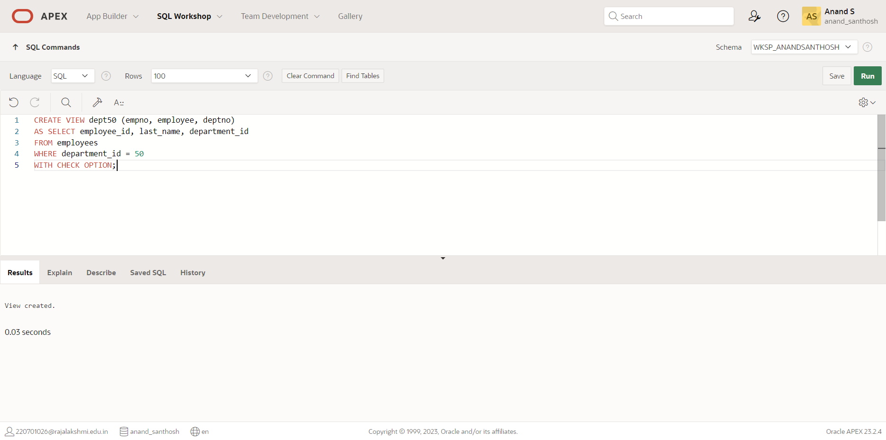

1. Display the structure and contents of the DEPT50 view.

**QUERY:**

DESRIBE dept50;

**OUTPUT:**

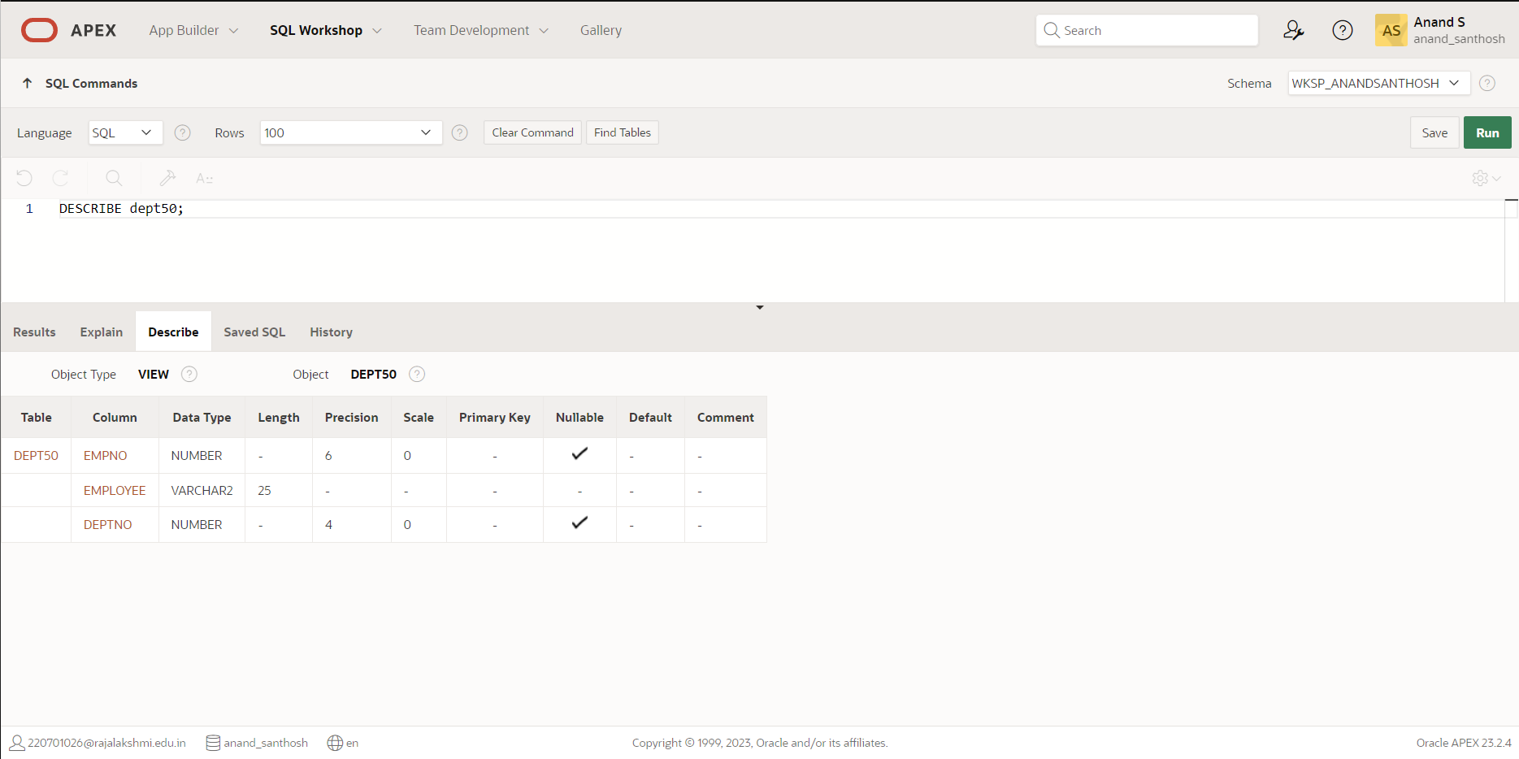

1. Attempt to reassign Matos to department 80.

**QUERY:**

UPDATE dept50 SET deptno = 80 WHERE empno = 201;

**OUTPUT:**

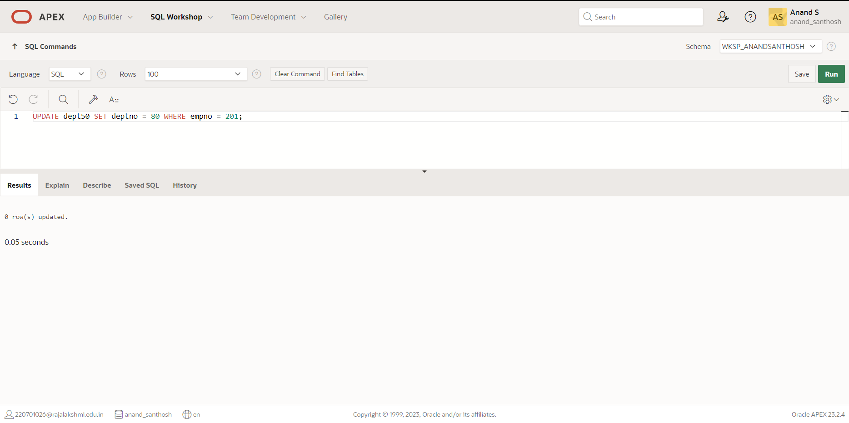

1. Create a view called SALARY_VU based on the employee last names, department names, salaries, and salary grades for all employees. Use the Employees, DEPARTMENTS and JOB_GRADE tables. Label the column Employee, Department, salary, and Grade respectively

**QUERY:**

create or replace view salary_vu as select e.last_name "Employee",d.dept_name Department, e.salary "Salary",j.grade_level "Grades" from employees e,departments d,job_grade j where e.department_id=d.dept_id and e.salary between j.lowest_sal and j.highest_sal;

**OUTPUT:**

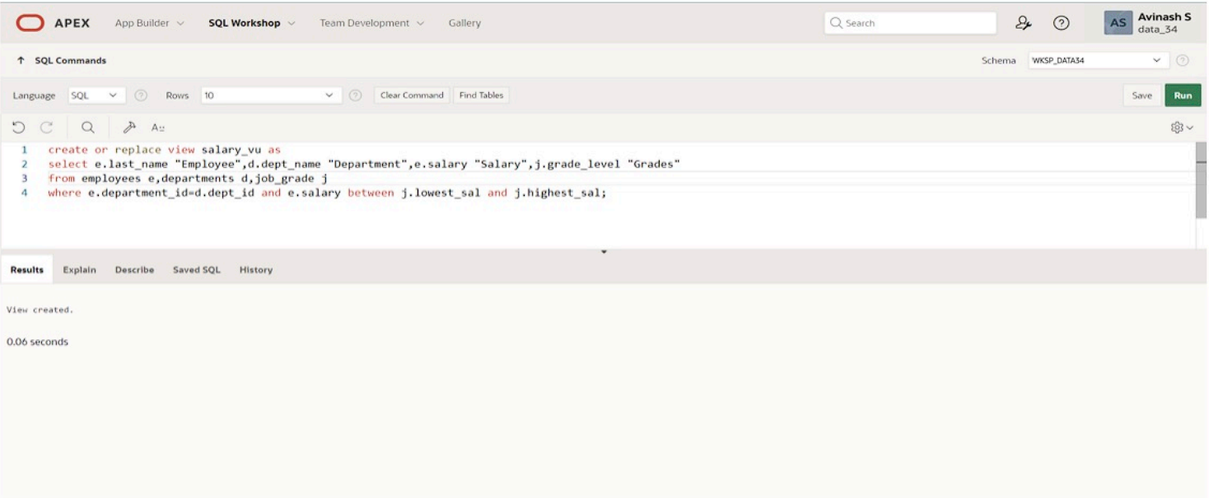

|  |  |
| --- | --- |
| Evaluation Procedure | Marks awarded |
| Query(5) |  |
| Execution (5) |  |
| Viva(5) |  |
| Total (15) |  |
| Faculty Signature |  |

**INTRO TO CONSTRAINTS: NOT NULL AND**

**UNIQUE CONSTRAINTS**

**EX.NO:12 DATE: 27 – 4 - 24**

**REG.NO: 220701306**

Global Fast Foods has been very successful this past year and has opened several new stores. They need to add a table to their database to store information about each of their store’s locations. The owners want to make sure that all entries have an identification number, date opened, address, and city and that no other entry in the table can have the same email address. Based on this information, answer the following questions about the global_locations table. Use the table for your answers.

|  |  |  |  |  |  |  |
| --- | --- | --- | --- | --- | --- | --- |
| **Global Fast Foods global_locations Table** | | | | | | |
| **NAME** | **TYPE** | **LENGTH** | **PRECISION** | **SCALE** | **NULLABLE** | **DEFAULT** |
| Id |  |  |  |  |  |  |
| name |  |  |  |  |  |  |
| date_opened |  |  |  |  |  |  |
| address |  |  |  |  |  |  |
| city |  |  |  |  |  |  |
| zip/postal code |  |  |  |  |  |  |
| phone |  |  |  |  |  |  |
| email |  |  |  |  |  |  |
| manager_id |  |  |  |  |  |  |
| Emergency contact |  |  |  |  |  |  |

1. What is a “constraint” as it relates to data integrity?

Database can be as reliable as the data in it, and database rules are implemented as Constraint to maintain data integrity.

1. What are the limitations of constraints that may be applied at the column level and at the table level?

* Constraints referring to more than one column are defined at Table Level
* NOT NULL constraint must be defined at column level as per ANSI/ISO SQL standard.

1. Why is it important to give meaningful names to constraints?

* If a constraint is violated in a SQL statement execution, it is easy to identify the cause with user-named constraints.
* It is easy to alter names/drop constraint.

1. Based on the information provided by the owners, choose a datatype for each column. Indicate the length, precision, and scale for each NUMBER datatype.

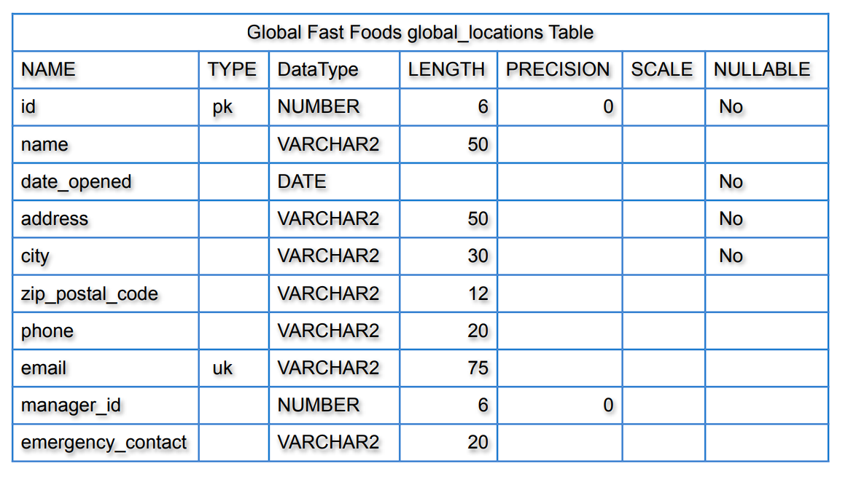

1. Use “(nullable)” to indicate those columns that can have null values.

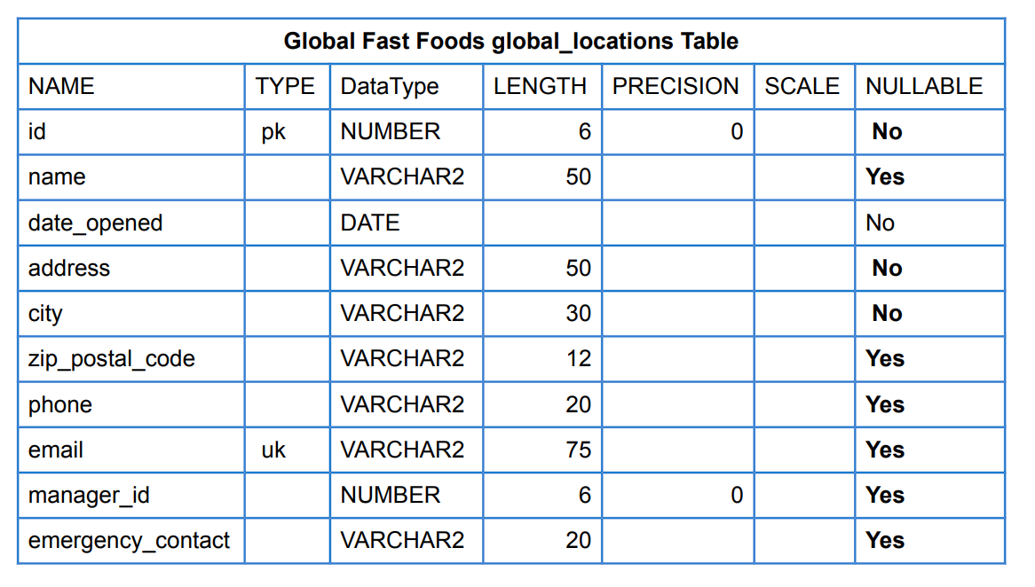

1. Write the CREATE TABLE statement for the Global Fast Foods locations table to define the constraints at the column level.

CREATE TABLE f_global_locations

( id NUMBER(6,0) CONSTRAINT f_gln_id_pk PRIMARY KEY ,

name VARCHAR2(50),

date_opened DATE CONSTRAINT f_gln_dt_opened_nn NOT NULL ENABLE,

address VARCHAR2(50) CONSTRAINT f_gln_add_nn NOT NULL ENABLE,

city VARCHAR2(30) CONSTRAINT f_gln_city_nn NOT NULL ENABLE,

zip_postal_code VARCHAR2(12),

phone VARCHAR2(20),

email VARCHAR2(75) CONSTRAINT f_gln_email_uk UNIQUE,

manager_id NUMBER(6,0),

emergency_contact VARCHAR2(20)

);

1. Execute the CREATE TABLE statement in Oracle Application Express.

Table Created.

1. Execute a DESCRIBE command to view the Table Summary information.

DESCRIBE f_global_locations;

1. Rewrite the CREATE TABLE statement for the Global Fast Foods locations table to define the UNIQUE constraints at the table level. Do not execute this statement.

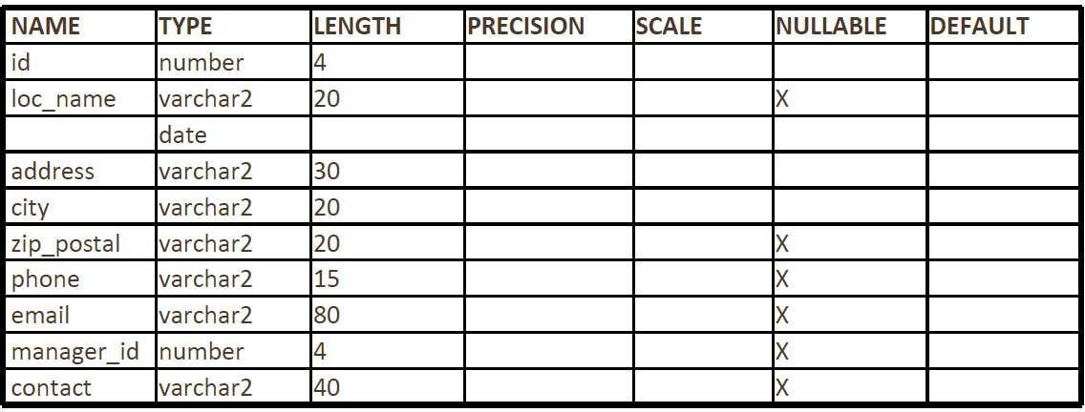

CREATE TABLE f_global_locations

( id NUMBER(6,0) CONSTRAINT f_gln_id_pk PRIMARY KEY ,

name VARCHAR2(50),

date_opened DATE CONSTRAINT f_gln_dt_opened_nn NOT NULL ENABLE,

address VARCHAR2(50) CONSTRAINT f_gln_add_nn NOT NULL ENABLE,

city VARCHAR2(30) CONSTRAINT f_gln_city_nn NOT NULL ENABLE,

zip_postal_code VARCHAR2(12),

phone VARCHAR2(20),

email VARCHAR2(75) ,

manager_id NUMBER(6,0),

emergency_contact VARCHAR2(20),

CONSTRAINT f_gln_email_uk UNIQUE(email)

);

# PRIMARY KEY, FOREIGN KEY, and CHECK Constraints

1. What is the purpose of a

* PRIMARY KEY
* FOREIGN KEY
* CHECK CONSTRAINT
  1. PRIMARY KEY Uniquely identify each row in table.

b. FOREIGN KEY Referential integrity constraint links back parent table's primary/unique key to child

table's column.

c. CHECK CONSTRAINT Explicitly define condition to be met by each row's fields. This condition must be returned as true or unknown.

1. Using the column information for the animals table below, name constraints where applicable at the table level, otherwise name them at the column level. Define the primary key (animal_id). The license_tag_number must be unique. The admit_date and vaccination_date columns cannot contain null values.

animal_id NUMBER(6) name VARCHAR2(25)

license_tag_number NUMBER(10) admit_date DATE

adoption_id NUMBER(5), vaccination_date DATE

animal_id NUMBER(6) - PRIMARY KEY

name VARCHAR2(25) license_tag_number NUMBER(10) - UNIQUE

admit_date DATE -NOT NULL

adoption_id NUMBER(5), vaccination_date DATE -NOT NULL

1. Create the animals table. Write the syntax you will use to create the table.

CREATE TABLE animals ( animal_id NUMBER(6,0) CONSTRAINT anl_anl_id_pk PRIMARY KEY , name VARCHAR2(25), license_tag_number NUMBER(10,0) CONSTRAINT anl_l_tag_num_uk UNIQUE, admit_date DATE CONSTRAINT anl_adt_dat_nn NOT NULL ENABLE, adoption_id NUMBER(5,0), vaccination_date DATE CONSTRAINT anl_vcc_dat_nn NOT NULL ENABLE );

1. Enter one row into the table. Execute a SELECT * statement to verify your input. Refer to the graphic below for input.

|  |  |  |  |  |  |
| --- | --- | --- | --- | --- | --- |
| **ANIMAL_I D** | **NAM E** | **LICENSE_TAG_NUMBE R** | **ADMIT_DAT E** | **ADOPTION_I D** | **VACCINATION_DAT E** |
| 101 | Spot | 35540 | 10-Oct-2004 | 205 | 12-Oct-2004 |

INSERT INTO animals (animal_id, name, license_tag_number, admit_date, adoption_id, vaccination_date) VALUES( 101, 'Spot', 35540, TO_DATE('10-Oct-2004', 'DD-Mon-YYYY'), 205, TO_DATE('12-Oct-2004', 'DD-Mon- YYYY'));

1. Write the syntax to create a foreign key (adoption_id) in the animals table that has a corresponding primary-key reference in the adoptions table. Show both the column-level and table-level syntax. Note that because you have not actually created an adoptions table, no adoption_id primary key exists, so the foreign key cannot be added to the animals table.

COLUMN LEVEL STATEMENT: ALTER TABLE animals MODIFY ( adoption_id NUMBER(5,0) CONSTRAINT anl_adopt_id_fk REFERENCES adoptions(id) ENABLE );

TABLE LEVEL STATEMENT: ALTER TABLE animals ADD CONSTRAINT anl_adopt_id_fk FOREIGN KEY (adoption_id) REFERENCES adoptions(id) ENABLE;

1. What is the effect of setting the foreign key in the ANIMAL table as:
   1. ON DELETE CASCADE
   2. ON DELETE SET NULL

a. ON DELETE CASCADE ALTER TABLE animals ADD CONSTRAINT anl_adopt_id_fk FOREIGN KEY (adoption_id) REFERENCES adoptions(id) ON DELETE CASCADE ENABLE ;

b. ON DELETE SET NULL ALTER TABLE animals ADD CONSTRAINT anl_adopt_id_fk FOREIGN KEY (adoption_id) REFERENCES adoptions(id) ON DELETE SET NULL ENABLE ;

1. What are the restrictions on defining a CHECK constraint?

* I cannot specify check constraint for a view however in this case I could use WITH CHECK OPTION clause
* I am restricted to columns from self table and fields in self row.
* I cannot use subqueries and scalar subquery expressions.

|  |  |
| --- | --- |
| Evaluation Procedure | Marks awarded |
| Query(5) |  |
| Execution (5) |  |
| Viva(5) |  |
| Total (15) |  |
| Faculty Signature |  |

**CREATING VIEWS**

**EX.NO:13 DATE: 27 – 4 - 24**

**REG.NO: 220701306**

1. What are three uses for a view from a DBA’s perspective?

* Restrict access and display selective columns
* Reduce complexity of queries from other internal systems. So, providing a way to view same data in a different manner.
* Let the app code rely on views and allow the internal implementation of tables to be modified late

1. Create a simple view called view_d_songs that contains the ID, title and artist from the DJs on Demand table for each “New Age” type code. In the subquery, use the alias “Song Title” for the title column.

CREATE VIEW view_d_songs AS SELECT d_songs.id, d_songs.title "Song Title", d_songs.artist from d_songs INNER JOIN d_types ON d_songs.type_code = d_types.code where d_types.description = 'New Age';

1. SELECT * FROM view_d_songs. What was returned?

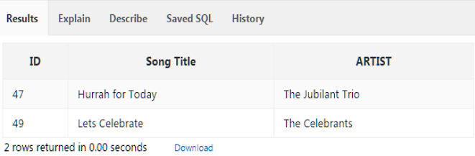

1. REPLACE view_d_songs. Add type_code to the column list. Use aliases for all columns. Or use alias after the CREATE statement as shown.

CREATE OR REPLACE VIEW view_d_songs AS SELECT d_songs.id, d_songs.title "Song Title", d_songs.artist, d_songs.type_code from d_songs INNER JOIN d_types ON d_songs.type_code = d_types.code where d_types.description = 'New Age';

1. Jason Tsang, the disk jockey for DJs on Demand, needs a list of the past events and those planned for the coming months so he can make arrangements for each event’s equipment setup. As the company manager, you do not want him to have access to the price that clients paid for their events. Create a view for Jason to use that displays the name of the event, the event date, and the theme description. Use aliases for each column name.

CREATE OR REPLACE VIEW view_d_events_pkgs AS SELECT evt.name "Name of Event", TO_CHAR(evt.event_date, 'dd-Month-yyyy') "Event date", thm.description "Theme description" FROM d_events evt INNER JOIN d_themes thm ON evt.theme_code = thm.code WHERE evt.event_date <= ADD_MONTHS(SYSDATE,1);

1. It is company policy that only upper-level management be allowed access to individual employee salaries. The department managers, however, need to know the minimum, maximum, and average salaries, grouped by department. Use the Oracle database to prepare a view that displays the needed information for department managers.

CREATE OR REPLACE VIEW view_min_max_avg_dpt_salary ("Department Id", "Department Name", "Max Salary", "Min Salary", "Average Salary") AS SELECT dpt.department_id, dpt.department_name, MAX(NVL(emp.salary,0)), MIN(NVL(emp.salary,0)), ROUND(AVG(NVL(emp.salary,0)),2) FROM departments dpt LEFT OUTER JOIN employees emp ON dpt.department_id = emp.department_id GROUP BY (dpt.department_id, dpt.department_name);

# DML OPERATIONS AND VIEWS

Use the DESCRIBE statement to verify that you have tables named copy_d_songs, copy_d_events, copy_d_cds, and copy_d_clients in your schema. If you don’t, write a query to create a copy of each.

* + - 1. Query the data dictionary USER_UPDATABLE_COLUMNS to make sure the columns in the base tables will allow UPDATE, INSERT, or DELETE. All table names in the data dictionary are stored in uppercase. Use the same syntax but change table_name of the other tables.

SELECT owner, table_name, column_name, updatable,insertable, deletable FROM user_updatable_columns WHERE LOWER(table_name) = 'copy_d_songs';

SELECT owner, table_name, column_name, updatable,insertable, deletable FROM user_updatable_columns WHERE LOWER(table_name) = 'copy_d_events';

SELECT owner, table_name, column_name, updatable,insertable, deletable FROM user_updatable_columns WHERE LOWER(table_name) = 'copy_d_cds';

* + - 1. Use the CREATE or REPLACE option to create a view of *all* the columns in the copy_d_songs table called view_copy_d_songs.

CREATE OR REPLACE VIEW view_copy_d_songs AS SELECT * FROM copy_d_songs;

SELECT * FROM view_copy_d_songs;

* + - 1. Use view_copy_d_songs to INSERT the following data into the underlying copy_d_songs table. Execute a SELECT * from copy_d_songs to verify your DML command. See the graphic.

|  |  |  |  |  |
| --- | --- | --- | --- | --- |
| **ID** | **TITLE** | **DURATION** | **ARTIST** | **TYPE_CODE** |
| 88 | Mello Jello | 2 | The What | 4 |

INSERT INTO view_copy_d_songs(id,title,duration,artist,type_code) VALUES(88,'Mello Jello','2 min','The What',4);

* + - 1. Create a view based on the DJs on Demand COPY_D_CDS table. Name the view read_copy_d_cds. Select all columns to be included in the view. Add a WHERE clause to restrict the year to 2000. Add the WITH READ ONLY option.

CREATE OR REPLACE VIEW read_copy_d_cds AS SELECT * FROM copy_d_cds WHERE year = '2000' WITH READ ONLY ; SELECT * FROM read_copy_d_cds;

* + - 1. Using the read_copy_d_cds view, execute a DELETE FROM read_copy_d_cds WHERE cd_number = 90;

ORA-42399: cannot perform a DML operation on a read-only view

* + - 1. Use REPLACE to modify read_copy_d_cds. Replace the READ ONLY option with WITH CHECK OPTION CONSTRAINT ck_read_copy_d_cds. Execute a SELECT * statement to verify that the view exists.

CREATE OR REPLACE VIEW read_copy_d_cds AS SELECT * FROM copy_d_cds WHERE year = '2000' WITH CHECK OPTION CONSTRAINT ck_read_copy_d_cds;

* + - 1. Use the read_copy_d_cds view to delete any CD of year 2000 from the underlying copy_d_cds.

DELETE FROM read_copy_d_cdsWHERE year = '2000';

* + - 1. 10Use the read_copy_d_cds view to delete cd_number 90 from the underlying copy_d_cds table.

DELETE FROM read_copy_d_cdsWHERE cd_number = 90;

1. Use the read_copy_d_cds view to delete year 2001 records.

DELETE FROM read_copy_d_cdsWHERE year = '2001';

1. Execute a SELECT * statement for the base table copy_d_cds. What rows were deleted?

Only the one in problem 7 above, not the one in 8 and 9

11.What are the restrictions on modifying data through a view?

DELETE.INSERT,MODIFY restricted if it contains:

Group functions

GROUP BY CLAUSE

DISTINCT

pseudocolumn ROWNUM Keyword

1. What is Moore’s Law? Do you consider that it will continue to apply indefinitely? Support your opinion with research from the internet.

It roughly predicted that computing power nearly doubles every year. But Moore also said in 2005 that as per nature of exponential functions, this trend may not continue forever.

1. What is the “singularity” in terms of computing?

Singularity is the hypothesis that the invention of artificial superintelligence will abruptly trigger runaway technological growth, resulting in unfathomable changes to human civilization

# Managing Views

1. Create a view from the copy_d_songs table called view_copy_d_songs that includes only the title and artist. Execute a SELECT * statement to verify that the view exists.

CREATE OR REPLACE VIEW view_copy_d_songs ASSELECT title, artistFROM copy_d_songs;SELECT * FROM view_copy_d_songs;

1. Issue a DROP view_copy_d_songs. Execute a SELECT * statement to verify that the view has been deleted.

DROP VIEW view_copy_d_songs; SELECT * FROM view_copy_d_songs;

ORA-00942: table or view does not exist

1. Create a query that selects the last name and salary from the Oracle database. Rank the salaries from highest to lowest for the top three employees.

SELECT * FROM(SELECT last_name, salary FROM employees ORDER BY salary DESC)WHERE ROWNUM <= 3;

1. Construct an inline view from the Oracle database that lists the last name, salary, department ID, and maximum salary for each department. Hint: One query will need to calculate maximum salary by department ID.

SELECT empm.last_name, empm.salary, dptmx.department_idFROM(SELECT dpt.department_id, MAX(NVL(emp.salary,0)) max_dpt_salFROM departments dpt LEFT OUTER JOIN employees emp ON dpt.department_id = emp.department_idGROUP BY dpt.department_id) dptmx LEFT OUTER JOIN employees empm ON dptmx.department_id = empm.department_idWHERE NVL(empm.salary,0) = dptmx.max_dpt_sal;

1. Create a query that will return the staff members of Global Fast Foods ranked by salary from lowest to highest.

SELECT ROWNUM,last_name, salaryFROM(SELECT * FROM f_staffs ORDER BY SALARY);

# Indexes and Synonyms

1. What is an index and what is it used for?

Definition: These are schema objects which make retrieval of rows from table faster.

Purpose: An index provides direct and fast access to row in table. They provide indexed path to locate data quickly, so hereby reduce necessity of heavy disk input/output operations.

1. What is a ROWID, and how is it used?

Indexes use ROWID's (base 64 string representation of the row address containing block identifier, row location in the block and the database file identifier) which is the fastest way to access any particular row.

1. When will an index be created automatically?

Primary key/unique key use already existing unique index but if index is not present already, it is created while applying unique/primary key constraint.

1. Create a nonunique index (foreign key) for the DJs on Demand column (cd_number) in the D_TRACK_LISTINGS table. Use the Oracle Application Express SQL Workshop Data Browser to confirm that the index was created.

CREATE INDEX d_tlg_cd_number_fk_i on d_track_listings (cd_number);

1. Use the join statement to display the indexes and uniqueness that exist in the data dictionary for the DJs on Demand D_SONGS table.

SELECT ucm.index_name, ucm.column_name, ucm.column_position, uix.uniquenessFROM user_indexes uix INNER JOIN user_ind_columns ucm ON uix.index_name = ucm.index_nameWHERE ucm.table_name = 'D_SONGS';

1. Use a SELECT statement to display the index_name, table_name, and uniqueness from the data dictionary USER_INDEXES for the DJs on Demand D_EVENTS table.

SELECT index_name, table_name,uniqueness FROM user_indexes where table_name = 'D_EVENTS';

1. Write a query to create a synonym called dj_tracks for the DJs on Demand d_track_listings table.

CREATE SYNONYM dj_tracks FOR d_track_listings;

1. Create a function-based index for the last_name column in DJs on Demand D_PARTNERS table that makes it possible not to have to capitalize the table name for searches. Write a SELECT statement that would use this index.

CREATE INDEX d_ptr_last_name_idxON d_partners(LOWER(last_name));

1. Create a synonym for the D_TRACK_LISTINGS table. Confirm that it has been created by querying the data dictionary.

CREATE SYNONYM dj_tracks2 FOR d_track_listings;

SELECT * FROM user_synonyms WHERE table_NAME=UPPER('d_track_listings');

10.Drop the synonym that you created in question

DROP SYNONYM dj_tracks2;

|  |  |
| --- | --- |
| Evaluation Procedure | Marks awarded |
| Query(5) |  |
| Execution (5) |  |
| Viva(5) |  |
| Total (15) |  |
| Faculty Signature |  |

**OTHER DATABASE OBJECTS**

**EX.NO:14 DATE: 07 – 5 - 24**

**REG.NO: 220701306**

1.Create a sequence to be used with the primary key column of the DEPT table. The

sequence should start at 200 and have a maximum value of 1000. Have your sequence increment

by ten numbers. Name the sequence DEPT_ID_SEQ.

**QUERY:**

CREATE SEQUENCE dept_id_seq START WITH 200 INCREMENT BY 10 MAXVALUE 1000;

**OUTPUT:**

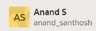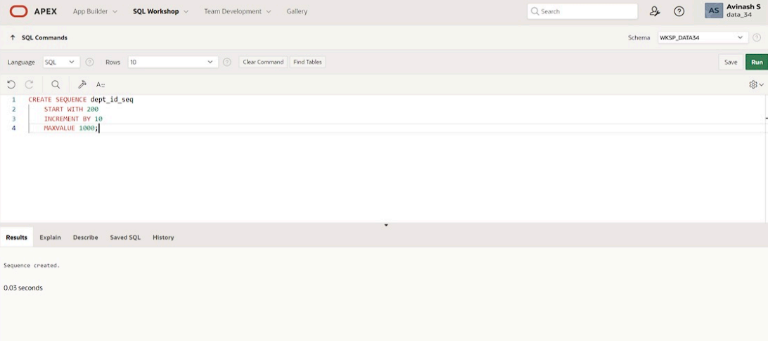

2. Write a query in a script to display the following information about your sequences: sequence

name, maximum value, increment size, and last number

**QUERY:**

SELECT sequence_name, max_value, increment_by, last_number FROM user_sequences;

**OUTPUT:**

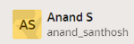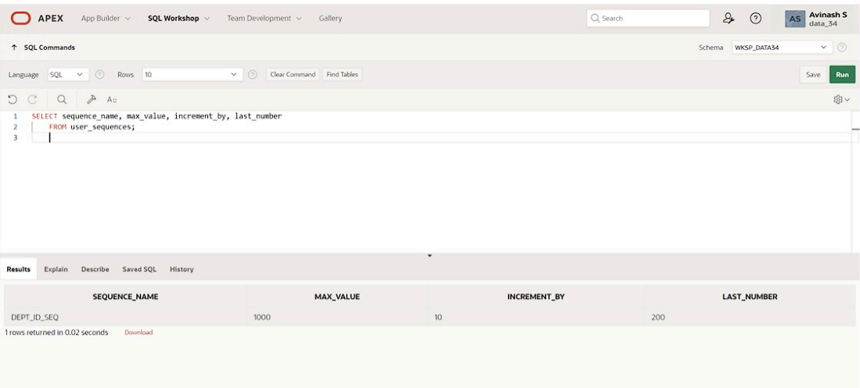

3. Write a script to insert two rows into the DEPT table. Name your script lab12_3.sql. Be sure

to use the sequence that you created for the ID column. Add two departments named Education and

Administration. Confirm your additions. Run the commands in your script.

**QUERY:**

INSERT INTO dept VALUES (dept_id_seq.nextval, 'Education');

**OUTPUT:**

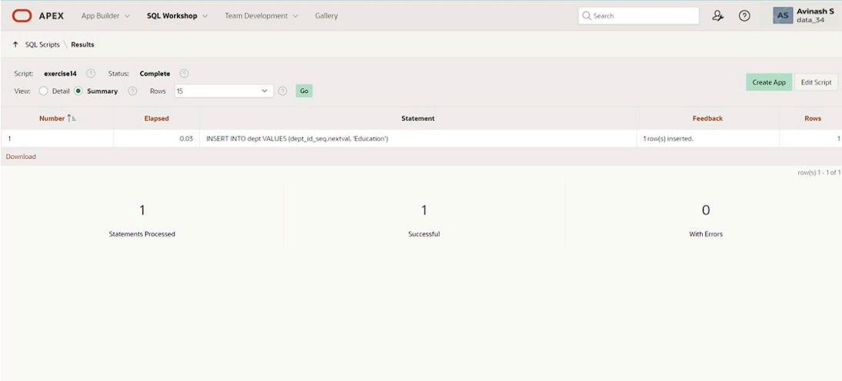

1. Create a nonunique index on the foreign key column (DEPT_ID) in the EMP table.

**QUERY:**

CREATE INDEX emp_dept_id_idx ON EMPLOYEES (department_id);

**OUTPUT:**

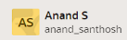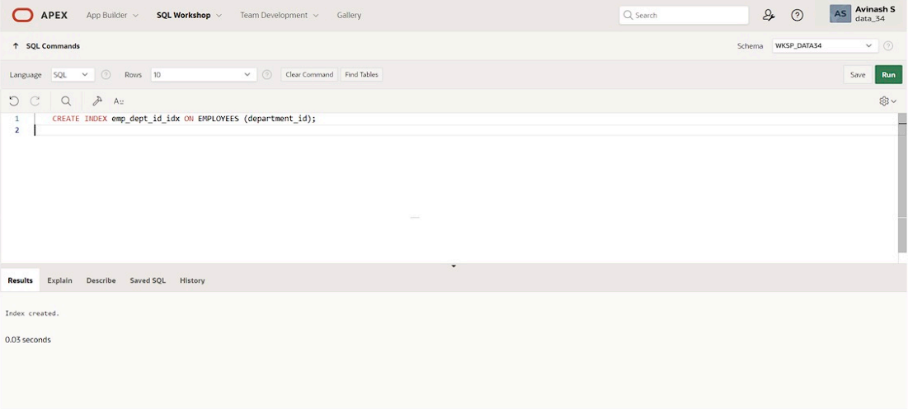

5. Display the indexes and uniqueness that exist in the data dictionary for the EMP table.

**QUERY:**

SELECT index_name,table_name,uniqueness FROM user_indexes WHERE table_name='EMPLOYEES';

**OUTPUT:**

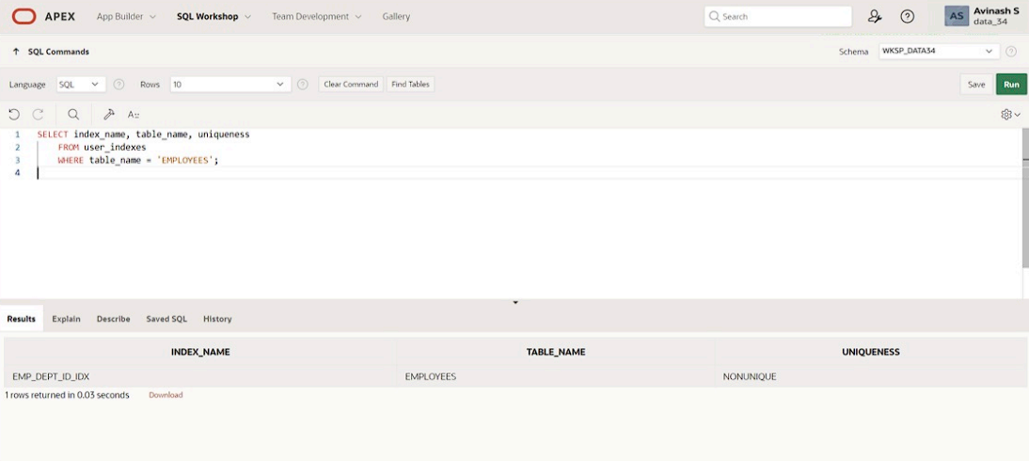

|  |  |
| --- | --- |
| Evaluation Procedure | Marks awarded |
| Query(5) |  |
| Execution (5) |  |
| Viva(5) |  |
| Total (15) |  |
| Faculty Signature |  |

**CONTROLLING USER ACCESS**

**EX.NO:15 DATE: 10 - 5 - 24**

**REG.NO: 220701306**

1. What privilege should a user be given to log on to the Oracle Server? Is this a system or an

object privilege?

The CREATE SESSION system privilege

2. What privilege should a user be given to create tables?

The CREATE TABLE privilege

3.If you create a table, who can pass along privileges to other users on your table?

You can, or anyone you have given those privileges to by using the WITH GRANT OPTION

4. You are the DBA. You are creating many users who require the same system privileges.

What should you use to make your job easier?

Create a role containing the system privileges and grant the role to the users

1. What command do you use to change your password?

The ALTER USER statement

6. Grant another user access to your DEPARTMENTS table. Have the user grant you query access

to his or her DEPARTMENTS table.

Team 2 executes the GRANT statement. GRANT select ON departments TO <user1> ;

Team 1 executes the GRANT statement. GRANT select ON departments TO <user2> ;

7. Query all the rows in your DEPARTMENTS table.

SELECT * FROM departments;

8. Add a new row to your DEPARTMENTS table. Team 1 should add Education as department

number 500. Team 2 should add Human Resources department number 510. Query the other

team’s table.

Team 1 executes this INSERT statement.

INSERT INTO departments(department_id, department_name) VALUES (500, ’Education’); COMMIT;

Team 2 executes this INSERT statement.

INSERT INTO departments(department_id, department_name) VALUES (510, ’Administration’); COMMIT;

9. Query the USER_TABLES data dictionary to see information about the tables that you own.

SELECT table_name FROM user_tables;

1. Revoke the SELECT privilege on your table from the other team.

Team 1 revokes the privilege. REVOKE select ON departments FROM user2;

Team 2 revokes the privilege. REVOKE select ON departments FROM user1;

11. Remove the row you inserted into the DEPARTMENTS table in step 8 and save the changes.

Team 1 executes this INSERT statement.

DELETE FROM departments WHERE department_id = 500; COMMIT;

Team 2 executes this INSERT statement.

DELETE FROM departments WHERE department_id = 510; COMMIT;

|  |  |
| --- | --- |
| Evaluation Procedure | Marks awarded |
| Query(5) |  |
| Execution (5) |  |
| Viva(5) |  |
| Total (15) |  |
| Faculty Signature |  |

**PL/SQL**

**CONTROL STRUCTURES**

**EX.NO:16 DATE: 21 – 5 - 24**

**REG.NO: 220701306**

PROGRAM 1

Write a PL/SQL block to calculate the incentive of an employee whose ID is 110.

**QUERY:**

DECLARE

incentive NUMBER(8,2);

BEGIN

SELECT salary*0.12 INTO incentive

FROM employees

WHERE employee_id = 110;

DBMS_OUTPUT.PUT_LINE('Incentive = ' || TO_CHAR(incentive));

END;

**OUTPUT:**

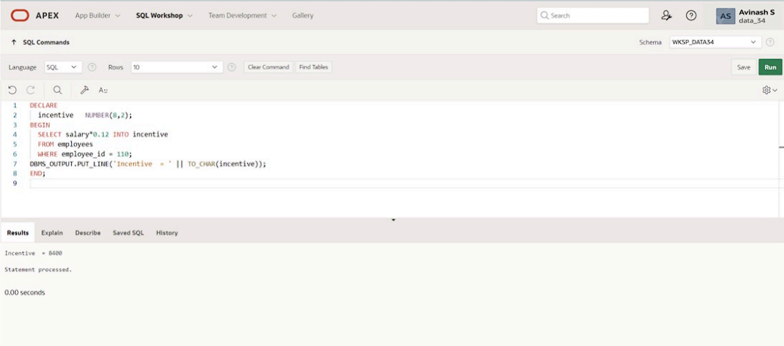

PROGRAM 2

Write a PL/SQL block to show an invalid case-insensitive reference to a quoted and without quoted user-defined identifier.

**QUERY:**

DECLARE DECLARE

WELCOME varchar2(10) := 'welcome'; WELCOME varchar2(10) := 'welcome';

BEGIN BEGIN

DBMS_Output.Put_Line("Welcome"); DBMS_Output.Put_Line("Welcome");

END; END;

/ /

**OUTPUT:**

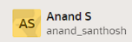

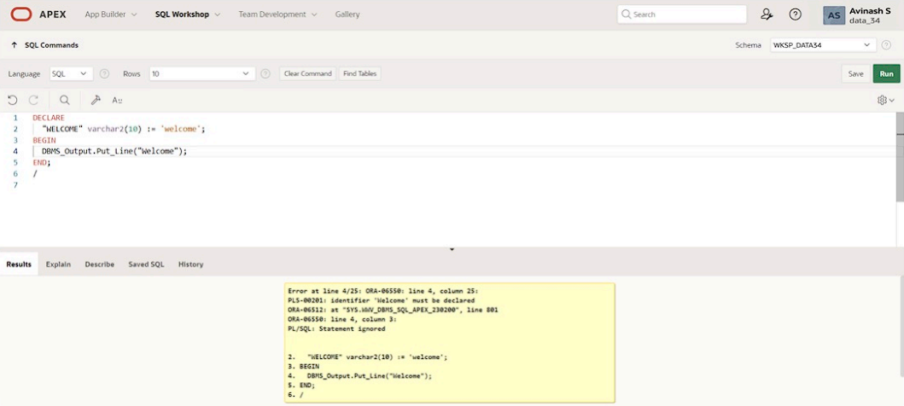

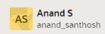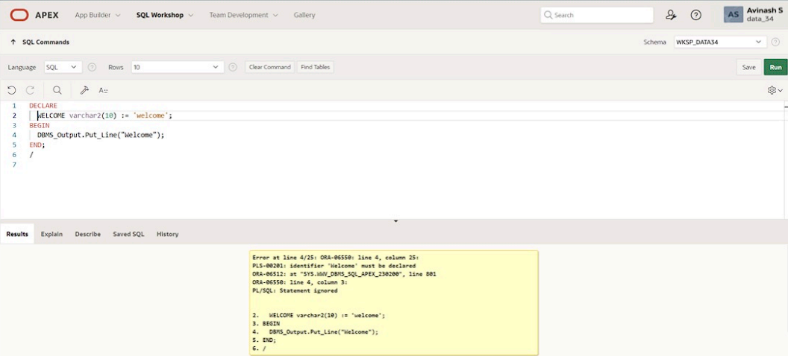

PROGRAM 3

Write a PL/SQL block to adjust the salary of the employee whose ID 122.

Sample table: employees

**QUERY:**

DECLARE

salary_of_emp NUMBER(8,2);

PROCEDURE approx_salary (

emp NUMBER,

empsal IN OUT NUMBER,

addless NUMBER

) IS

BEGIN

empsal := empsal + addless;

END;

BEGIN

SELECT salary INTO salary_of_emp

FROM employees

WHERE employee_id = 122;

DBMS_OUTPUT.PUT_LINE

('Before invoking procedure, salary_of_emp: ' || salary_of_emp);

approx_salary (100, salary_of_emp, 1000);

DBMS_OUTPUT.PUT_LINE

('After invoking procedure, salary_of_emp: ' || salary_of_emp);

END;

/

**OUTPUT:**

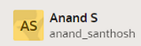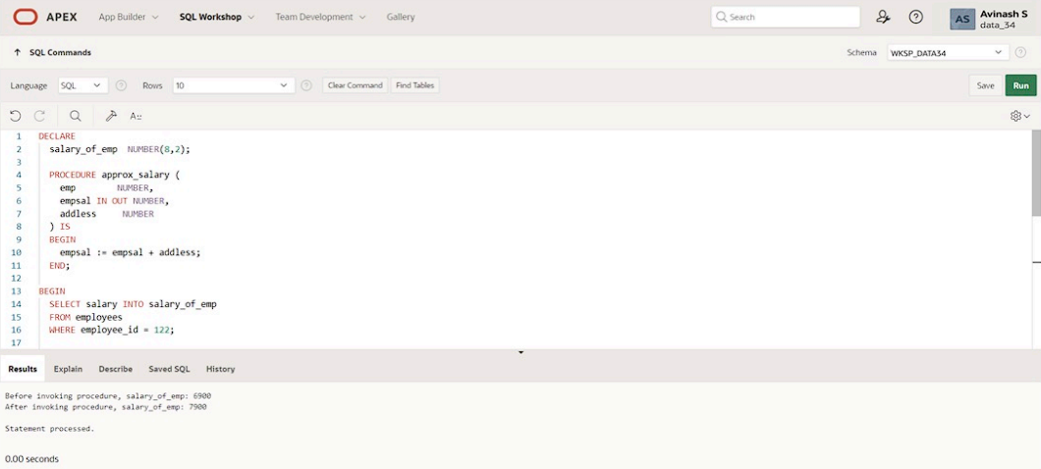

PROGRAM 4

Write a PL/SQL block to create a procedure using the "IS [NOT] NULL Operator" and show AND operator returns TRUE if and only if both operands are TRUE.

**QUERY:**

CREATE OR REPLACE PROCEDURE pri_bool(

boo_name VARCHAR2,

boo_val BOOLEAN

) IS

BEGIN

IF boo_val IS NULL THEN

DBMS_OUTPUT.PUT_LINE( boo_name || ' = NULL');

ELSIF boo_val = TRUE THEN

DBMS_OUTPUT.PUT_LINE( boo_name || ' = TRUE');

ELSE

DBMS_OUTPUT.PUT_LINE( boo_name || ' = FALSE');

END IF;

END;

/

**OUTPUT:**

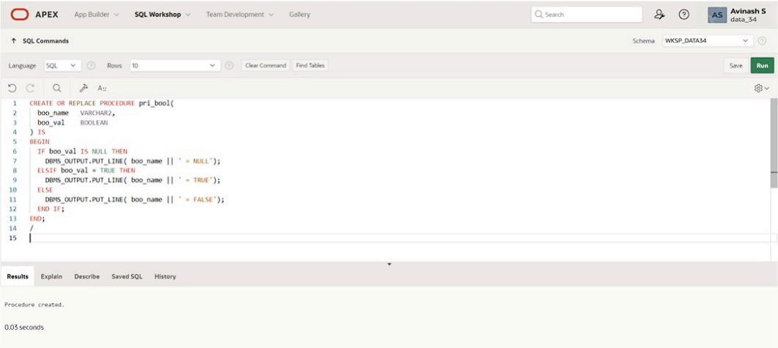

PROGRAM 5

Write a PL/SQL block to describe the usage of LIKE operator including wildcard characters and escape character.

**QUERY:**

DECLARE

PROCEDURE pat_match (

test_string VARCHAR2,

pattern VARCHAR2

) IS

BEGIN

IF test_string LIKE pattern THEN

DBMS_OUTPUT.PUT_LINE ('TRUE');

ELSE

DBMS_OUTPUT.PUT_LINE ('FALSE');

END IF;

END;

BEGIN

pat_match('Blweate', 'B%a_e');

pat_match('Blweate', 'B%A_E');

END;

/

**OUTPUT:**

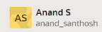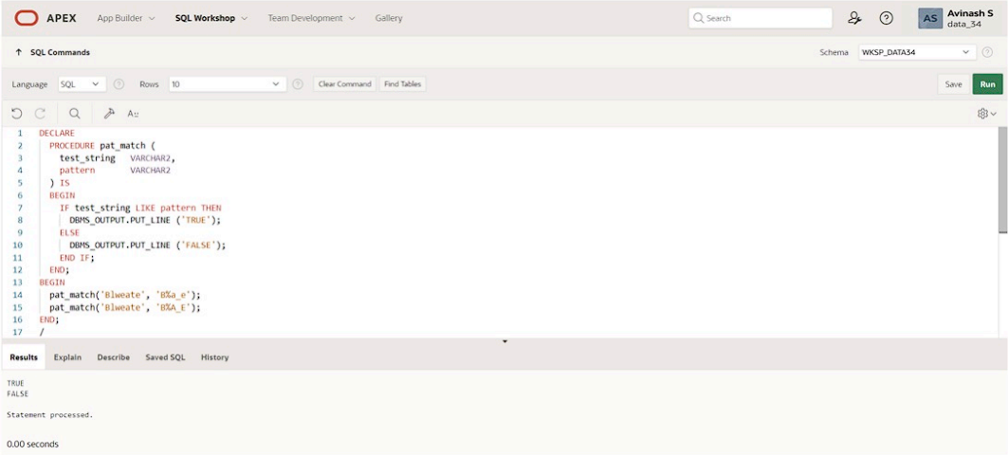

PROGRAM 6

Write a PL/SQL program to arrange the number of two variable in such a way that the small number will store in num_small variable and large number will store in num_large variable.

**QUERY:**

DECLARE

num_small NUMBER := 8;

num_large NUMBER := 5;

num_temp NUMBER;

BEGIN

IF num_small > num_large THEN

num_temp := num_small;

num_small := num_large;

num_large := num_temp;

END IF;

DBMS_OUTPUT.PUT_LINE ('num_small = '||num_small);

DBMS_OUTPUT.PUT_LINE ('num_large = '||num_large);

END;

/

**OUTPUT:**

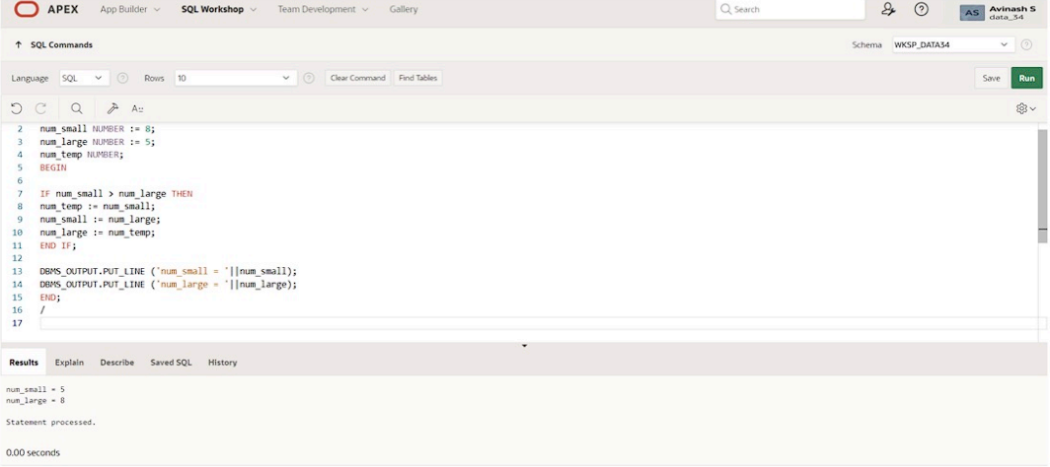

PROGRAM 7

Write a PL/SQL procedure to calculate the incentive on a target achieved and display the message either the record updated or not.

**QUERY:**

DECLARE

PROCEDURE test1 (

sal_achieve NUMBER,

target_qty NUMBER,

emp_id NUMBER

)

IS

incentive NUMBER := 0;

updated VARCHAR2(3) := 'No';

BEGIN

IF sal_achieve > (target_qty + 200) THEN

incentive := (sal_achieve - target_qty)/4;

UPDATE employees

SET salary = salary + incentive

WHERE employee_id = emp_id;

updated := 'Yes';

END IF;

DBMS_OUTPUT.PUT_LINE (

'Table updated? ' || updated || ', ' ||

'incentive = ' || incentive || '.'

);

END test1;

BEGIN

test1(2300, 2000, 144);

test1(3600, 3000, 145);

END;

/

**OUTPUT:**



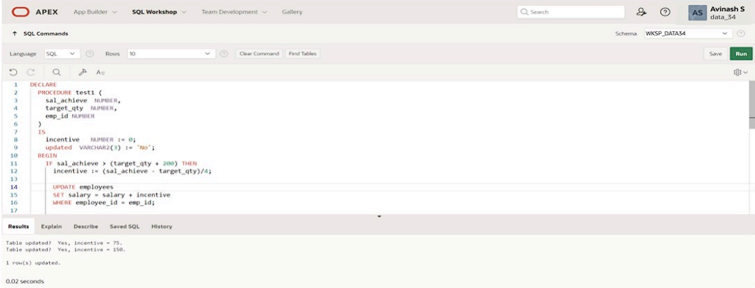

PROGRAM 8

Write a PL/SQL procedure to calculate incentive achieved according to the specific sale limit.

**QUERY:**

DECLARE

PROCEDURE test1 (sal_achieve NUMBER)

IS

incentive NUMBER := 0;

BEGIN

IF sal_achieve > 44000 THEN

incentive := 1800;

ELSIF sal_achieve > 32000 THEN

incentive := 800;

ELSE

incentive := 500;

END IF;

DBMS_OUTPUT.NEW_LINE;

DBMS_OUTPUT.PUT_LINE (

'Sale achieved : ' || sal_achieve || ', incentive : ' || incentive || '.'

);

END test1;

BEGIN

test1(45000);

test1(36000);

test1(28000);

END;

/

**OUTPUT:**

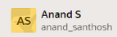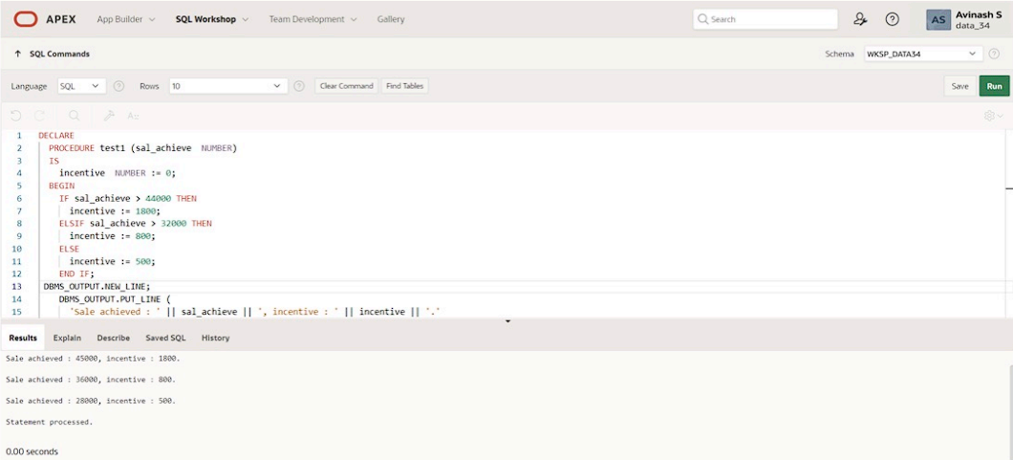

PROGRAM 9

Write a PL/SQL program to count number of employees in department 50 and check whether this department have any vacancies or not. There are 45 vacancies in this department.

**QUERY:**

SET SERVEROUTPUT ON

DECLARE

tot_emp NUMBER;

get_dep_id NUMBER;

BEGIN

get_dep_id := 80;

SELECT Count(*)

INTO tot_emp

FROM employees e

join departments d

ON e.department_id = d.department_id

WHERE e.department_id = get_dep_id;

dbms_output.Put_line ('The employees are in the department '||get_dep_id||' is: '

||To_char(tot_emp));

IF tot_emp >= 45 THEN

dbms_output.Put_line ('There are no vacancies in the department '||get_dep_id);

ELSE

dbms_output.Put_line ('There are '||to_char(45-tot_emp)||' vacancies in department '|| get_dep_id );

END IF;

END;

/

**OUTPUT:**

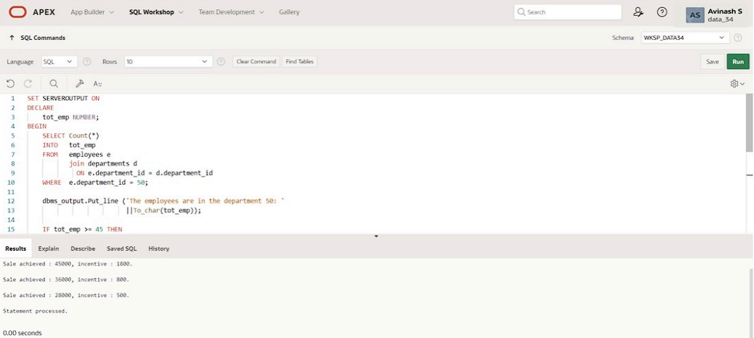

PROGRAM 10

Write a PL/SQL program to count number of employees in a specific department and check whether this department have any vacancies or not. If any vacancies, how many vacancies are in that department.

**QUERY:**

SET SERVEROUTPUT ON

DECLARE

tot_emp NUMBER;

get_dep_id NUMBER;

BEGIN

get_dep_id := 80;

SELECT Count(*)

INTO tot_emp

FROM employees e

join departments d

ON e.department_id = d.department_id

WHERE e.department_id = get_dep_id;

dbms_output.Put_line ('The employees are in the department '||get_dep_id||' is: '

||To_char(tot_emp));

IF tot_emp >= 45 THEN

dbms_output.Put_line ('There are no vacancies in the department '||get_dep_id);

ELSE

dbms_output.Put_line ('There are '||to_char(45-tot_emp)||' vacancies in department '|| get_dep_id );

END IF;

END;

/

**OUTPUT:**

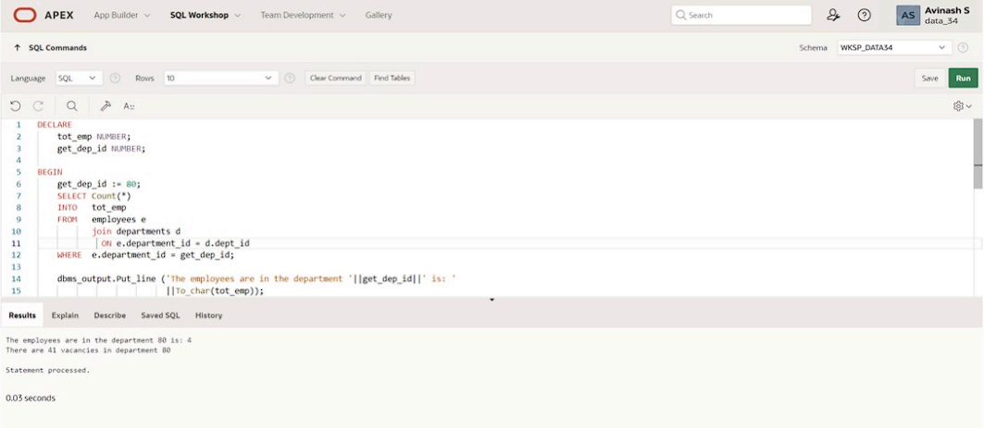

PROGRAM 11

Write a PL/SQL program to display the employee IDs, names, job titles, hire dates, and salaries of all employees.

**QUERY:**

DECLARE

v_employee_id employees.employee_id%TYPE;

v_full_name employees.first_name%TYPE;

v_job_id employees.job_id%TYPE;

v_hire_date employees.hire_date%TYPE;

v_salary employees.salary%TYPE;

CURSOR c_employees IS

SELECT employee_id, first_name || ' ' || last_name AS full_name, job_id, hire_date, salary

FROM employees;

BEGIN

DBMS_OUTPUT.PUT_LINE('Employee ID | Full Name | Job Title | Hire Date | Salary');

DBMS_OUTPUT.PUT_LINE('-------------------------------------------------------------------');

OPEN c_employees;

FETCH c_employees INTO v_employee_id, v_full_name, v_job_id, v_hire_date, v_salary;

WHILE c_employees%FOUND LOOP

DBMS_OUTPUT.PUT_LINE(v_employee_id || ' | ' || v_full_name || ' | ' || v_job_id || ' | ' || v_hire_date || ' | ' || v_salary);

FETCH c_employees INTO v_employee_id, v_full_name, v_job_id, v_hire_date, v_salary;

END LOOP;

CLOSE c_employees;

END;

/

**OUTPUT:**

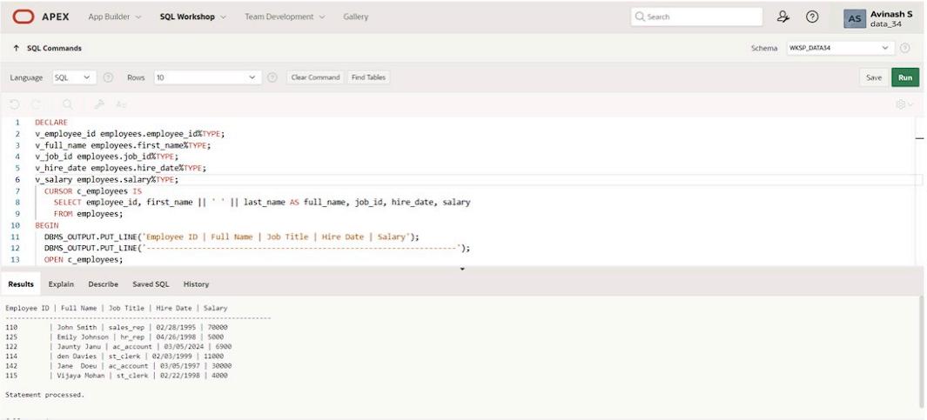

PROGRAM 12

Write a PL/SQL program to display the employee IDs, names, and department names of all employees.

**QUERY:**

DECLARE

CURSOR emp_cursor IS

SELECT e.employee_id, e.first_name, m.first_name AS manager_name

FROM employees e

LEFT JOIN employees m ON e.manager_id = m.employee_id;

emp_record emp_cursor%ROWTYPE;

BEGIN

OPEN emp_cursor;

FETCH emp_cursor INTO emp_record;

WHILE emp_cursor%FOUND LOOP

DBMS_OUTPUT.PUT_LINE('Employee ID: ' || emp_record.employee_id);

DBMS_OUTPUT.PUT_LINE('Employee Name: ' || emp_record.first_name);

DBMS_OUTPUT.PUT_LINE('Manager Name: ' || emp_record.manager_name);

DBMS_OUTPUT.PUT_LINE('-------------------------');

FETCH emp_cursor INTO emp_record;

END LOOP;

CLOSE emp_cursor;

END;

/

**OUTPUT:**

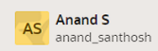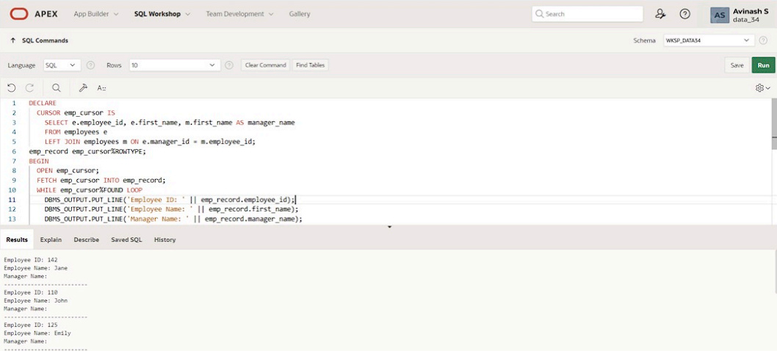

PROGRAM 13

Write a PL/SQL program to display the job IDs, titles, and minimum salaries of all jobs.

**QUERY:**

DECLARE

CURSOR job_cursor IS

SELECT e.job_id, j.lowest_sal

FROM job_grade j,employees e;

job_record job_cursor%ROWTYPE;

BEGIN

OPEN job_cursor;

FETCH job_cursor INTO job_record;

WHILE job_cursor%FOUND LOOP

DBMS_OUTPUT.PUT_LINE('Job ID: ' || job_record.job_id);

DBMS_OUTPUT.PUT_LINE('Minimum Salary: ' || job_record.lowest_sal);

DBMS_OUTPUT.PUT_LINE('-------------------------');

FETCH job_cursor INTO job_record;

END LOOP;

CLOSE job_cursor;

END;

/

**OUTPUT:**

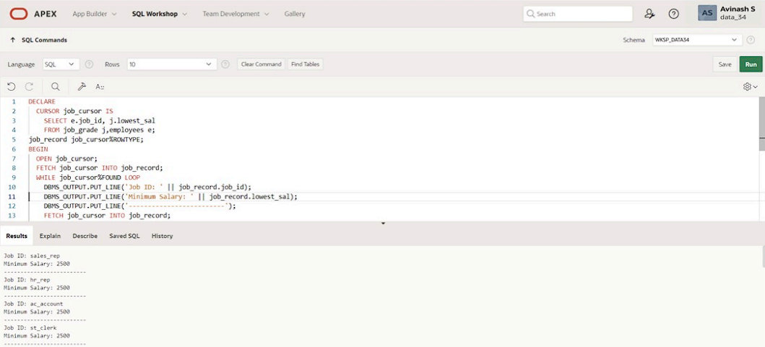

PROGRAM 15

Write a PL/SQL program to display the employee IDs, names, and job history end dates of all employees.

**QUERY:**

DECLARE

CURSOR employees_cur IS

SELECT employee_id,last_name, job_id,start_date

FROM employees NATURAL join job_history;

emp_start_date DATE;

BEGIN

dbms_output.Put_line(Rpad('Employee ID', 15)||Rpad('Last Name', 25)|| Rpad('Job Id', 35) ||'Start Date');

dbms_output.Put_line('-----------------------------------------------------------------------------------------');

FOR emp_sal_rec IN employees_cur LOOP

-- find out most recent end_date in job_history

SELECT Max(end_date) + 1

INTO emp_start_date

FROM job_history

WHERE employee_id = emp_sal_rec.employee_id;

IF emp_start_date IS NULL THEN

emp_start_date := emp_sal_rec.start_date;

END IF;

dbms_output.Put_line(Rpad(emp_sal_rec.employee_id, 15)

||Rpad(emp_sal_rec.last_name, 25)

|| Rpad(emp_sal_rec.job_id, 35)

|| To_char(emp_start_date, 'dd-mon-yyyy'));

END LOOP;

END;

/

**OUTPUT:**

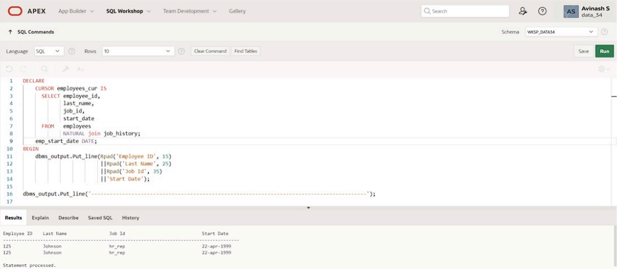

|  |  |
| --- | --- |
| **Evaluation Procedure** | **Marks awarded** |
| **PL/SQL Procedure(5)** |  |
| **Program/Execution (5)** |  |
| **Viva(5)** |  |
| **Total (15)** |  |
| **Faculty Signature** |  |

**PROCEDURES AND FUNCTIONS**

**EX.NO:17 DATE: 21 – 5 - 24**

**REG.NO: 220701306**

**Program 1**

**FACTORIAL OF A NUMBER USING FUNCTION**

**QUERY:**

DECLARE

fac NUMBER := 1;

n NUMBER := :1;

BEGIN

WHILE n > 0 LOOP

fac := n * fac;

n := n - 1;

END LOOP;

DBMS_OUTPUT.PUT_LINE(fac);

END;

**OUTPUT:**



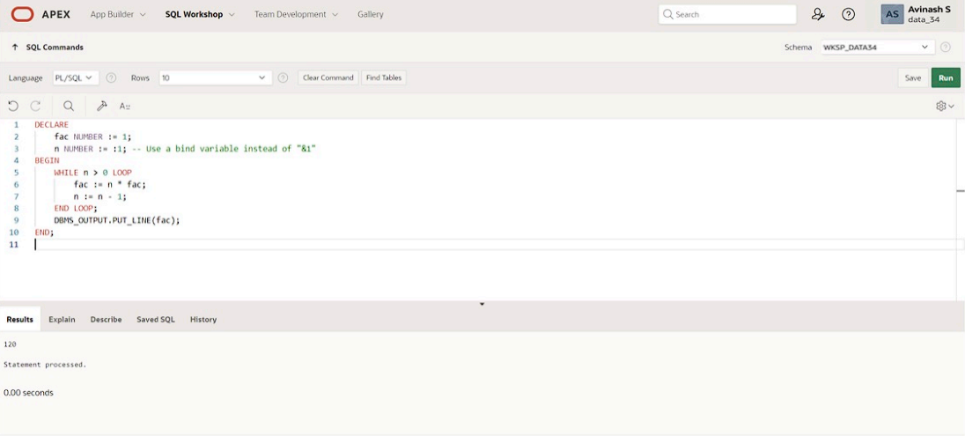

**Program 2**

**Write a PL/SQL program using Procedures IN,INOUT,OUT parameters to retrieve the corresponding book information in library**

**QUERY:**

CREATE OR REPLACE PROCEDURE get_book_info (

p_book_id IN NUMBER,

p_title IN OUT VARCHAR2,

p_author OUT VARCHAR2,

p_year_published OUT NUMBER

)

AS

BEGIN

SELECT title, author, year_published INTO p_title, p_author, p_year_published

FROM books

WHERE book_id = p_book_id;

p_title := p_title || ' - Retrieved';

EXCEPTION

WHEN NO_DATA_FOUND THEN

p_title := NULL;

p_author := NULL;

p_year_published := NULL;

END;

DECLARE

v_book_id NUMBER := 1;

v_title VARCHAR2(100);

v_author VARCHAR2(100);

v_year_published NUMBER;

BEGIN

v_title := 'Initial Title';

get_book_info(p_book_id => v_book_id, p_title => v_title, p_author => v_author, p_year_published => v_year_published);

DBMS_OUTPUT.PUT_LINE('Title: ' || v_title);

DBMS_OUTPUT.PUT_LINE('Author: ' || v_author);

DBMS_OUTPUT.PUT_LINE('Year Published: ' || v_year_published);

END;

/

**OUTPUT:**

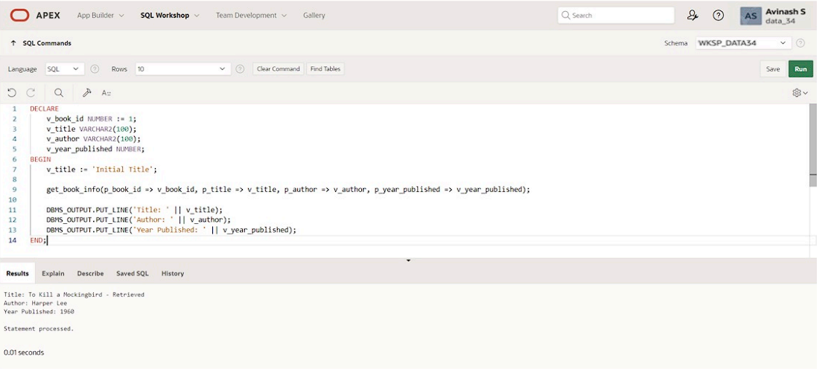

|  |  |
| --- | --- |
| **Evaluation Procedure** | **Marks awarded** |
| **PL/SQL Procedure(5)** |  |
| **Program/Execution (5)** |  |
| **Viva(5)** |  |
| **Total (15)** |  |
| **Faculty Signature** |  |

**TRIGGER**

**EX.NO:18 DATE: 21 – 5 - 24**

**REG.NO: 220701306**

Program 1

Write a code in PL/SQL to develop a trigger that enforces referential integrity by preventing the deletion of a parent record if child records exist.

**QUERY:**

CREATE OR REPLACE TRIGGER prevent_parent_deletion

BEFORE DELETE ON parent_table

FOR EACH ROW

DECLARE

child_exists EXCEPTION;

PRAGMA EXCEPTION_INIT(child_exists, -20001);

v_child_count NUMBER;

BEGIN

SELECT COUNT(*) INTO v_child_count FROM child_table WHERE parent_id = :OLD.parent_id;

IF v_child_count > 0 THEN

RAISE child_exists;

END IF;

EXCEPTION

WHEN child_exists THEN

RAISE_APPLICATION_ERROR(-20001, 'Cannot delete parent record while child records exist.');

END;

**OUTPUT:**

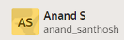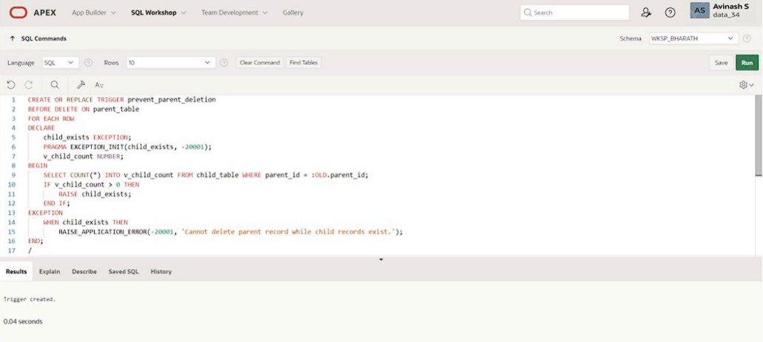

Program 2

Write a code in PL/SQL to create a trigger that checks for duplicate values in a specific column and raises an exception if found.

**QUERY:**

CREATE OR REPLACE TRIGGER check_duplicates

BEFORE INSERT OR UPDATE ON unique_values_table

FOR EACH ROW

DECLARE

duplicate_found EXCEPTION;

PRAGMA EXCEPTION_INIT(duplicate_found, -20002);

v_count NUMBER;

BEGIN

SELECT COUNT(*) INTO v_count FROM unique_values_table

WHERE unique_col = :NEW.unique_col AND id != :NEW.id;

IF v_count > 0 THEN

RAISE duplicate_found;

END IF;

EXCEPTION

WHEN duplicate_found THEN

RAISE_APPLICATION_ERROR(-20002, 'Duplicate value found in unique_col.');

END;

**OUTPUT:**



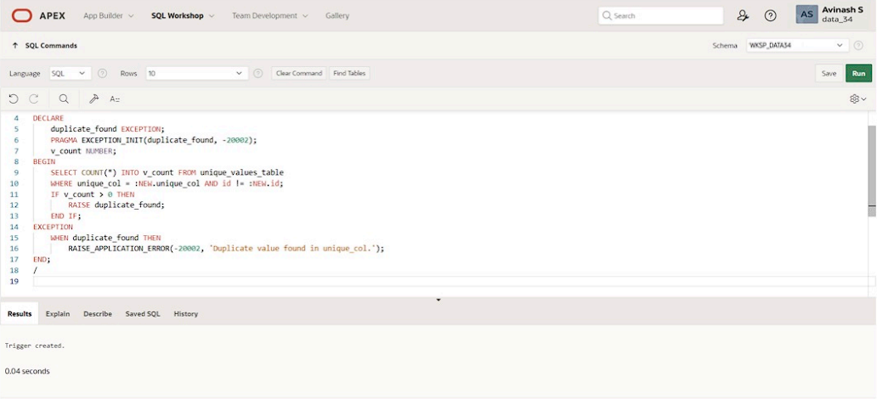

Program 3

Write a code in PL/SQL to create a trigger that restricts the insertion of new rows if the total of a column's values exceeds a certain threshold.

**QUERY:**

CREATE OR REPLACE TRIGGER check_threshold

BEFORE INSERT OR UPDATE ON threshold_table

FOR EACH ROW

DECLARE

threshold_exceeded EXCEPTION;

PRAGMA EXCEPTION_INIT(threshold_exceeded, -20003);

v_sum NUMBER;

v_threshold NUMBER := 10000; -- Set your threshold here

BEGIN

SELECT SUM(value_col) INTO v_sum FROM threshold_table;

v_sum := v_sum + :NEW.value_col;

IF v_sum > v_threshold THEN

RAISE threshold_exceeded;

END IF;

EXCEPTION

WHEN threshold_exceeded THEN

RAISE_APPLICATION_ERROR(-20003, 'Threshold exceeded for value_col.');

END;

**OUTPUT:**

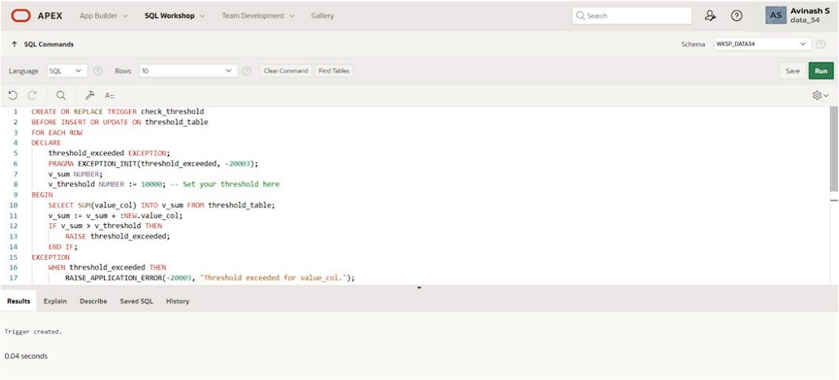

Program 4

Write a code in PL/SQL to design a trigger that captures changes made to specific columns and logs them in an audit table.

**QUERY:**

CREATE OR REPLACE TRIGGER log_changes

AFTER UPDATE ON main_table

FOR EACH ROW

BEGIN

INSERT INTO audit_table (audit_id, changed_id, old_col1, new_col1, old_col2, new_col2, change_time)

VALUES (audit_seq.NEXTVAL, :OLD.id, :OLD.col1, :NEW.col1, :OLD.col2, :NEW.col2, SYSTIMESTAMP);

END;

**OUTPUT:**

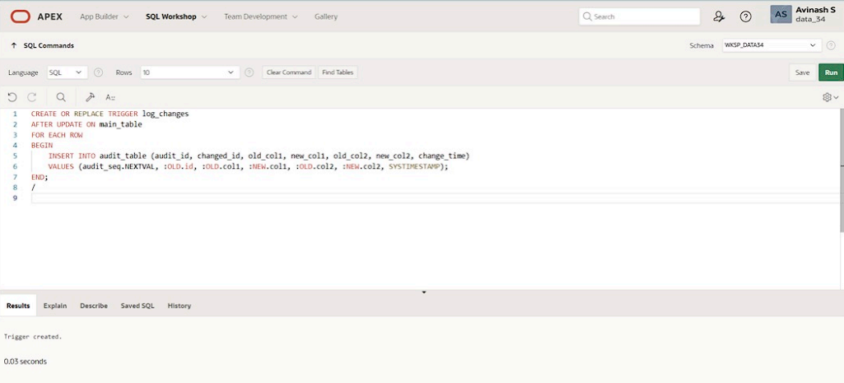

Program 5

Write a code in PL/SQL to implement a trigger that records user activity (inserts, updates, deletes) in an audit log for a given set of tables.

**QUERY:**

CREATE OR REPLACE TRIGGER log_user_activity

AFTER INSERT OR UPDATE OR DELETE ON activity_table

FOR EACH ROW

BEGIN

IF INSERTING THEN

INSERT INTO user_activity_log (log_id, action, table_name, record_id, change_time)

VALUES (activity_log_seq.NEXTVAL, 'INSERT', 'activity_table', :NEW.id, SYSTIMESTAMP);

ELSIF UPDATING THEN

INSERT INTO user_activity_log (log_id, action, table_name, record_id, change_time)

VALUES (activity_log_seq.NEXTVAL, 'UPDATE', 'activity_table', :NEW.id, SYSTIMESTAMP);

ELSIF DELETING THEN

INSERT INTO user_activity_log (log_id, action, table_name, record_id, change_time)

VALUES (activity_log_seq.NEXTVAL, 'DELETE', 'activity_table', :OLD.id, SYSTIMESTAMP);

END IF;

END;

**OUTPUT:**

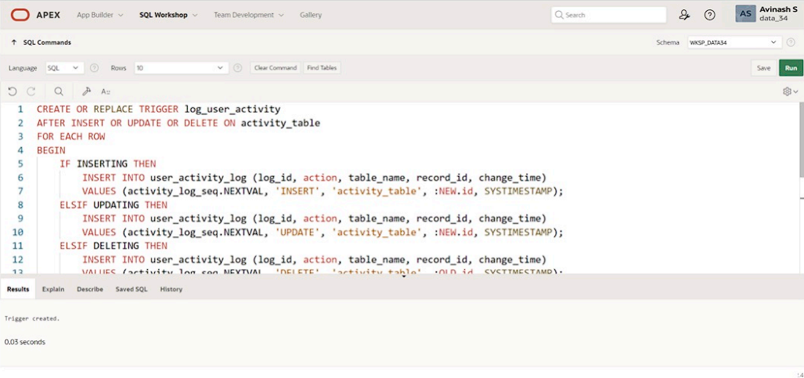

Program 6

Write a code in PL/SQL to implement a trigger that automatically calculates and updates a running total column for a table whenever new rows are inserted.

**QUERY:**

CREATE OR REPLACE TRIGGER update_running_total

BEFORE INSERT ON running_total_table

FOR EACH ROW

DECLARE

v_total NUMBER;

BEGIN

SELECT NVL(SUM(amount), 0) INTO v_total FROM running_total_table;

:NEW.running_total := v_total + :NEW.amount;

END;

**OUTPUT:**



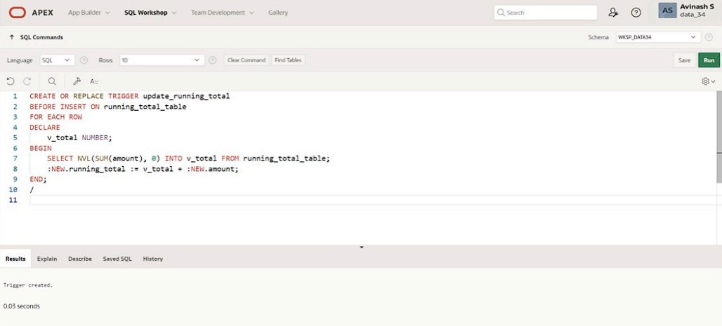

Program 7

Write a code in PL/SQL to create a trigger that validates the availability of items before allowing an order to be placed, considering stock levels and pending orders

**QUERY:**

CREATE OR REPLACE TRIGGER validate_order

BEFORE INSERT ON orders

FOR EACH ROW

DECLARE

v_stock NUMBER;

insufficient_stock EXCEPTION;

PRAGMA EXCEPTION_INIT(insufficient_stock, -20004);

BEGIN

SELECT stock_quantity INTO v_stock FROM items WHERE item_id = :NEW.item_id;

IF v_stock < :NEW.order_quantity THEN

RAISE insufficient_stock;

END IF;

UPDATE items SET stock_quantity = stock_quantity - :NEW.order_quantity WHERE item_id = :NEW.item_id;

EXCEPTION

WHEN insufficient_stock THEN

RAISE_APPLICATION_ERROR(-20004, 'Insufficient stock for the item.');

END;

**OUTPUT:**

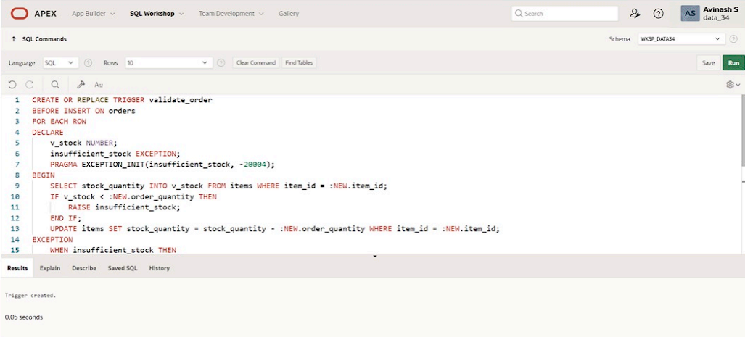

|  |  |
| --- | --- |
| **Evaluation Procedure** | **Marks awarded** |
| **PL/SQL Procedure(5)** |  |
| **Program/Execution (5)** |  |
| **Viva(5)** |  |
| **Total (15)** |  |
| **Faculty Signature** |  |

**MONGO DB**

**EX.NO:19 DATE: 24 – 5 - 24**

**REG.NO: 220701306**

**1.)**Write a MongoDB query to find the restaurant Id, name, borough and cuisine for those restaurants which prepared dish except 'American' and 'Chinees' or restaurant's name begins with letter 'Wil'.

**QUERY:**

db.restaurants.find( { $or: [{ name: /^Wil/ }, { cuisine: { $nin: ['American', 'Chinese'] } } ] , { restaurant_id: 1, name: 1, borough: 1, cuisine: 1 });

**OUTPUT:**

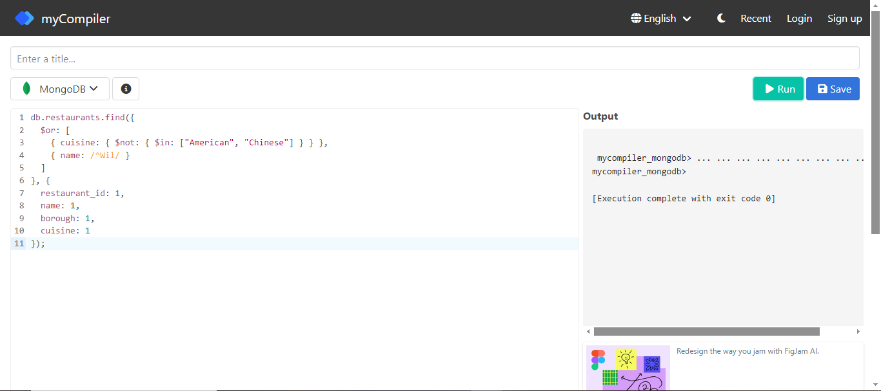

**2.)**Write a MongoDB query to find the restaurant Id, name, and grades for those restaurants which achieved a grade of "A" and scored 11 on an ISODate "2014-08- 11T00:00:00Z" among many of survey dates.

**QUERY:**

db.restaurants.find( { grades: { $elemMatch: { grade: "A",score: 11, date: ISODate("2014-08-11T00:00:00Z")} }},{ restaurant_id: 1,name: 1,grades: 1 });

**OUTPUT:**

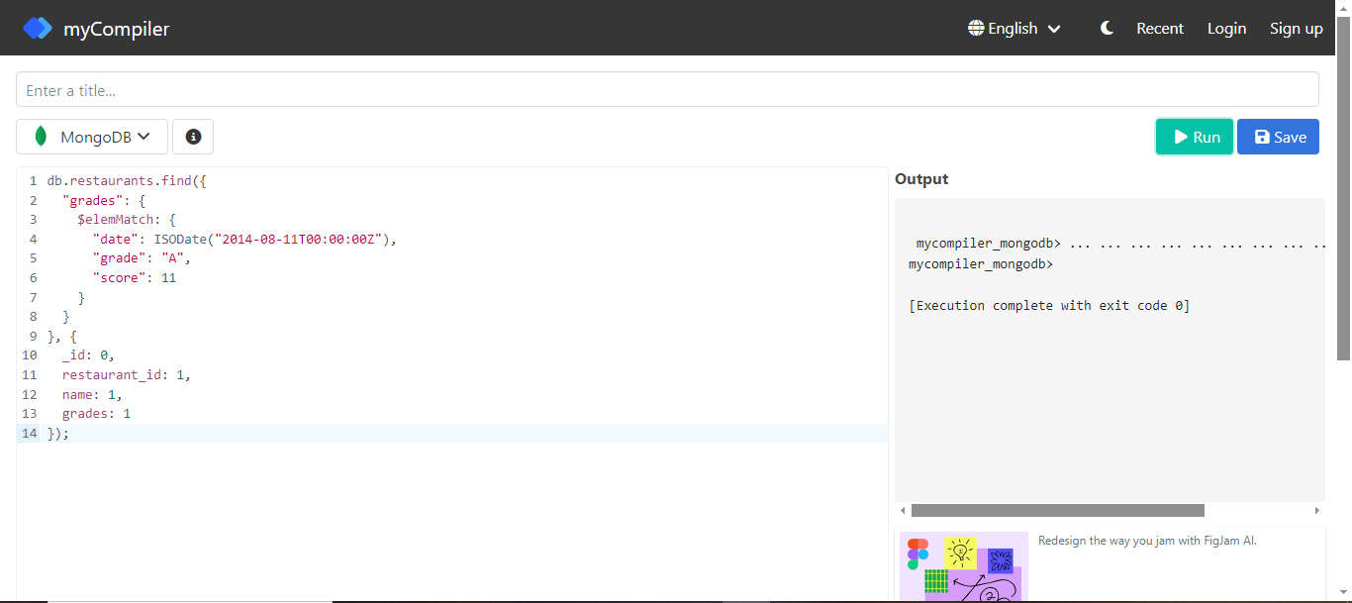

**3.)**Write a MongoDB query to find the restaurant Id, name and grades for those restaurants where the 2nd element of grades array contains a grade of "A" and score 9 on an ISODate "2014-08-11T00:00:00Z".

**QUERY:**

db.restaurants.find( {"grades.1.grade": "A", "grades.1.score": 9, "grades.1.date": ISODate("2014-08-1T00:00:00Z") },{ restaurant_id: 1, name: 1, grades: 1 });

**OUTPUT:**

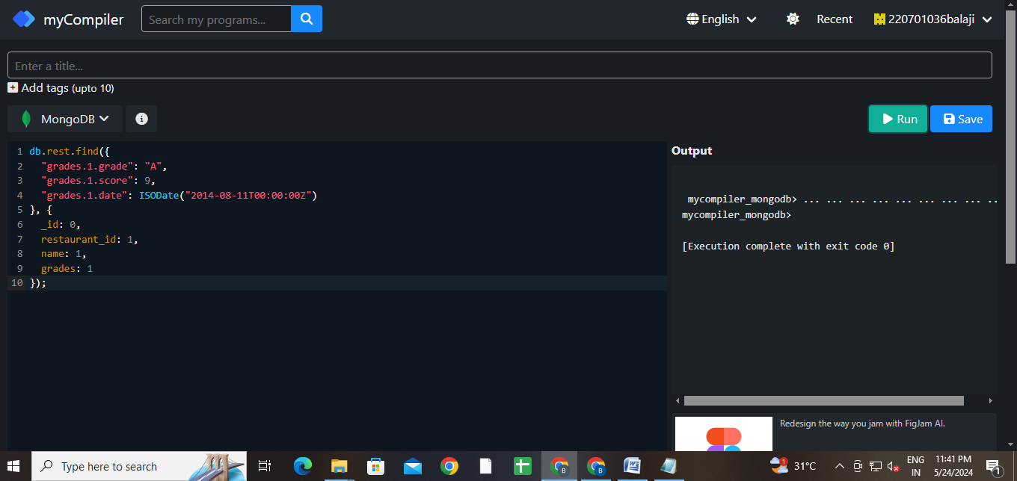

**4.)**Write a MongoDB query to find the restaurant Id, name, address and geographical location for those restaurants where 2nd element of coord array contains a value which is more than 42 and upto 52

**QUERY:**

db.restaurants.find({$and : [{"address.coord.1": {$gt : 42}},{"address.coord.1": {$lte : 52}}]}, {_id:0, restaurant_id:1, name:1, address:1})

**OUTPUT:**

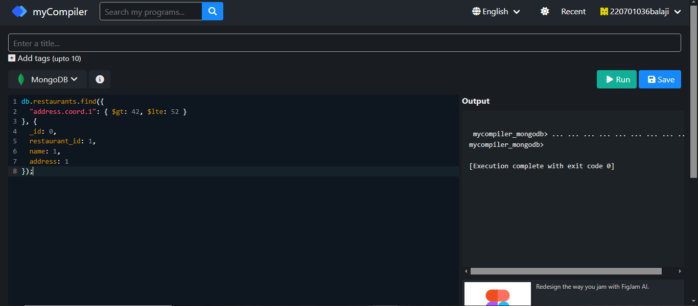

**5.)**Write a MongoDB query to arrange the name of the restaurants in ascending order along with all the columns.

**QUERY:**

db.restaurants.find({}, { _id: 0 }).sort({ name: 1 });

**OUTPUT:**

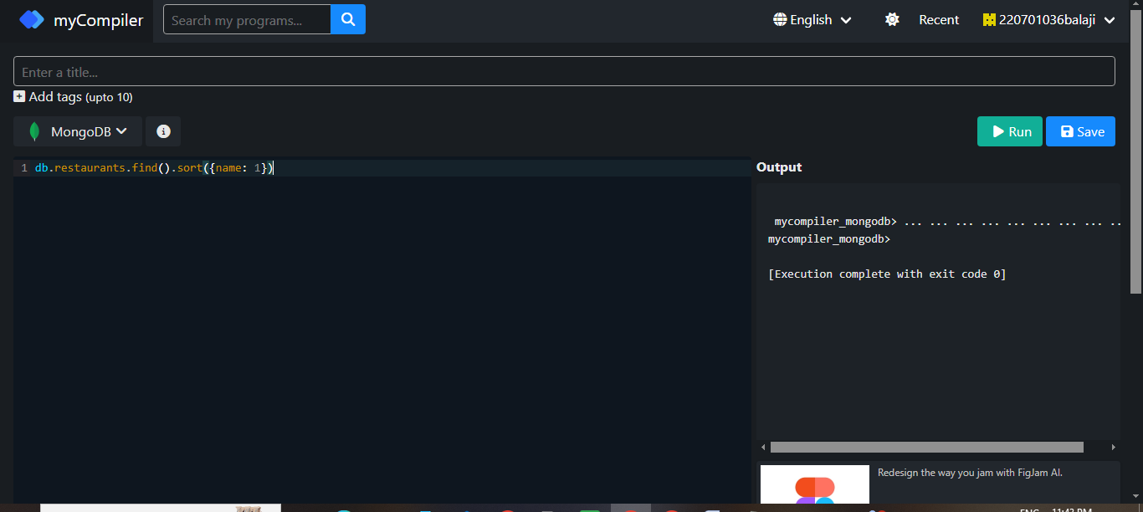

**6.)**Write a MongoDB query to arrange the name of the restaurants in descending along with all the columns.

**QUERY:**

db.restaurants.find({}, { _id: 0 }).sort({ name: -1 })

**OUTPUT:**

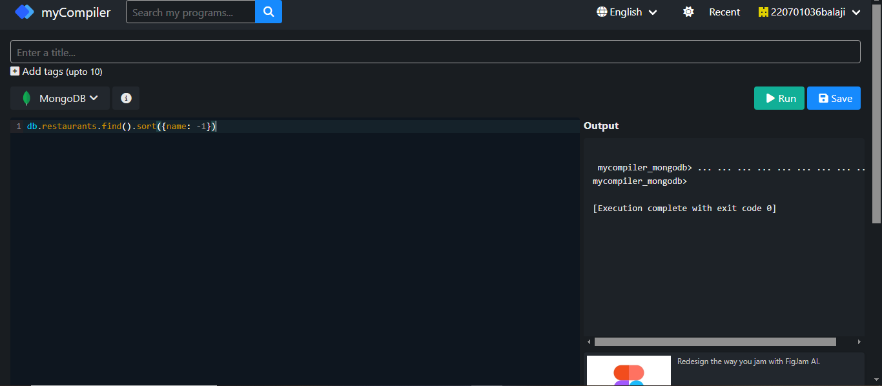

**7.)**Write a MongoDB query to arranged the name of the cuisine in ascending order and for that same cuisine borough should be in descending order.

**QUERY:**

db.restaurants.find({}, { _id: 0 }).sort({ cuisine: 1, borough: -1 })

**OUTPUT:**

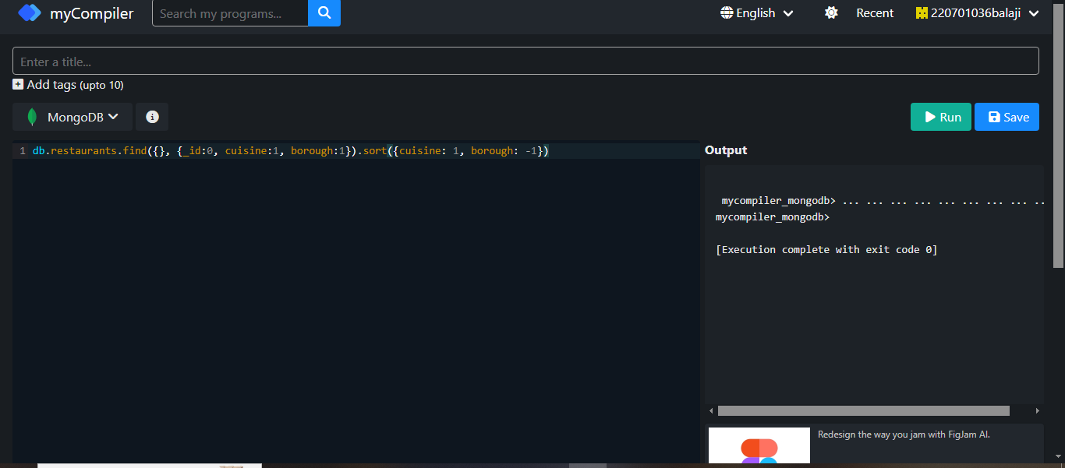

**8.)**Write a MongoDB query to know whether all the addresses contains the street or not.

**QUERY:**

db.restaurants.find({ "address.street": { $exists: true, $ne: "" } })

**OUTPUT:**

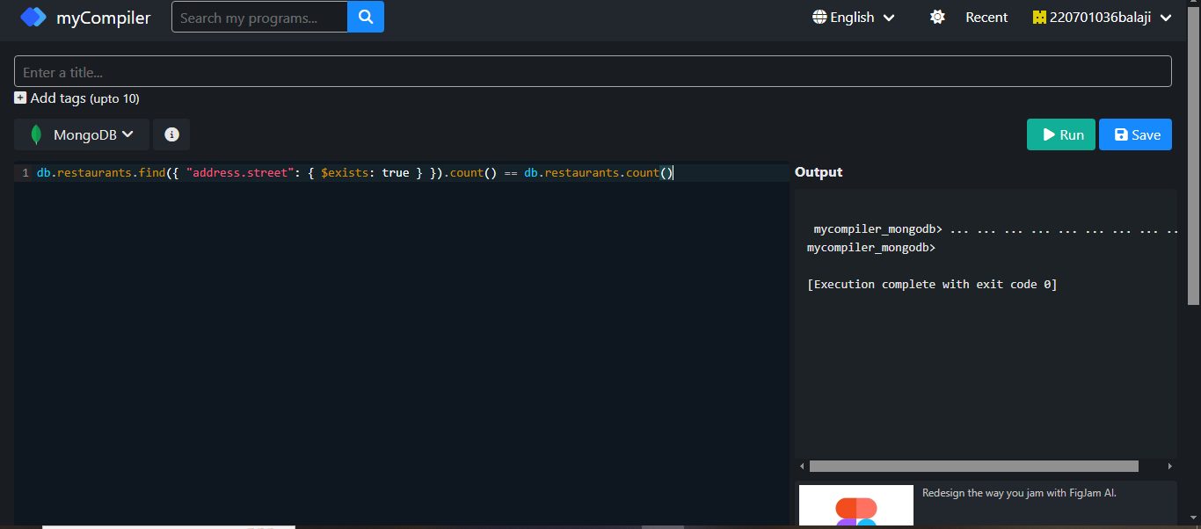

**9.)**Write a MongoDB query which will select all documents in the restaurants collection where the coord field value is Double.

**QUERY:**

db.restaurants.find({ "address.coord": { $elemMatch: { $type: "double" } } })

**OUTPUT:**

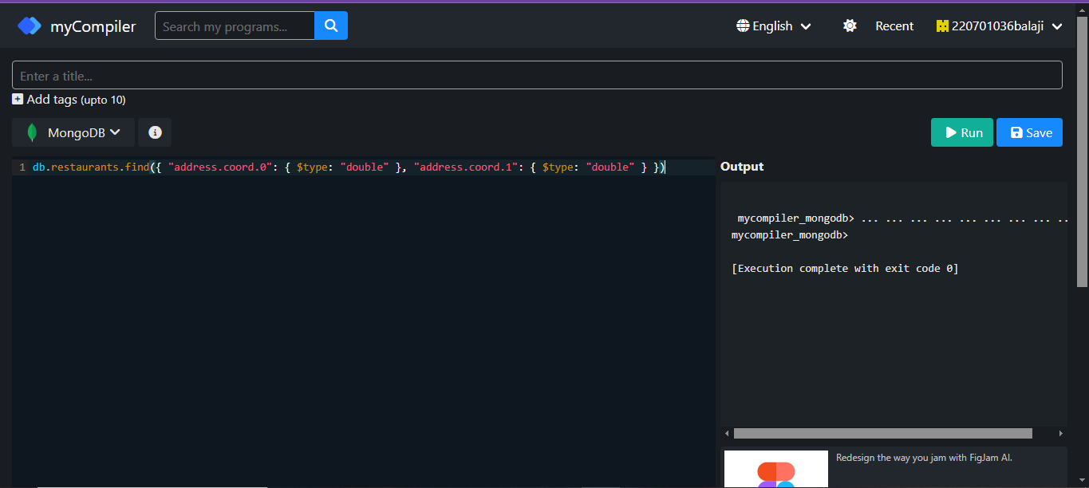

10. Write a MongoDB query which will select the restaurant Id, name and grades for those restaurants which returns 0 as a remainder after dividing the score by 7.

**QUERY:**

db.restaurants.find({ "grades.score": { $mod: [7, 0] } }, { restaurant_id: 1, name: 1, grades: 1 });

**OUTPUT:**

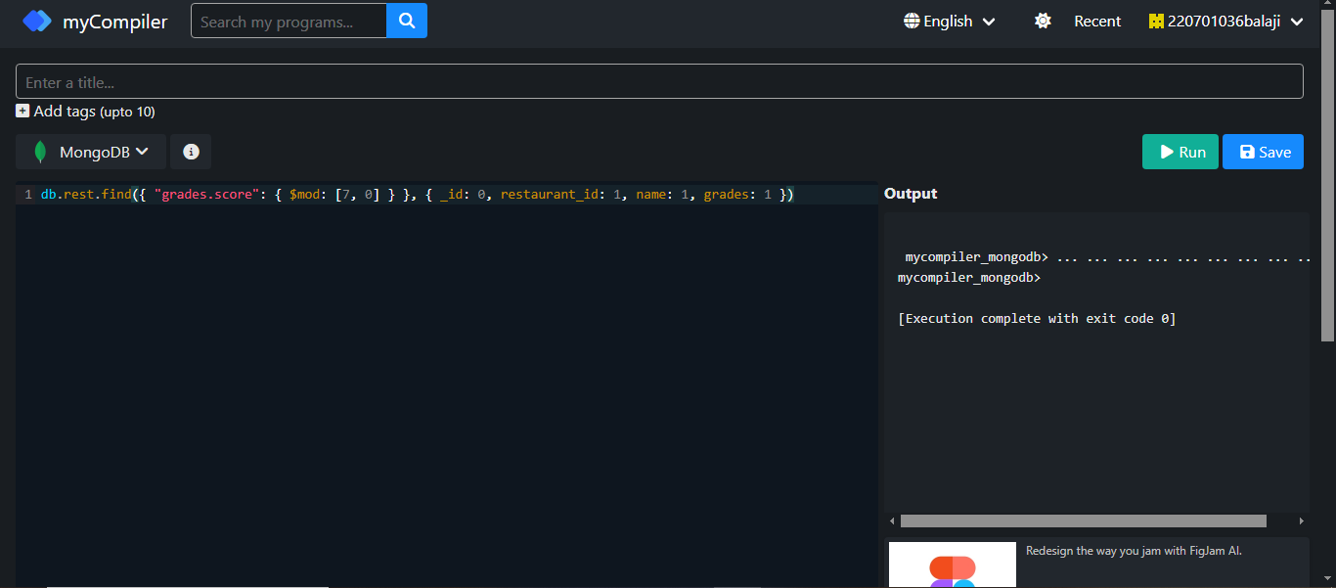

11. Write a MongoDB query to find the restaurant name, borough, longitude and attitude and cuisine for those restaurants which contains 'mon' as three letters somewhere in its name.

**QUERY:**

db.restaurants.find({ name: /mon/i }, { name: 1, borough: 1, "address.coord": 1, cuisine: 1 })

**OUTPUT:**

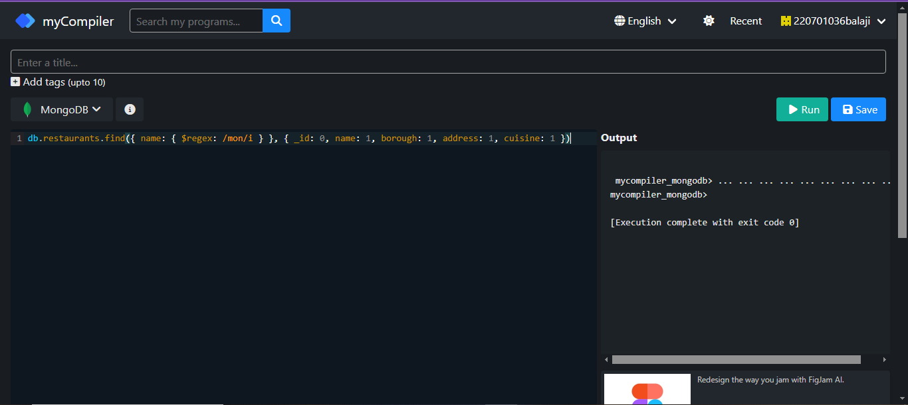

12. Write a MongoDB query to find the restaurant name, borough, longitude and latitude and cuisine for those restaurants which contain 'Mad' as first three letters of its name.

**QUERY:**

db.restaurants.find({ name: /^Mad/i }, { name: 1, borough: 1, "address.coord": 1, cuisine: 1 })

**OUTPUT:**

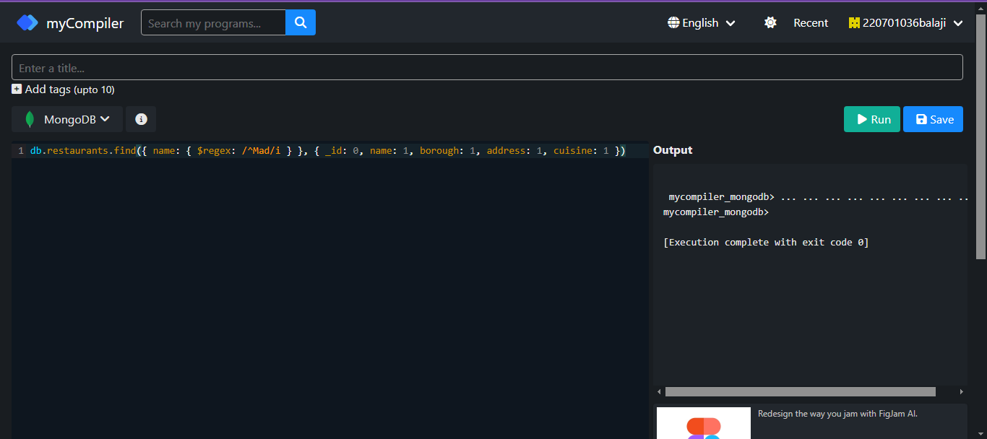

13. Write a MongoDB query to find the restaurants that have at least one grade with a score of less than 5.

**QUERY:**

db.restaurants.find({ "grades": { $elemMatch: { "score": { $lt: 5 } } } })

**OUTPUT:**

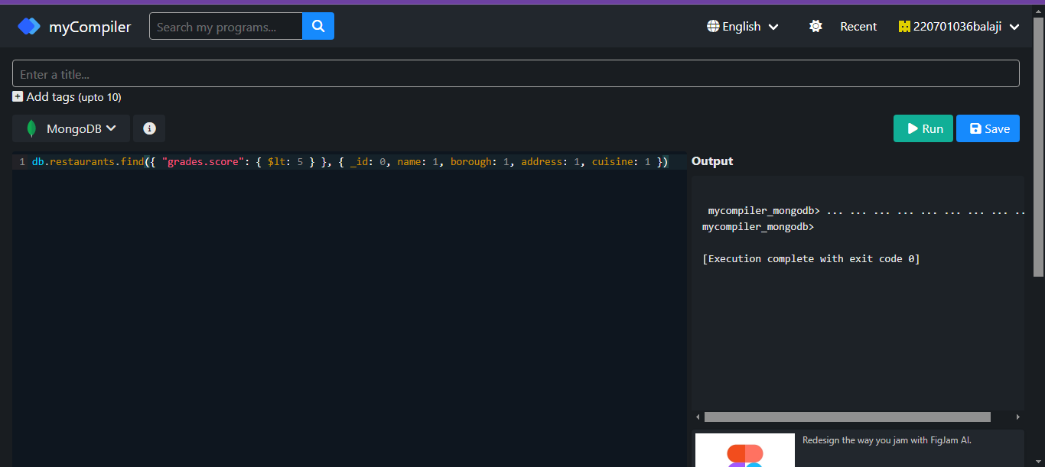

14. Write a MongoDB query to find the restaurants that have at least one grade with a score of less than 5 and that are located in the borough of Manhattan.

**QUERY:**

db.restaurants.find({ "grades": { $elemMatch: { "score": { $lt: 5 } } }, "borough": "Manhattan" })

**OUTPUT:**

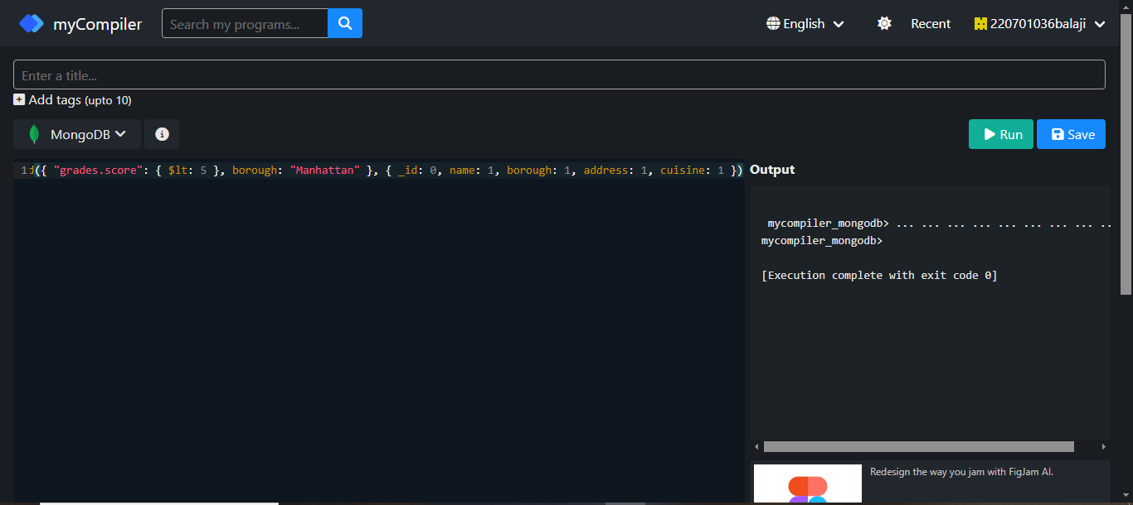

15.Write a MongoDB query to find the restaurants that have at least one grade with a score of less than 5 and that are located in the borough of Manhattan or Brooklyn.

**QUERY:**

db.restaurants.find({ "grades": { $elemMatch: { "score": { $lt: 5 } } }, $or: [{ "borough": "Manhattan" }, { "borough": "Brooklyn" }] })

**OUTPUT:**

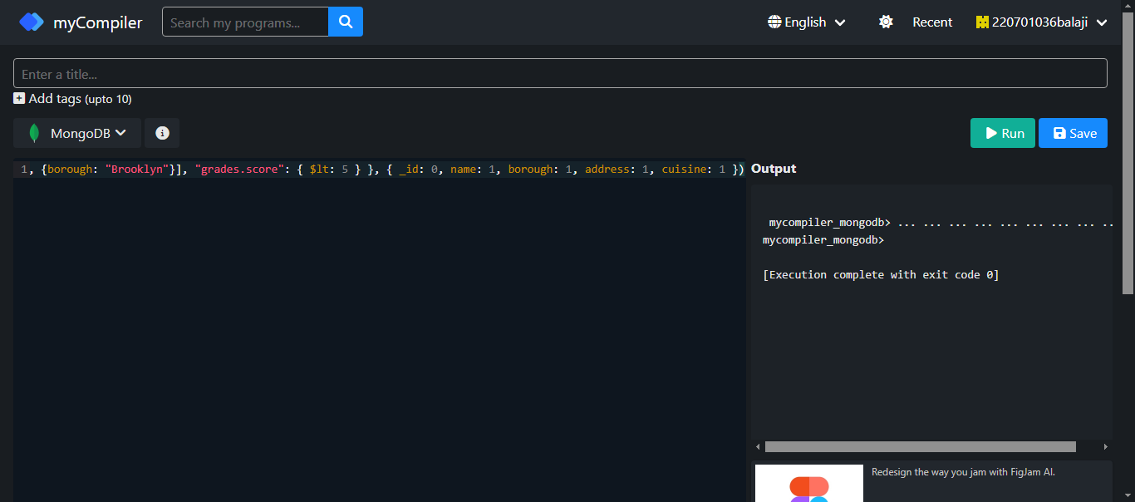

16. Write a MongoDB query to find the restaurants that have at least one grade with a score of less than 5 and that are located in the borough of Manhattan or Brooklyn, and their cuisine is not American.

**QUERY:**

db.restaurants.find({ "grades": { $elemMatch: { "score": { $lt: 5 } } }, $or: [{ "borough": "Manhattan" }, { "borough": "Brooklyn" }], "cuisine": { $ne: "American" } })

**OUTPUT:**

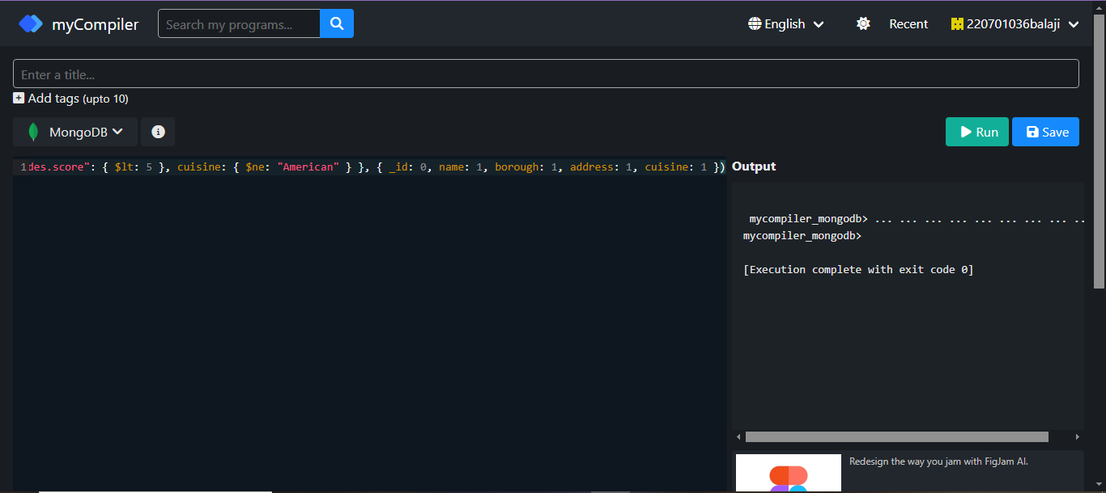

17. Write a MongoDB query to find the restaurants that have at least one grade with a score of less than 5 and that are located in the borough of Manhattan or Brooklyn, and their cuisine is not American or Chinese.

**QUERY:**

db.restaurants.find({ "grades": { $elemMatch: { "score": { $lt: 5 } } }, $or: [{ "borough": "Manhattan" }, { "borough": "Brooklyn" }], "cuisine": { $nin: ["American", "Chinese"] } })

**OUTPUT:**

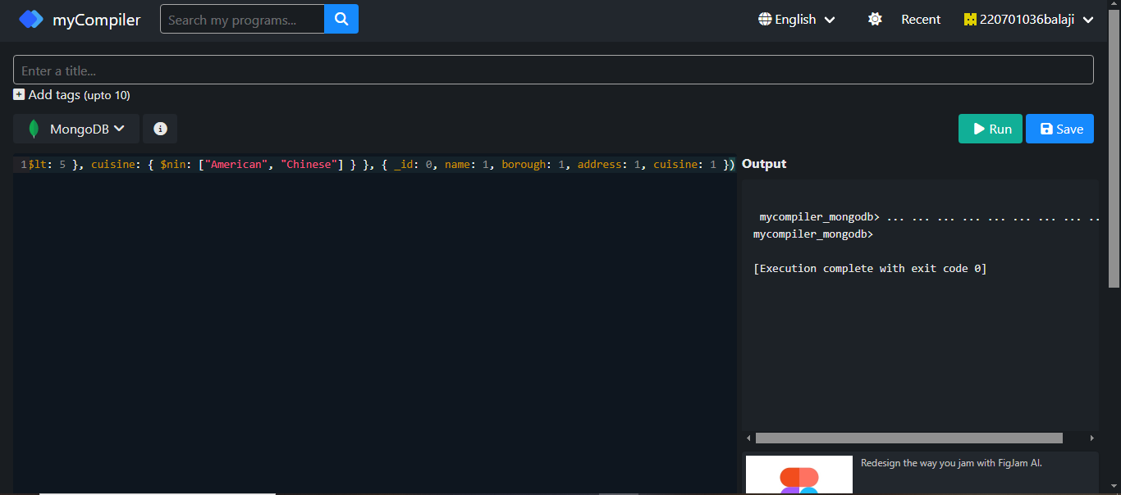

18. Write a MongoDB query to find the restaurants that have a grade with a score of 2 and a grade with a score of 6.

**QUERY:**

db.restaurants.find({ $and: [{ "grades.grade": "A", "grades.score": 2 }, { "grades.grade": "A", "grades.score": 6 }] })

**OUTPUT:**

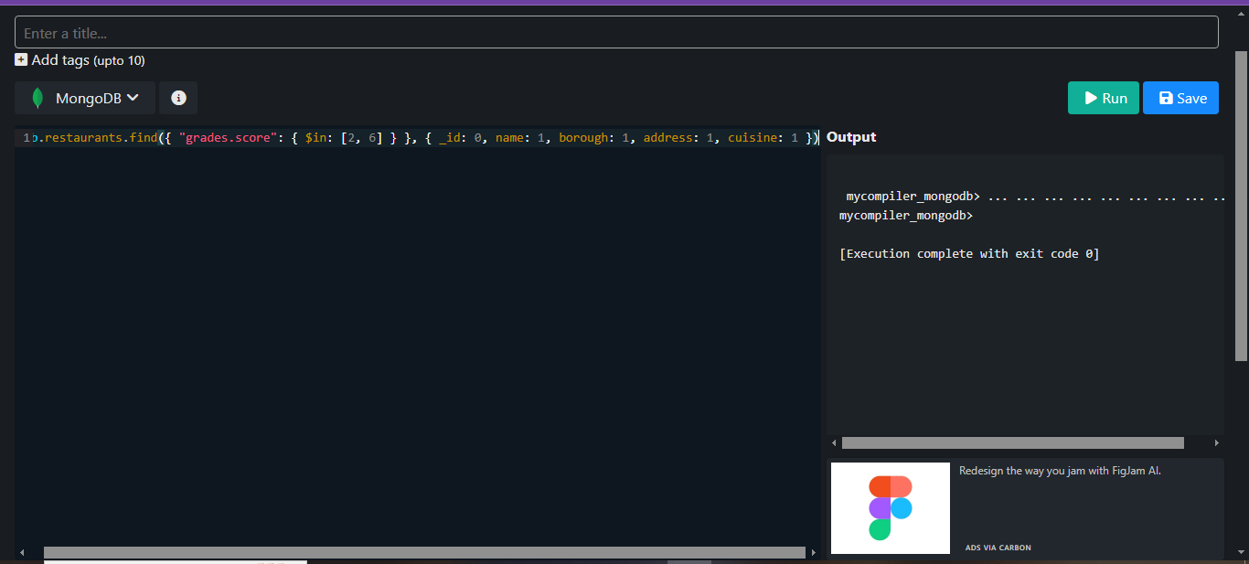

19. Write a MongoDB query to find the restaurants that have a grade with a score of 2 and a grade with a score of 6 and are located in the borough of Manhattan.

**QUERY:**

db.restaurants.find({ $and: [{ "grades.grade": "A", "grades.score": 2 }, { "grades.grade": "A", "grades.score": 6 }], "borough": "Manhattan" })

**OUTPUT:**

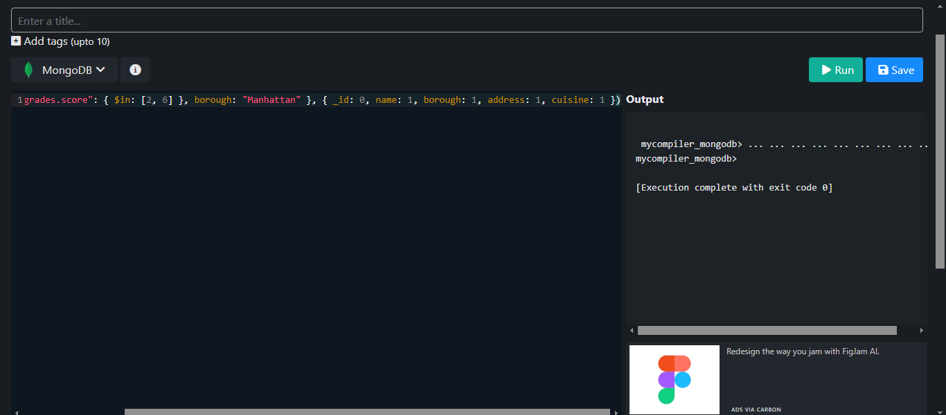

20. Write a MongoDB query to find the restaurants that have a grade with a score of 2 and a grade with a score of 6 and are located in the borough of Manhattan or Brooklyn.

**QUERY:**

db.restaurants.find({ $and: [{ "grades.grade": "A", "grades.score": 2 }, { "grades.grade": "A", "grades.score": 6 }], $or: [{ "borough": "Manhattan" }, { "borough": "Brooklyn" }] })

**OUTPUT:**

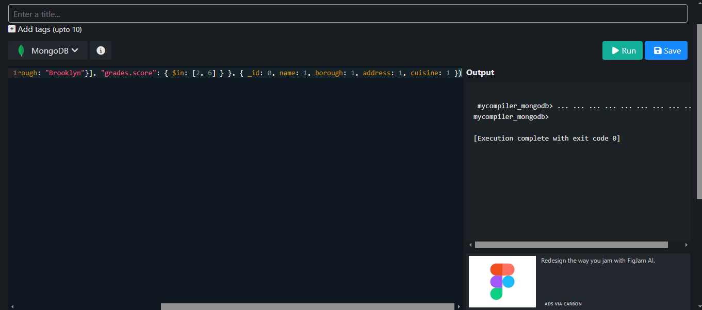

21. Write a MongoDB query to find the restaurants that have a grade with a score of 2 and a grade with a score of 6 and are located in the borough of Manhattan or Brooklyn, and their cuisine is not American.

**QUERY:**

db.restaurants.find({ $and: [{ "grades.grade": "A", "grades.score": 2 }, { "grades.grade": "A", "grades.score": 6 }], $or: [{ "borough": "Manhattan" }, { "borough": "Brooklyn" }], "cuisine": { $ne: "American" } })

**OUTPUT:**

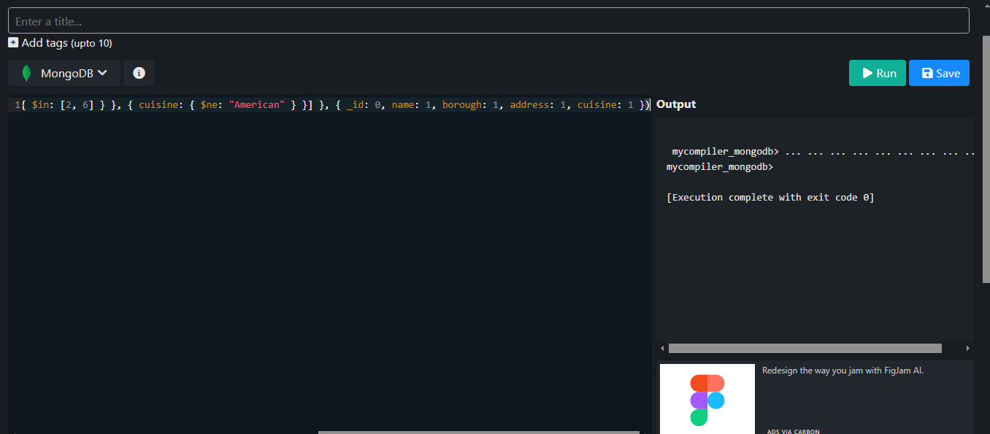

22. Write a MongoDB query to find the restaurants that have a grade with a score of 2 and a grade with a score of 6 and are located in the borough of Manhattan or Brooklyn, and their cuisine is not American or Chinese.

**QUERY:**

db.restaurants.find({ $and: [{ "grades.grade": "A", "grades.score": 2 }, { "grades.grade": "A", "grades.score": 6 }], $or: [{ "borough": "Manhattan" }, { "borough": "Brooklyn" }], "cuisine": { $nin: ["American", "Chinese"] } })

**OUTPUT:**

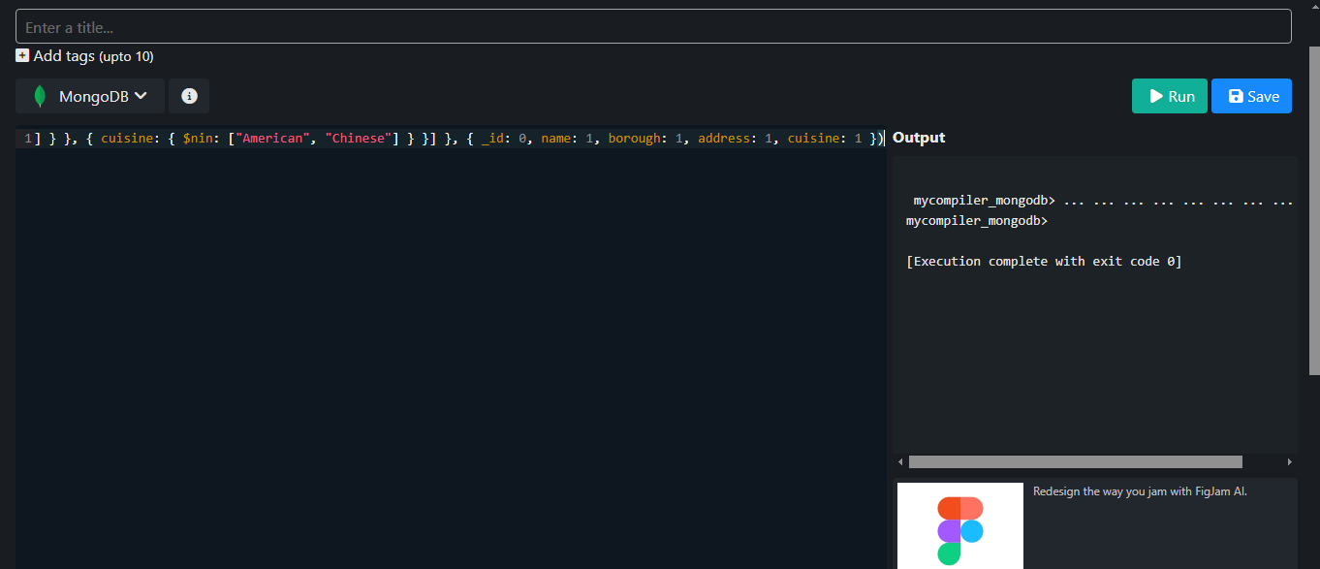

23. Write a MongoDB query to find the restaurants that have a grade with a score of 2 or a grade with a score of 6.

**QUERY:**

db.restaurants.find({ $or: [{ "grades.score": 2 }, { "grades.score": 6 }] })

**OUTPUT:**

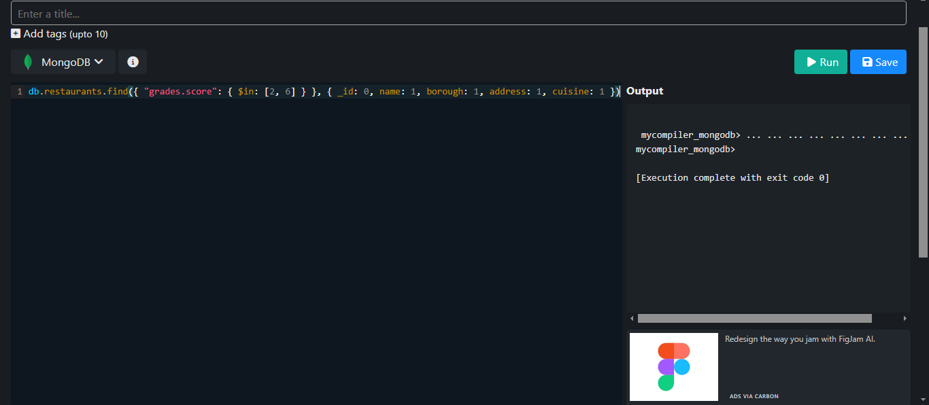

|  |  |
| --- | --- |
| Evaluation Procedure | Marks awarded |
| Query(5) |  |
| Execution (5) |  |
| Viva(5) |  |
| Total (15) |  |
| Faculty Signature |  |

**MONGO DB**

**EX.NO:20 DATE: 24 – 5 - 24**

**REG.NO: 220701306**

**1.)Find all movies with full information from the 'movies' collection that released in the year 1893.**

**QUERY:**

db.movies.find({ year: 1893 })

**OUTPUT:**

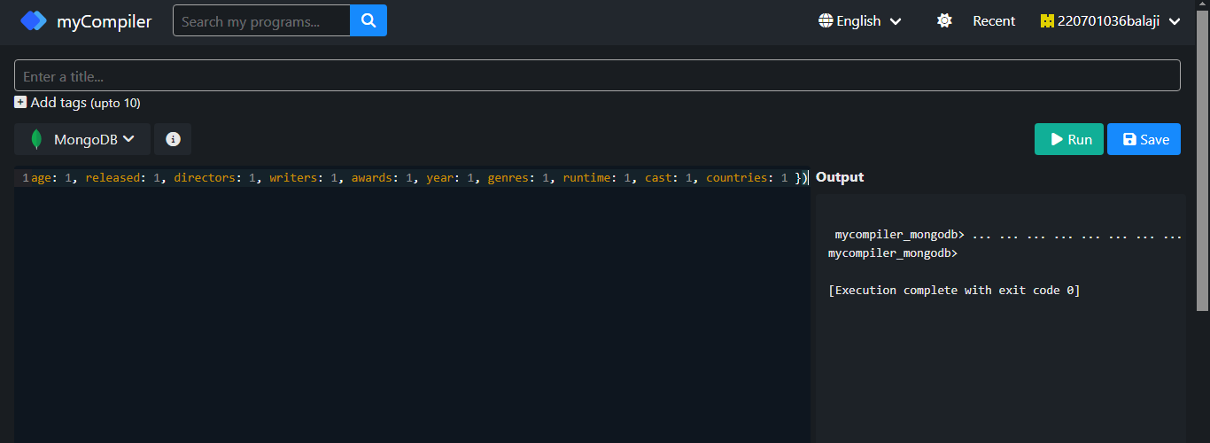

**2.)Find all movies with full information from the 'movies' collection that have a runtime greater than 120 minutes.**

**QUERY:**

db.movies.find({ runtime: { $gt: 120 } })

**OUTPUT:**

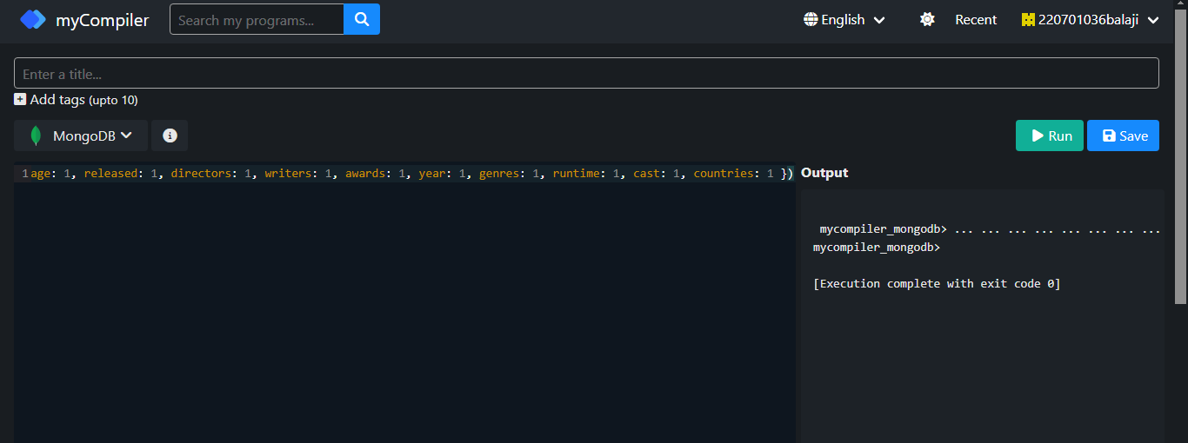

**3.)Find all movies with full information from the 'movies' collection that have "Short" genre.**

**QUERY:**

db.movies.find({ genres: 'Short' })

**OUTPUT:**

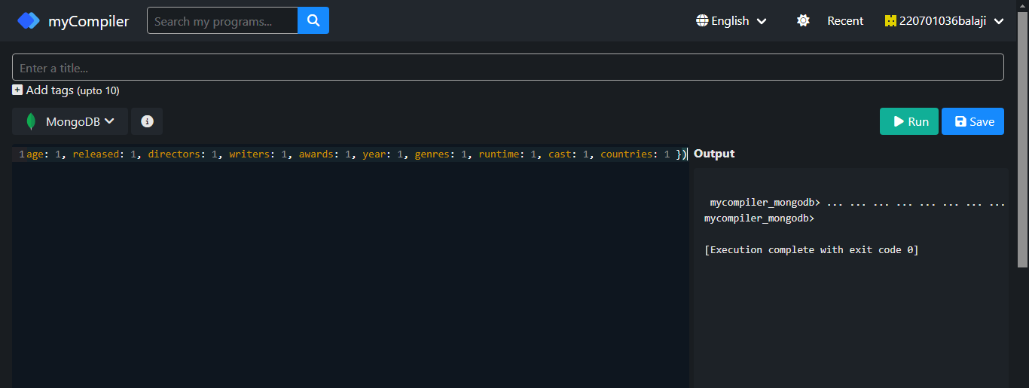

**4.)Retrieve all movies from the 'movies' collection that were directed by "William K.L. Dickson" and include complete information for each movie.**

**QUERY:**

db.movies.find({ directors: 'William K.L. Dickson' })

**OUTPUT:**

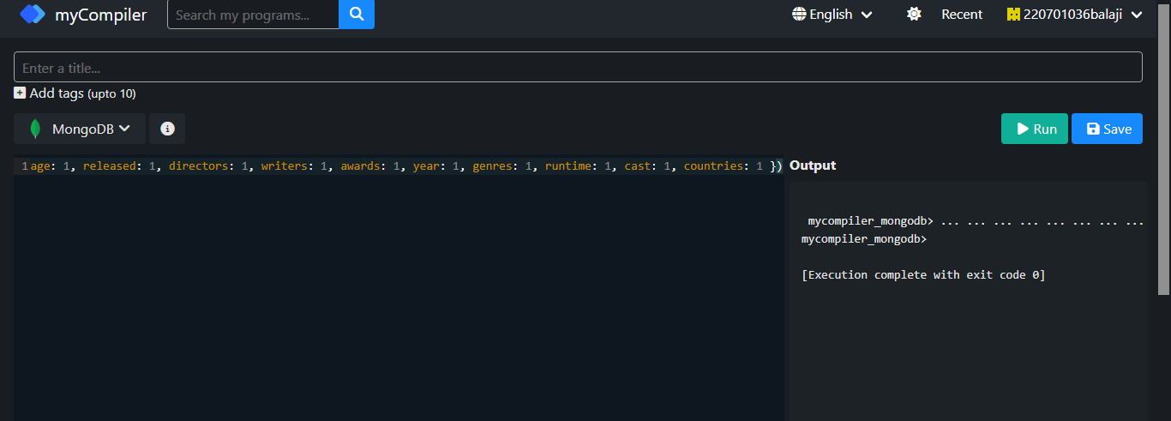

**5.)Retrieve all movies from the 'movies' collection that were released in the USA and include complete information for each movie.**

**QUERY:**

db.movies.find({ countries: 'USA' })

**OUTPUT:**

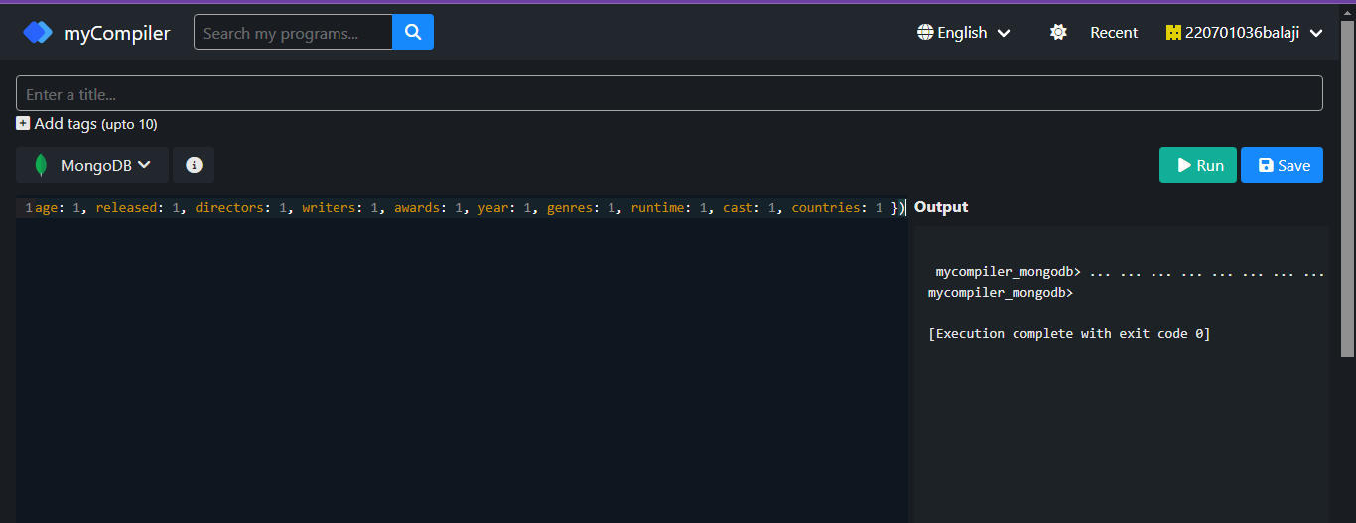

**6.)Retrieve all movies from the 'movies' collection that have complete information and are rated as "UNRATED".**

**QUERY:**

db.movies.find({ rated: 'UNRATED' })

**OUTPUT:**

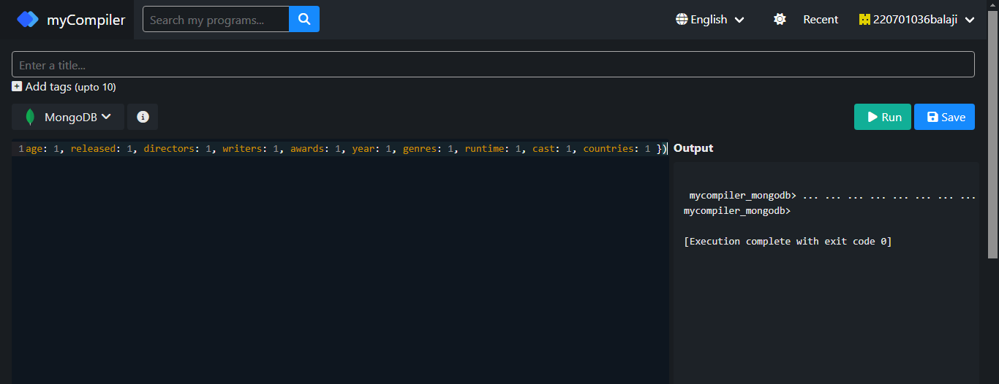

**7.)Retrieve all movies from the 'movies' collection that have complete information and have received more than 1000 votes on IMDb.**

**QUERY:**

db.movies.find({ 'imdb.votes': { $gt: 1000 } })

**OUTPUT:**

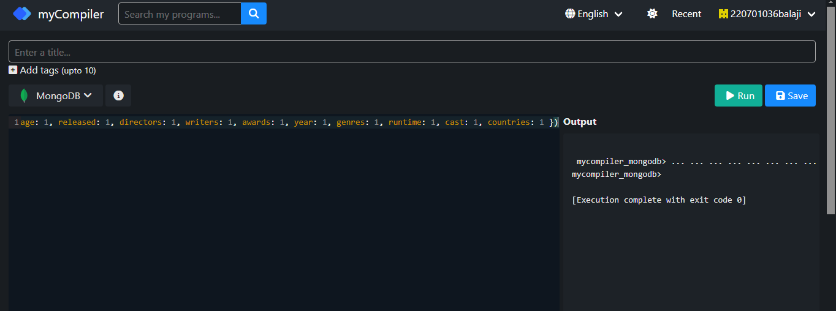

**8.)Retrieve all movies from the 'movies' collection that have complete information and have an IMDb rating higher than 7.**

**QUERY:**

db.movies.find({ 'imdb.rating': { $gt: 7 } })

**OUTPUT:**

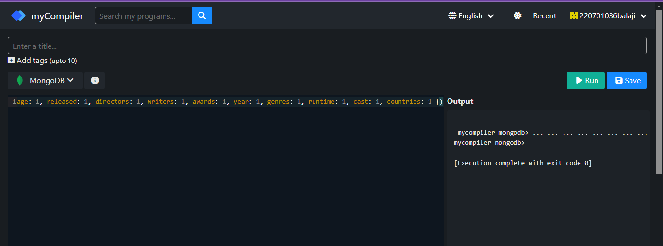

**9.)Retrieve all movies from the 'movies' collection that have complete information and have a viewer rating higher than 4 on Tomatoes.**

**QUERY:**

db.movies.find({ 'tomatoes.viewer.rating': { $gt: 4 } })

**OUTPUT:**

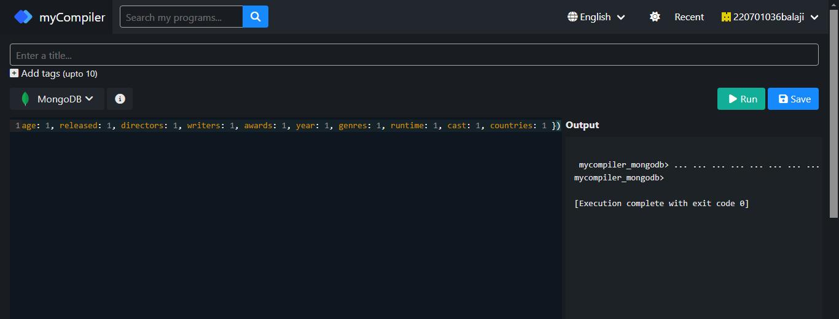

**10.)Retrieve all movies from the 'movies' collection that have received an award.**

**QUERY:**

db.movies.find({ 'awards.wins': { $gt: 0 } })

**OUTPUT:**

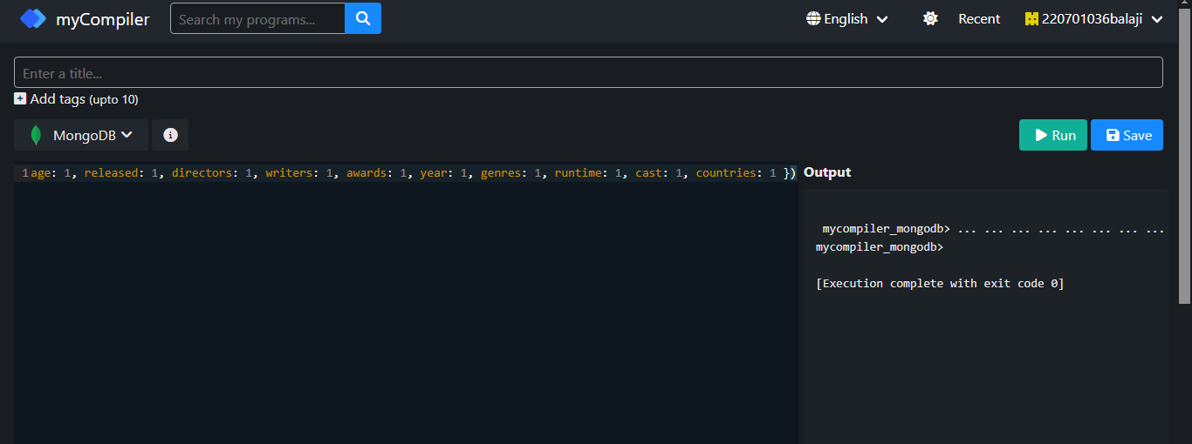

**11.)Find all movies with title, languages, released, directors, writers, awards, year, genres, runtime, cast, countries from the 'movies' collection in MongoDB that have at least one nomination.**

**QUERY:**

db.movies.find( { 'awards.nominations': { $gt: 0 } }, { title: 1, languages: 1, released: 1, directors: 1, writers: 1, awards: 1, year: 1, genres: 1, runtime: 1, cast: 1, countries: 1 })

**OUTPUT:**

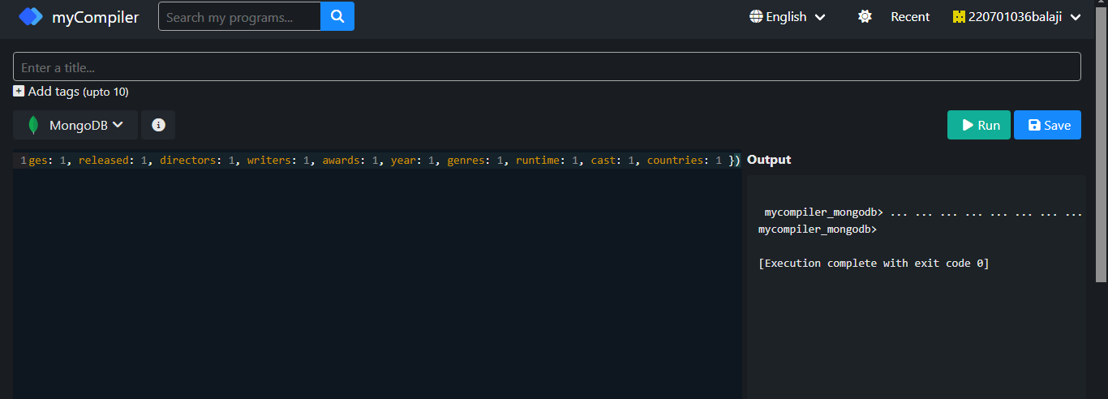

**12.)Find all movies with title, languages, released, directors, writers, awards, year, genres, runtime, cast, countries from the 'movies' collection in MongoDB with cast including "Charles Kayser".**

**QUERY:**

db.movies.find( { cast: 'Charles Kayser' }, { title: 1, languages: 1, released: 1, directors: 1, writers: 1, awards: 1, year: 1, genres: 1, runtime: 1, cast: 1, countries: 1 })

**OUTPUT:**

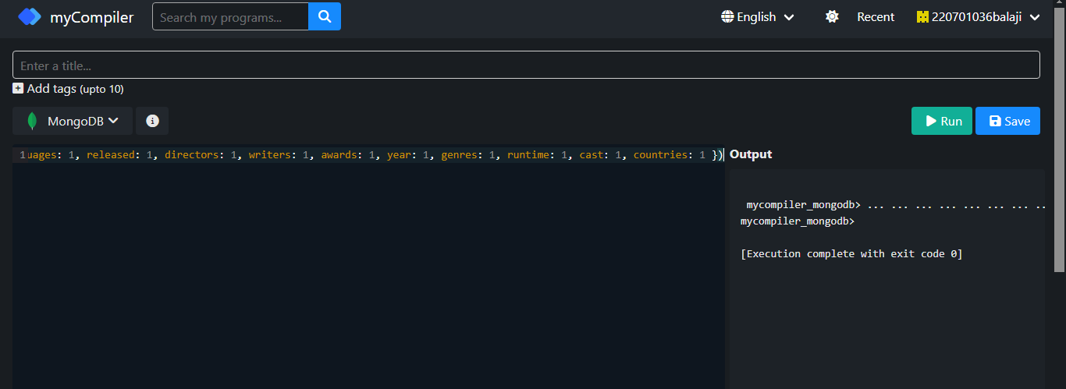

**13.)Retrieve all movies with title, languages, released, directors, writers, countries from the 'movies' collection in MongoDB that released on May 9, 1893.**

**QUERY:**

db.movies.find( { released: ISODate("1893-05-09T00:00:00.000Z") }, { title: 1, languages: 1, released: 1, directors: 1, writers: 1, countries: 1 })

**OUTPUT:**

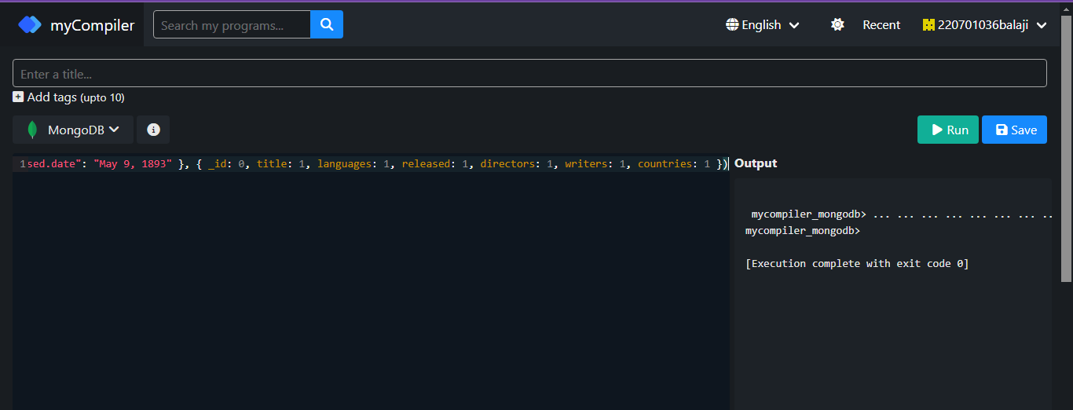

**14.)Retrieve all movies with title, languages, released, directors, writers, countries from the 'movies' collection in MongoDB that have a word "scene" in the title.**

**QUERY:**

db.movies.find( { title: /scene/i }, { title: 1, languages: 1, released: 1, directors: 1, writers: 1, countries: 1 })

**OUTPUT:**

|  |  |
| --- | --- |
| Evaluation Procedure | Marks awarded |
| Query(5) |  |
| Execution (5) |  |
| Viva(5) |  |
| Total (15) |  |
| Faculty Signature |  |

